Looking up payment status on a PO in BuyWays
- Enter the PO# in the top right of the search menu. Click on the arrow to search on other documents types (contract, document, supplier invoice, etc…)
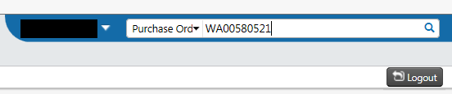
- Click on the invoices tab. It will list all of the invoices processed against the PO.
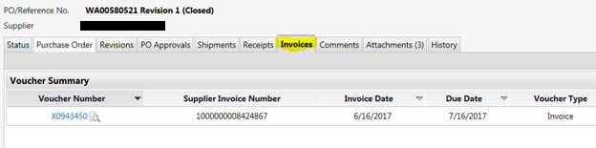
- Look at the payment status field to see if the invoice has been paid.

Payment statuses
- Paid = invoice has been paid
- In process = the invoice is in workflow pending an action. It will not pay until the issue is addressed
- Payable= invoice will be paid when it reaches the 30 day payment terms

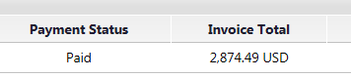

- Click on the voucher hyperlink to review a copy of the invoice or see payment details.
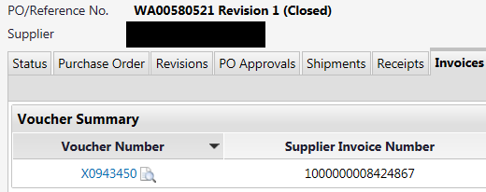
- Click on the hyperlink next to the invoice image to view the invoice. It’s on the top of the voucher page or it also may be reviewed in the “Notes/Attachments” section under “Internal Attachments. If there is no image check the voucher source on the page. If it says electronic there will not be an image available.

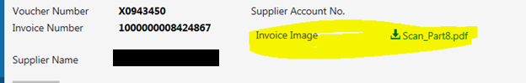
- To review payment details scroll to the middle of the page to review payment date and check number
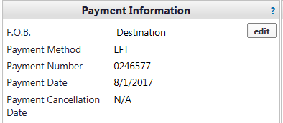

- To review why an invoice is in process check the matching tab. It will show you if the invoice line exceeded system tolerance or if it’s pending a receipt from the department in BuyWays
