Split transaction reallocation:
When you have the transactions showing on the screen – click on ‘clear all’ to clear any checkboxes. This is important – anything with a check will be split, so you want to be sure you control what you are selecting.
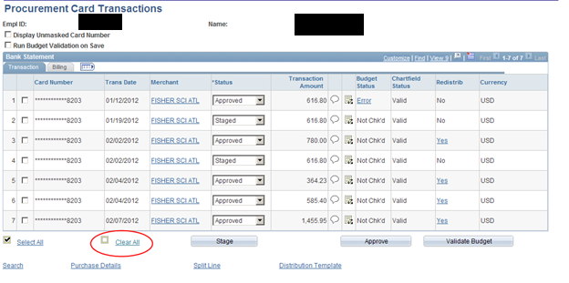

Check the transaction you want to work on, then click on the ‘split line’ hyperlink.
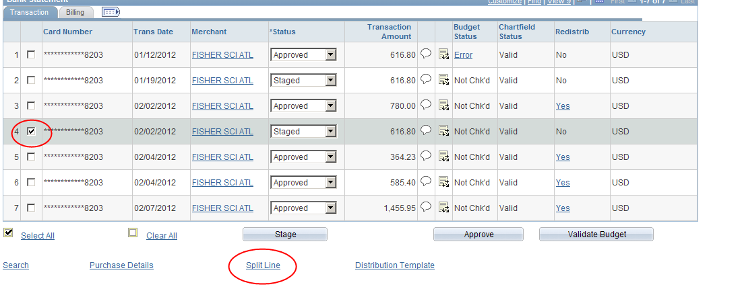

Adjust the billing amount for the first line to the first amount, then click on the plus sign. A second line will appear with the remaining balance. You can keep adjusting and adding lines until you use all of the transaction amount. Then click OK
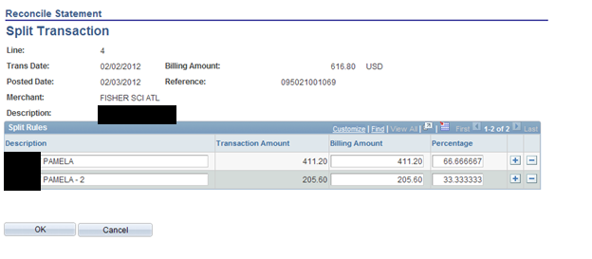
You will be brought back to the bank statement, where the transaction will be in 2 parts based on the split you created above, each of which can then be reallocated separately.
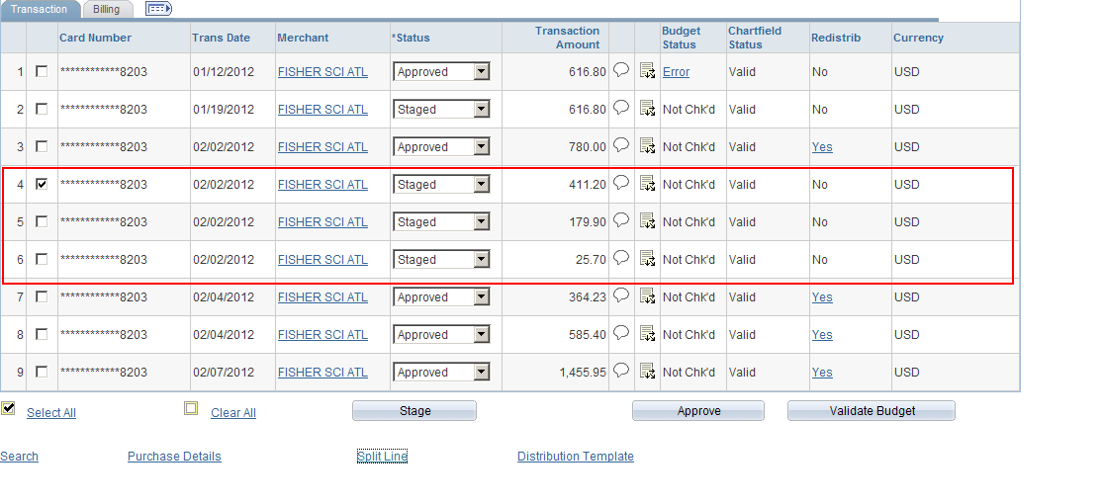
Be sure to save your transaction before exiting the reallocation panels.

