Entering an Honorarium using the Direct Payment Form in BuyWays

From the Home/Shop page, click on the ‘Forms’ hyperlink

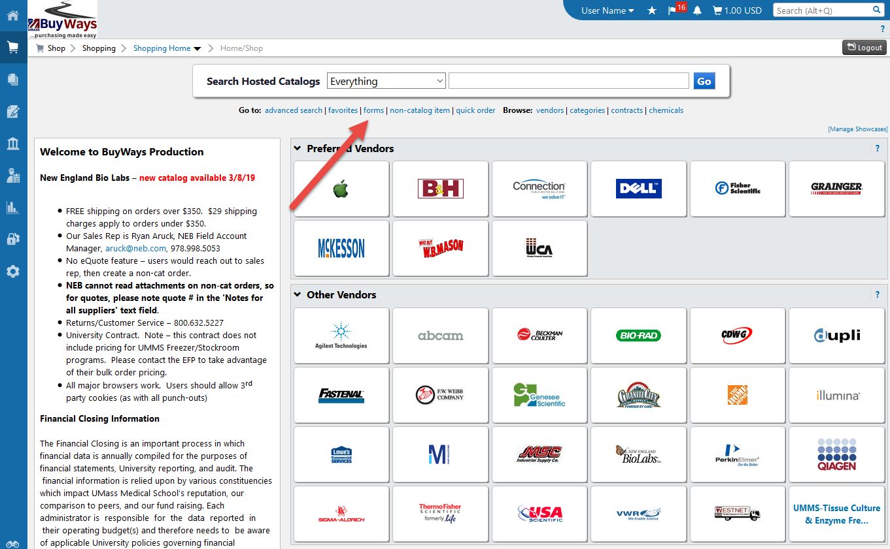

Click on ‘Medical School Direct Payment Form’. Note: The Special Handling version of the form should only be used when there are specific handling instructions eg: Home Check, due now, etc.

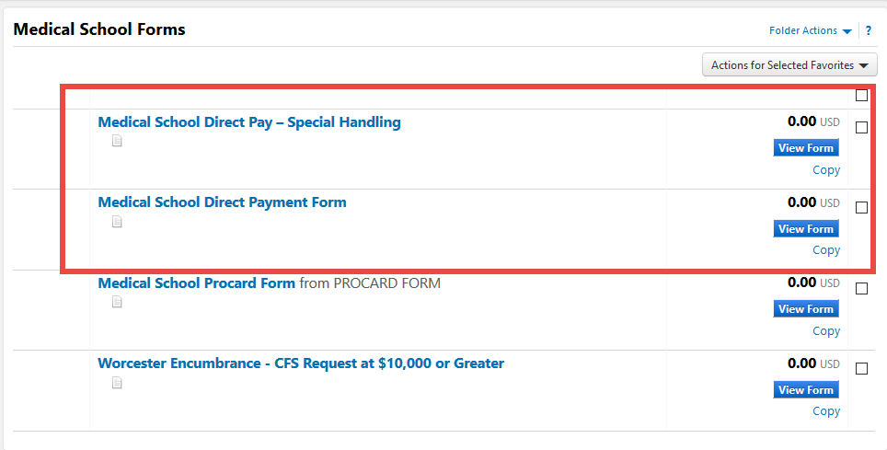

Choose the radio button for honorarium in the Purchase Category section

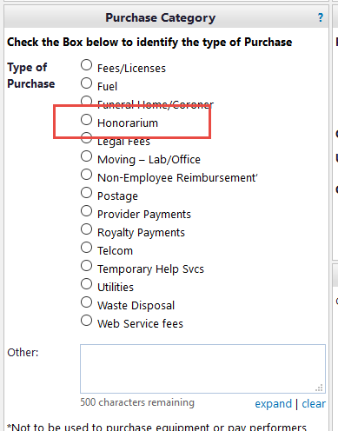

add the Date of the speaking engagement as the invoice date
add the Supplier Invoice #
* The invoice number should be inputted on the DP Form as follows
MAWH followed by the date (see example below)
Speaking date of 12/14/2018 should be processed as follows (MAWH121418)
add the Vendor Name. Note – after typing the 1st 3 letters, BuyWays will begin displaying a list to choose from. The vendor address information will auto populate from the vendor name chosen. Please be sure it is the address the speaker gave you. If the address you need is not available, please request an updated W9 and send to A/P for processing prior to preparing the form.

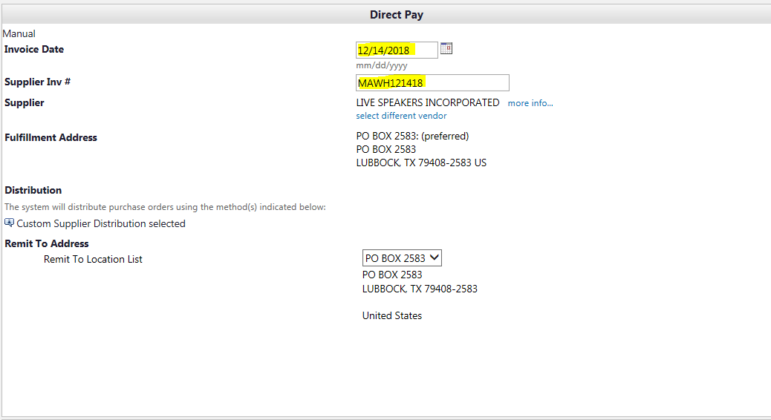

Add the Description (speaker name/event), Qty (1) and Unit Price (honorarium amount) and select the commodity code from the drop down list (Consulting Services, includes CFS).

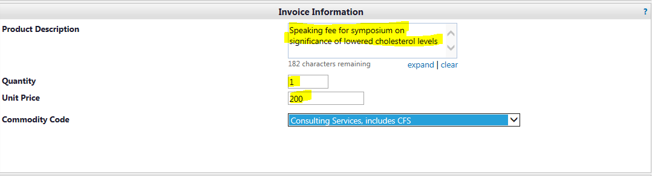

Scroll to the top of the page and choose ‘Add and go to Cart’, the click ‘Go’

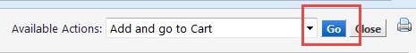

A BuyWays cart will be displayed with your invoice information.

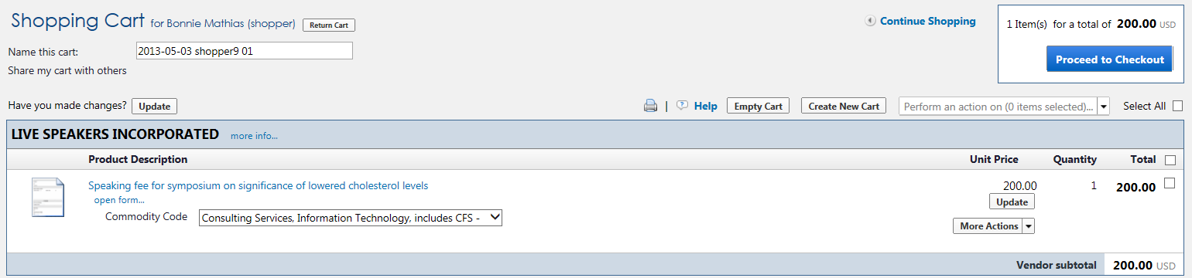

Proceed to check out and process as a requisition

On the Accounting tab of the requisition, add your ST and Account Code.

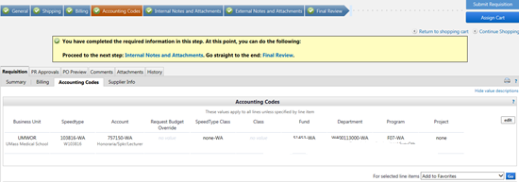
On the ‘Internal Notes and Attachments’ tab of the requisition, click on ‘Add Attachment’ and upload a copy of the event flyer if one was described.

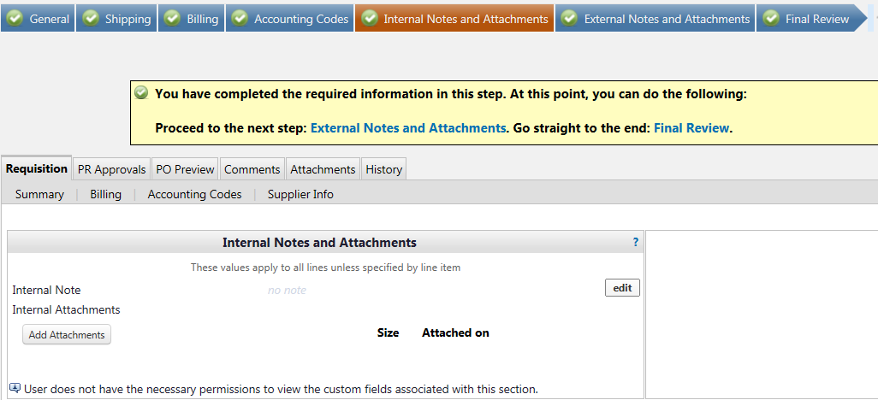

Click on ‘Select Files’ and browse for your file, or drag your file from your desktop to the box for upload

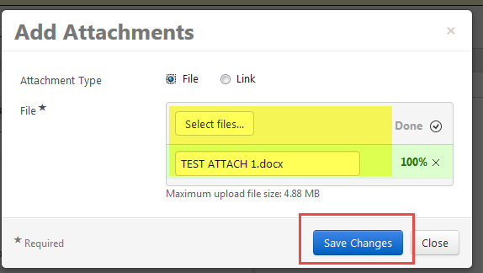

Go to the ‘Final Review’ tab and submit the requisition. Direct Pay requisitions will go to workflow for approval – the same way other requisitions are approved

Viewing your Voucher

Your Direct Pay requisition will route through approvals, then create both a Purchase Order and the Voucher. To view the voucher, go to the Purchase Order and click on the Invoices tab. You can view the Supplier Invoice number you entered and see the payment status. Click on the Voucher Number hyperlink to go to the voucher page.

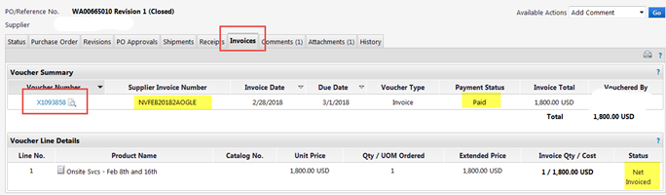

From the voucher, you can view the payment information and open a copy of the invoice:

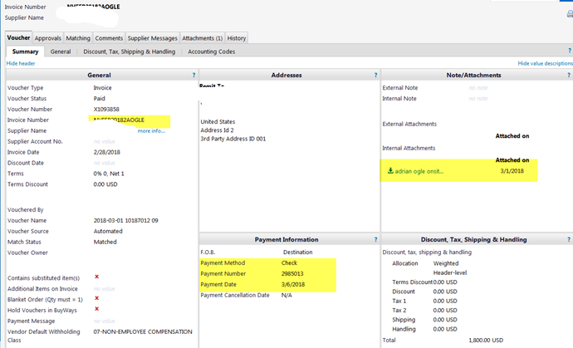

If you only have an invoice number, you can search for it by using the Search function in the upper right corner

