# **TCM – Contract Notification Set up**

To turn on contract notifications in BuyWays, open the drop down box next to your name in the upper right, then click on ‘View My Profile’

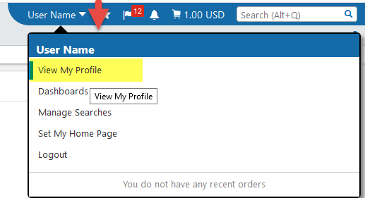

From the left navigation menu, open the ‘Notification Preferences’ section, then click on ‘Contracts’

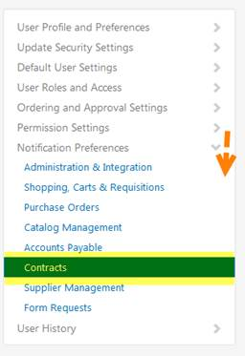

Update the setting on the following by clicking on ‘Edit Section in the upper right  cid:image005.png@01D3A577.9DAB8030.  Then click the radio button for ‘Override’ on the following items and select Email & Notification for the following items.  Be sure to click the ‘Save Changes’ button when you have completed your changes

Contract Budget/Tier Notification

Contract end date – advance notices

Contract End Date Passed

Contract Renewal Date – Advance Notices

Contract Returned Notice

New Contract Request Discussion Thread

New Contract Request Discussion Reply

Contract Approval Workflow Completed

