Create an Export template for BuyWays queries:

From the left nav bar, follow Documents, Document Search, Create and Manage Export templates

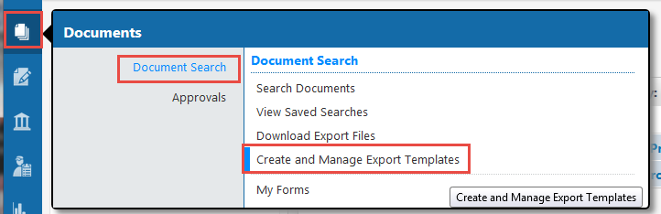

Choose the type of document you will use in your search under ‘My Templates’
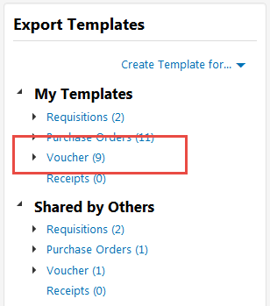

A pop up box will appear and allow you to choose the fields to be included in your template. I typically use All in one file and Let me choose. Then click ‘Next’

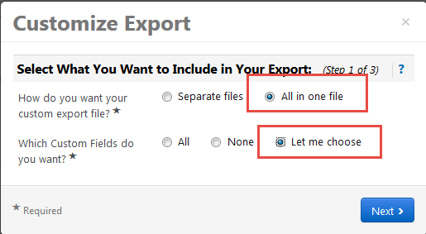

A pop up box will appear where you can check the fields that you want to include in your export file. The System Fields will create a single line, while the Custom Fields may create multiple columns at the end of the output (It can be messy)
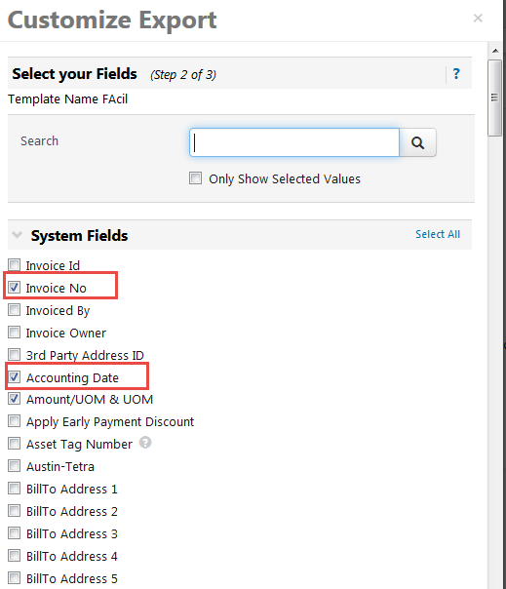

Click on ‘Next’, then Name your template and (optional) provide a description of the expected output
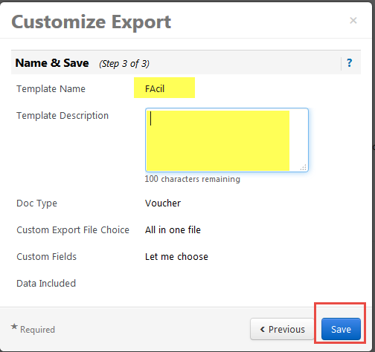

The template will be available for you to use and will be listed in the ‘My Templates’ section of the page by the type of document you searched for.

Using a template:
From the Document icon on the left nav bar, choose Document Search, Search Documents

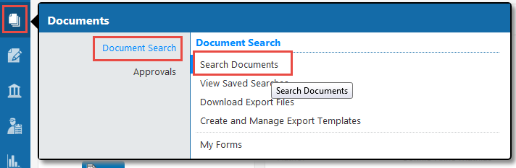

Select the document type from the Search drop down box, then scroll down and put any criteria for your search
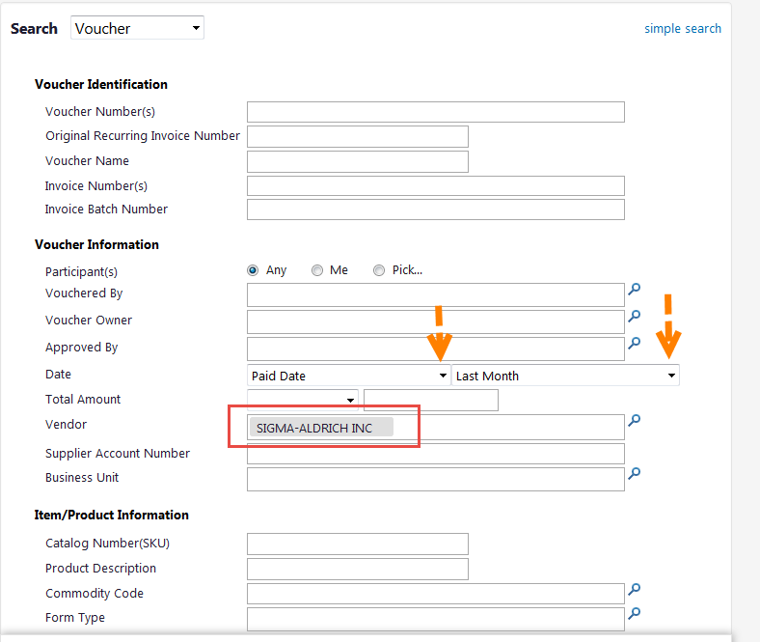
For example, I chose the Voucher Paid Date of ‘Last Month’, Supplier name of ‘Sigma-Aldrich’. You can choose any field that you want to use as criteria. Or, start simply and then further refine the results using the left menu options.
Once you have a query with the results you need, use the ‘Save New Search’ if you plan to use this query again (optional if you don’t think you will use it).

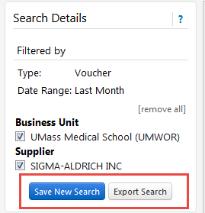

To export the results, choose ‘Export Search’ from the left nav menu. Add a File name, then use the drop down list to select your export template. Click ‘Submit’
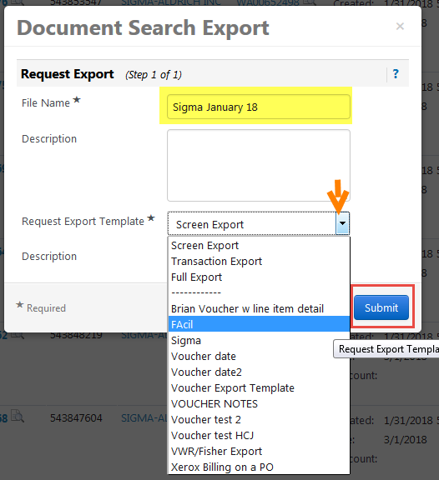

You will receive a confirmation pop up box. You can go to the Download page from the box and wait for the export to complete, or you can close the box and check for the file later
Now:
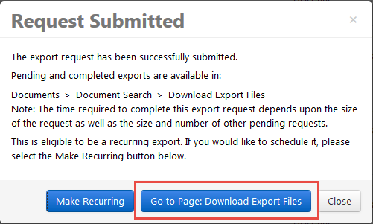
Later:
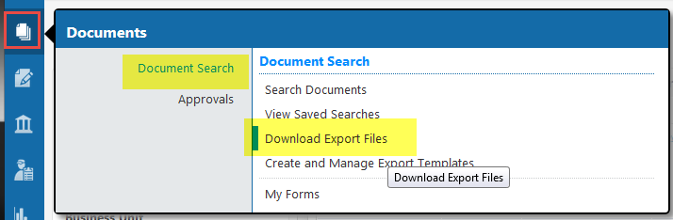

To open the file, click on the file name when the Export Status is ‘Completed’. Please note the Remove selected check box and action button below. Be sure to clean up download files when you have completed your download as there is limited space in BuyWays.
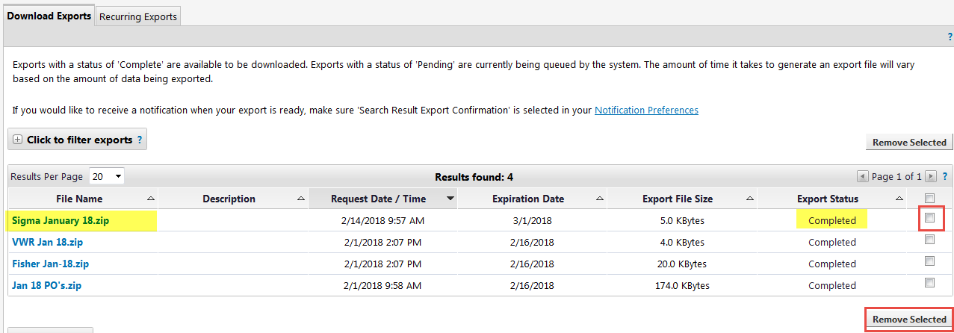

A message box will open, Choose ‘Open with’ Windows Explorer, then OK

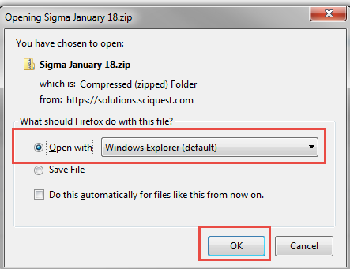

When the explorer window opens, you can double click on the file to open
