How to back up your iPhone
First you will need an iTunes account. An iTunes account is not only used for backing up your device but it is also required to purchase and download content from the iTunes Store. Your iTunes/iCloud account username are one in the same.
The links below provide you with step by step instructions to set this up.
- How to create an iTunes/iCloud account
https://support.apple.com/en-us/HT204316
- How to back up iPhones to iTunes/iCloud
https://support.apple.com/en-us/HT203977
***Note***
You will be prompted to choose what you want to back up (ie… photos, calendar, email, etc…) please make sure the mail option is turned off. Your mail will be backed up to the server and does not require iCloud backup.

How to back up an Android Device
First you will need a Google/Gmail account.
The link below provides you with step by step instructions to set this up.
- How to create a Google/Gmail account
https://accounts.google.com/signup
Once you’ve created the account or if you have an existing Google account, please follow the steps below to back up your Android device
- On your device, go to Settings, Personal, Backup and reset, and select both Backup my data and Automatic restore.
- On your device, go to Settings, Personal, Accounts & Sync, and select your Google account.
- Select all of the option boxes listed, to ensure that all available data is synced.
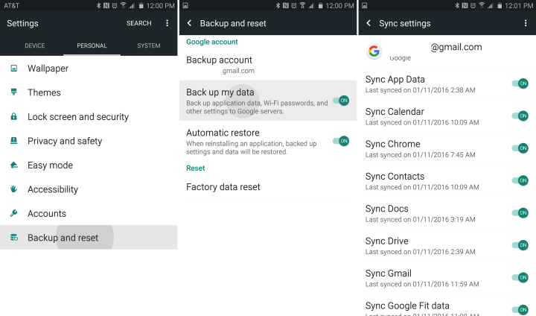
*** Note***
The specific procedure may vary slightly between Android devices but the process is generally the same.

