[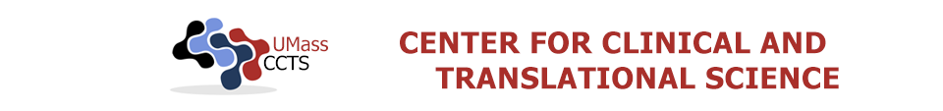](http://qaedit-www.umassmed.edu/CCTS/)[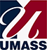](http://qaedit-www.umassmed.edu/)

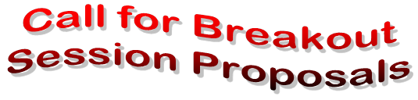

**2020 9th Annual UMCCTS Community Engagement and Research Symposium**

**Friday, March 20, 2020; 8:00 AM – 1:30 PM**

**UMass Medical School, Worcester, MA**

**Keynote:** Dr. Peter D. Friedmann, MD, MPH, DFASAM, FACP

Associate Dean for Research, Division of General Internal Medicine

Department of Medicine, University of Massachusetts Medical School- Baystate

Chief Research Officer, Baystate Health

**Breakout Session Proposals Due:**

**Wednesday, November 20, 2019, 5:00 PM**

The breakout sessions serve as an opportunity for learning about innovative initiatives from community-engaged research teams from the UMass system, other academic institutions, our local communities and beyond.

**Audience:** Community leaders, faculty and staff from UMass’ five campuses as well as other organizations and institutions interested in partnered research.

**Breakout Session Format:** Breakout sessions should be 60 minutes long and include interactive discussion. Sessions or trainings previously presented at other conferences are welcome.

**Possible formats include:        Panel Discussion**

**Training/Workshop**

**Presentation of Research Results**

**Suggested themes include but are not limited to:** health disparities, underserved populations, patient-centered communication, community-clinic partnerships, social media, environmental health, obtaining funding, methods and tools for community-engaged research, specific diseases or conditions, prevention, health promotion, implementation and dissemination research. [**Please visit this link to view previous sessions.**](https://escholarship.umassmed.edu/chr_symposium/)

**Please submit your proposal via email by Wednesday, November 20, 2019 to:** [communityengagement@umassmed.edu](mailto:communityengagement@umassmed.edu) with the following information:

* Title of the breakout session
* Name(s) and affiliation of moderator(s)
* List of breakout session presenters with email/phone
* Background and purpose of the breakout session
* Anticipated format, including a description of how you will interact with the audience

**Notification Date:**  You will be notified by December 13, 2019 regarding the status of your proposal.

**Questions?** Email [Communityengagement@umassmed.edu](mailto:Communityengagement@umassmed.edu)

**For more information, visit our website:** [www.umassmed.edu/ccts/community](http://www.umassmed.edu/ccts/community)

**Registration for the Symposium will open on January 10, 2020.**

***The UMass Center for Clinical and Translational Science is part of a national Clinical and Translational Science Award (CTSA) led by the National Institutes of Health's National Center for Advancing Translational Sciences (NCATS). This Symposium is supported through grant number UL1TR001453..***

*Confidentiality Notice:*

*This e-mail message, including any attachments, is for the sole use of the intended recipient(s) and may contain confidential, proprietary and privileged information. Any unauthorized review, use, disclosure or distribution is prohibited. If you are not the intended recipient, please contact the sender immediately and destroy or permanently delete all copies of the original message.*

UMCCTS Community Engagement and Research Section  
University of Massachusetts Medical School  
Community Engagement@ umassmed.edu

Confidentiality Notice:  
This e-mail message, including any attachments, is for the sole use of the intended recipient(s) and may contain confidential, proprietary and privileged information. Any unauthorized review, use, disclosure or distribution is prohibited. If you are not the intended recipient, please contact the sender immediately and destroy or permanently delete all copies of the original message.  
________________________________  
You are currently subscribed to communityengagement as: [Nathaniel.Hafer@umassmed.edu](mailto:Nathaniel.Hafer@umassmed.edu)  
To unsubscribe click here: <http://lists.umassmed.edu/u?id=92185&l=communityengagement&u=http://umassmed.edu&n=T&c=F>  
or send a blank email to [leave-139101-92185.d4abeacd70d6f2afb745c9ff76b0bbd8@lists.umassmed.edu](mailto:leave-139101-92185.d4abeacd70d6f2afb745c9ff76b0bbd8@lists.umassmed.edu)