Sample YAC Offer Letter
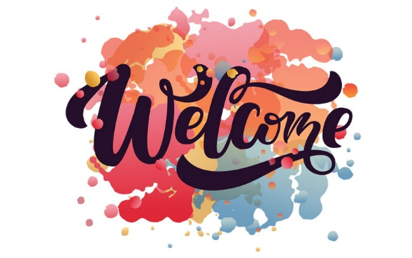

Afternoon [Insert YAC Member’s Name],

I am very excited to be welcoming you into the Youth Advisory Board (YAB)! I have forwarded you the meeting information and calendar invite for our meeting next week on September 29th from 12 to 2pm EST. Shortly you will receive a DOCUsign email to complete your Scope of Work for the 2023-2024 year. This should be the only thing you need to complete to transfer you over to the YAB completely and I have attached a copy above so you may see your compensation rate. 😊

Overview of the YAB:
The YAB is comprised of Young Adults between the ages of 18-30 with Mental Health Conditions (MHC) from across the nation. We currently have about 12 active members ranging in ages, mental health conditions, diversity, and backgrounds. We have a comfort clause that we bring up at the beginning of every meeting, and you will be sent all materials to review before each meeting. If you are going to be late, or need to miss a meeting, please be sure to let me know. We treat the YAB as a part time job, as you are compensated for your time and efforts, we also allow opportunities for extra work. Your membership will be subject to a meeting with me if you miss three consecutive meetings.

Please provide me with:
- Best email to reach you
- Best phone number to reach you
- Full address (123 Happy Lane, Shrewsbury, MA. 01234) for billing purposes- be sure to provide the address you want your physical check to be mailed to

You are not required to answer the following voluntary questions, please only share what you are comfortable with. This information will remain private and only be seen by myself. I do not share this information out without your permission, and I collect this demographic information solely to continue building an inclusive and diverse community board.
- Your Age
- State you live in
- Small summary of your Mental Health Diagnosis (Only answer if you feel comfortable sharing that information with me)
- Your birthday

We cannot wait to get your valuable input at our next meeting! If you have any questions, please do not hesitate to contact me. 😊

