How to fill and submit your PEP(Proposed Enrollment Plan) Form for your 4th year classes
This document will walk you through the steps to follow while filling your PEP form

Step 1: Login to Oracle PeopleSoft Student using the below link with your UMMS credentials.
URL: https://pscs.wsa.umasscs.net/psc/prd/EMPLOYEE/SA/c/NUI_FRAMEWORK.PT_LANDINGPAGE.GBL

You can also find the link under https://umassmed.edu/studentlife

Step 2: After you land on the below homepage, click on the ‘PEP Form’ tile.
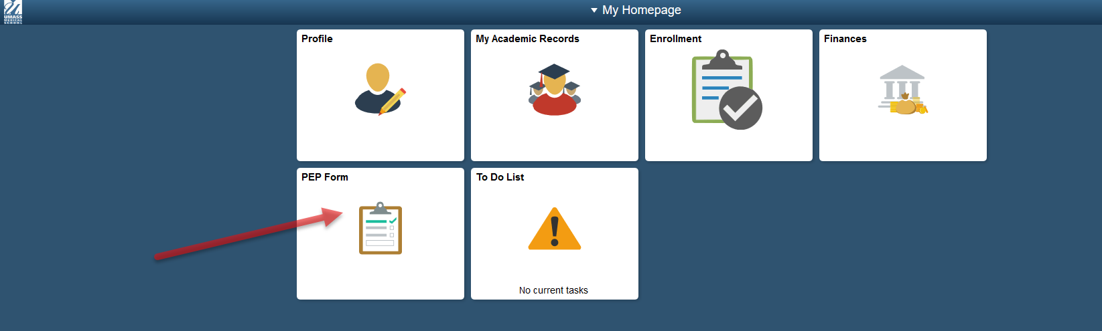
You will be taken to below screen.
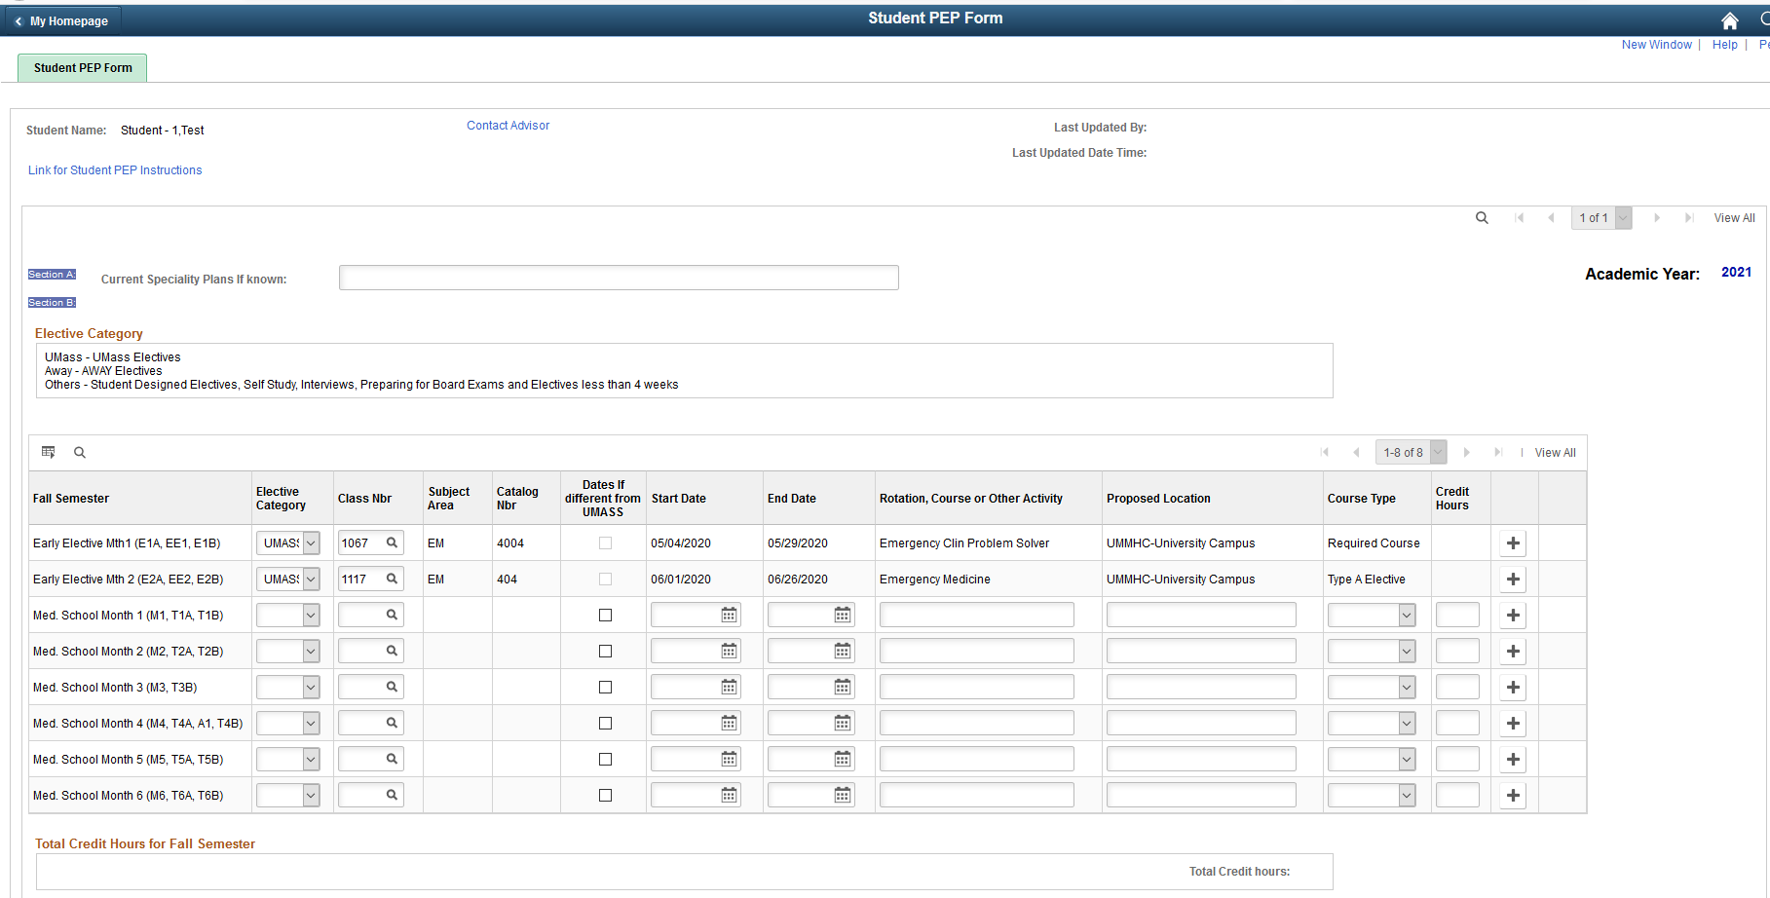

The top of the page carries links to ‘Student PEP Instructions’ document and a ‘Contact Advisor’ link, which will enable you to send an email from this page to your mentor for any questions/discussions related to your electives plan.

When you open the PEP Form for the first time, only classes that you are already been enrolled into through the lottery process will be populated. In the above example, it is EM4004 & EM404 in the first 2 months of Fall Semester.

Under Section B, you will have an option to select from UMMS or AWAY electives under the Elective Category. Also if you would be doing something else during the month other than UMMS/AWAY electives, please enter them under OTHERS category.
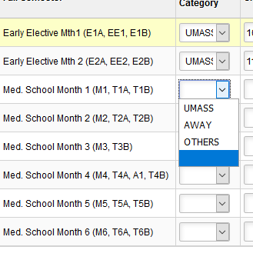

For UMMS electives, dates will be auto-populated when you select a class.
Please note that when you select AWAY or OTHERS category, you would need to enter the dates as well.

Ensure you select atleast 1 entry(UMMS/AWAY/OTHERS) for each of the months across Fall & Spring Semesters, as shown in below screenshot. You can also select more than 1 class for a single Semester month by adding a new row clicking on the ‘+’ button to the right; provided no 2 classes overlap with a single month. An example is Month-10 in below screen.

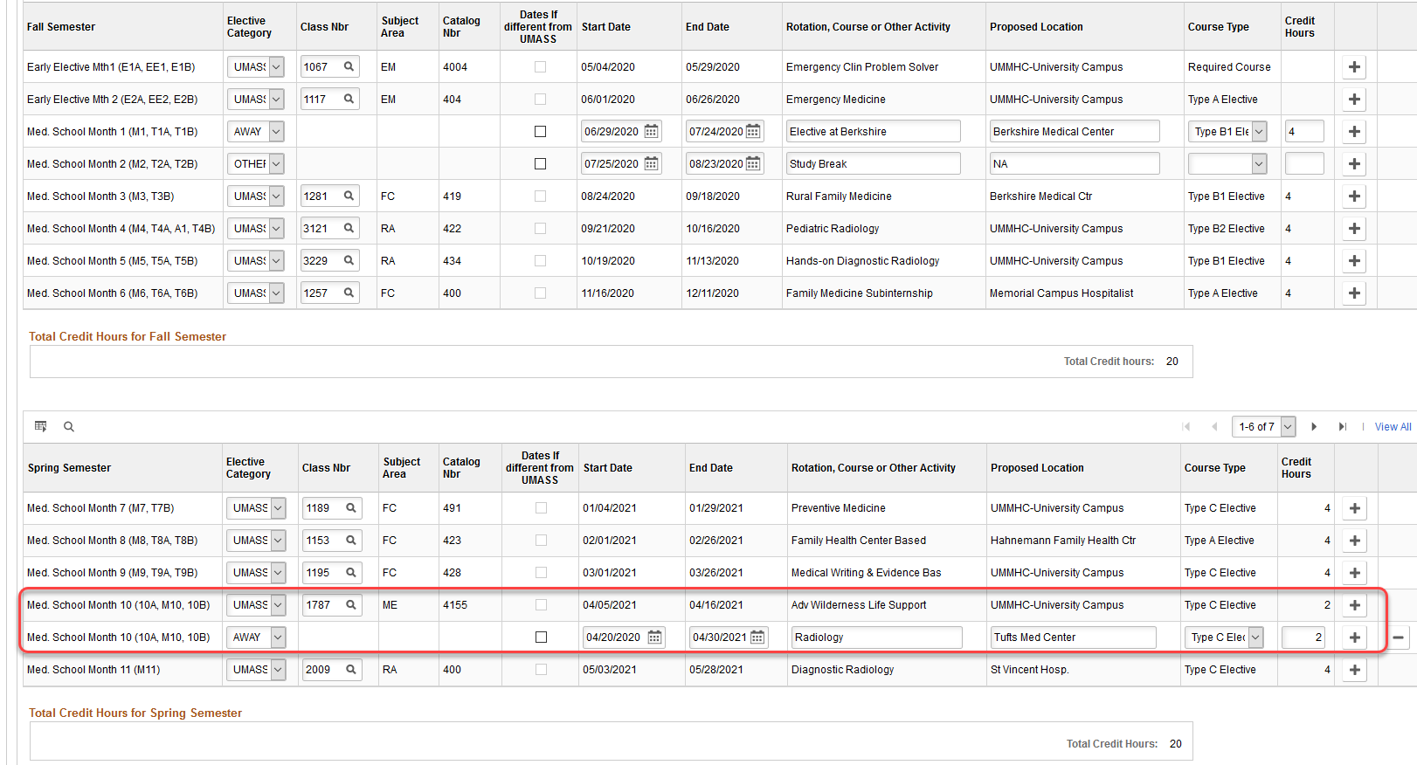

As you scroll further down, you have an option to enter Tentative plan under Section-C, where you can enter any alternative options or any additional activities you may be doing during the terms, with dates. This is an optional section.
Section-D shows dates of your STEP exams.
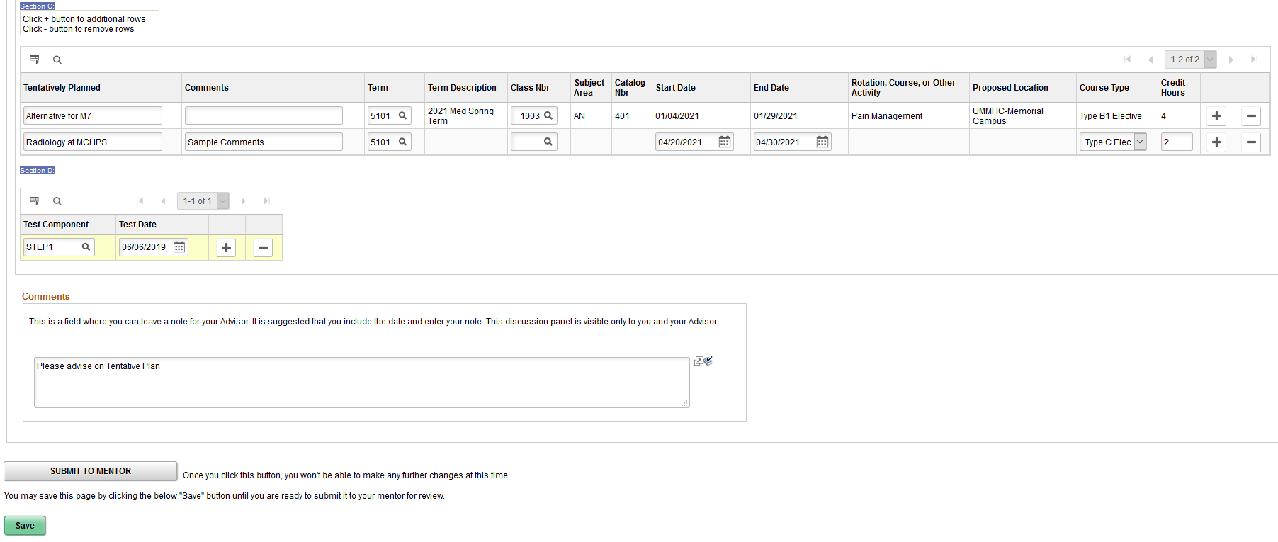

The Comments section allows you to enter and track all prior comments by you and your advisor, which gets saved upon hitting ‘Save’.

Also note that you need NOT complete filling the entire form in 1 sitting. You can hit a ‘Save’ to retain your data and continue from same point upon next login to complete the rest of your form. Do not hit ‘Submit’ unless you have completed your form, as it will become uneditable after it is sent to the Advisor.

Step 3: Once you have entered all your details and are ready to submit your form to your Advisor, click on ‘Submit to Mentor’ button. You will see a message as below.
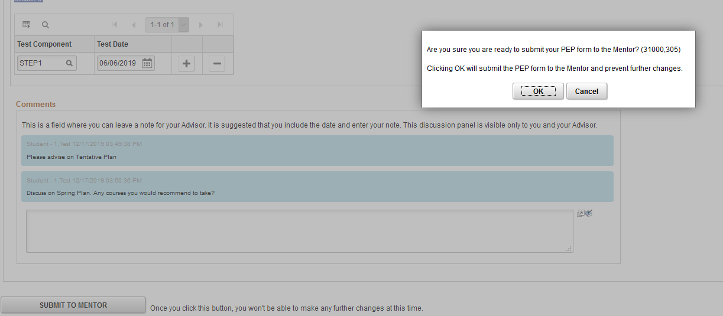
When you hit ‘OK’, the form is saved and no longer editable. The system will send an email notification to your Advisor.

Mentor Not Available:
If your Mentor has set his/her leave information on their end of the PEP form, you will have an option to Self-Approve your PEP form in case it is urgent.

You will need to follow the same steps as shown until this point on this document to fill your PEP form and save the details.

When you scroll down your PEP form, you will see 2 buttons.
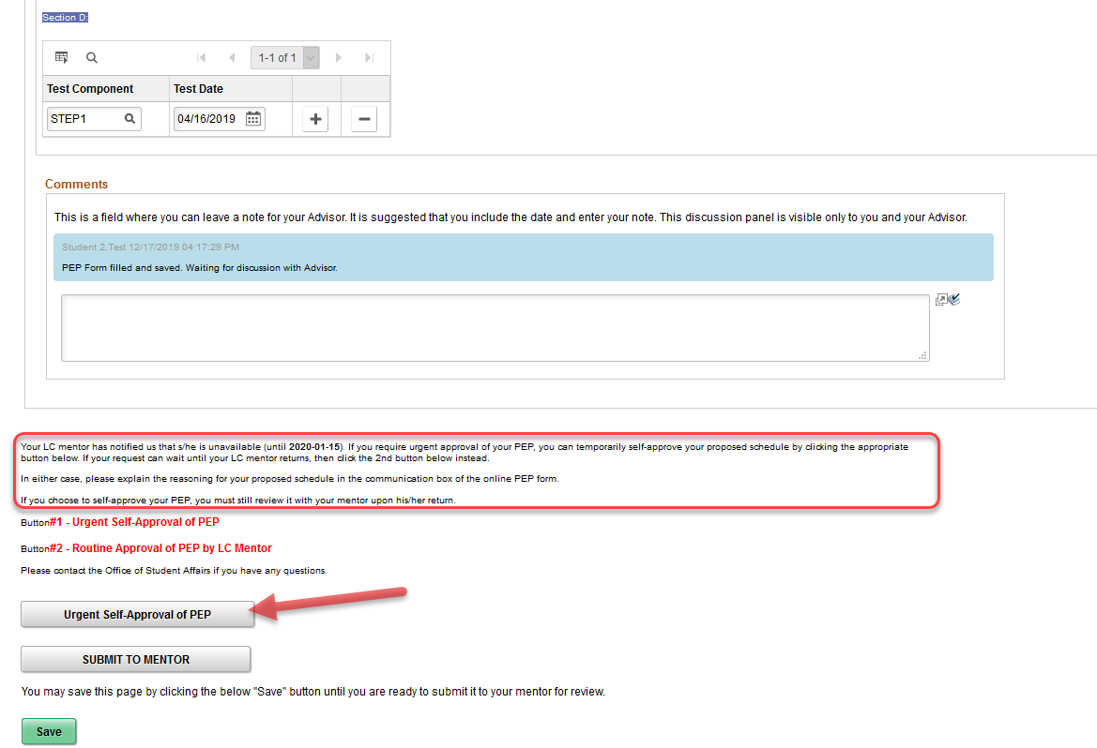
You can see from the text in Red box above, you will find the date until when your mentor is unavailable. If you need not have to enroll into any classes until that date, you can use the usual approach of clicking the ‘Submit to Mentor’ button and wait until your Mentor is back to approve it.

However, if you would need to get an approval urgently, please click on the ‘Urgent Self-Approval of PEP’ as shown by the red arrow above.
After saving a comment and clicking the Self Approval button, you will see a message as below.

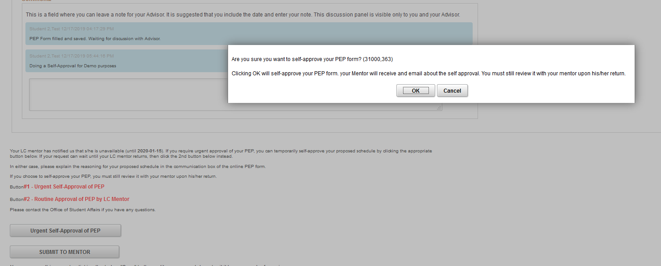
After you acknowledge the message by clicking on ‘OK’ the form is approved and a message is saved in the Comments section as below.

