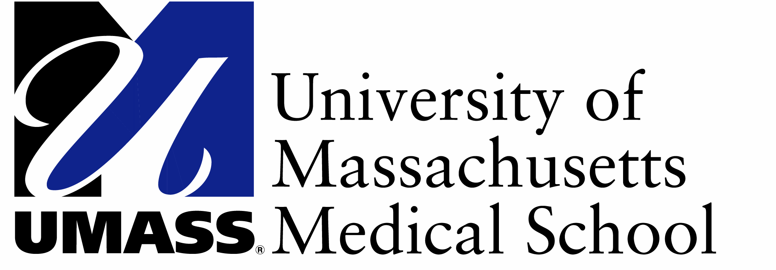

AY 17-18 Academic Calendar at a Glance
Foundations of Medicine 2 (Year 2)

Fall 2017
08/03/17 | Fall semester begins, first day of classes
08/07/17 | Careers in Medicine 2: Welcome Back! 12:30-3pm
09/04/17 | Labor Day (no classes)
10/09/17 | Columbus Day (no classes)
10/16/17 – 10/27/17 | Population Health Clerkship
11/10/17 | Veteran's Day (no classes)
11/23/17 | Thanksgiving (no classes)
11/24/17 | Day after Thanksgiving (no classes)
12/21/17 | Fall semester ends, last day of exams
12/22/17 – 1/1/18 | Vacation

Spring 2018
01/02/18 | Spring semester begins, first day of classes
01/15/18 | Martin Luther King Day (no classes)
01/29/18 | Careers in Medicine 3: Intro to CCE Year, 2-5pm
02/19/18 | Presidents Day (no classes)
03/19/18 – 04/20/18 | Reading Period
04/16/18 | Patriots Day (no classes)
04/23/18 – 05/04/18 | Transition to CCE
05/04/18 | Spring semester ends, last day of classes
An hour by hour calendar of your class schedule is available at: http://i.umassmed.edu/curriculumcalendar
OSA.Academic Calendars.AY1718.FOM1/2
JH 1/12/17

