Tubulopathies:
- Renal Tubular Acidosis (Objective I.4)
  - Renal tubular acidosis (RTA) is a group of four disorders characterized by a hypokalemic non-anion gap metabolic acidosis. RTA is caused by a defect in the renal tubules resulting in impaired hydrogen secretion or bicarbonate reabsorption (Alexander 2019, Bagga 2020).
    - Type 1 (distal) RTA is caused by a defect in hydrogen ion secretion in the collecting duct. This classically presents with a non-anion gap metabolic acidosis, hypokalemia, alkaline urine, hypercalciuria, and nephrocalcinosis (Alexander 2019).
    - Type 2 (proximal) RTA is caused by a defect in bicarbonate reabsorption in the proximal tubule. This classically presents with a non-anion gap metabolic acidosis and hypokalemia. Unlike type 1 RTA, the ability to acidify the urine is preserved (Alexander 2019).
    - Type 3 (mixed) RTA is caused by a defect in carbonic anhydrase resulting in impaired hydrogen secretion and bicarbonate reabsorption. This disorder includes features of type 1 and 2 RTA in addition to osteopetrosis, cerebral calcifications, nephrocalcinosis, facial dysmorphism, conductive hearing loss, and cognitive impairment (Alexander 2019, Bagga 2020).
    - Type 4 RTA is caused by Hypoaldosteronism resulting in a defect in hydrogen and potassium secretion. This is characterized by a hyperkalemic non-anion gap metabolic acidosis (Alexander 2019, Bagga 2020).
  - The following two algorithms were adapted from the Bagga 2020 review article and outline the diagnostic steps for patients with suspected RTA.

Adapted from Bagga 2020
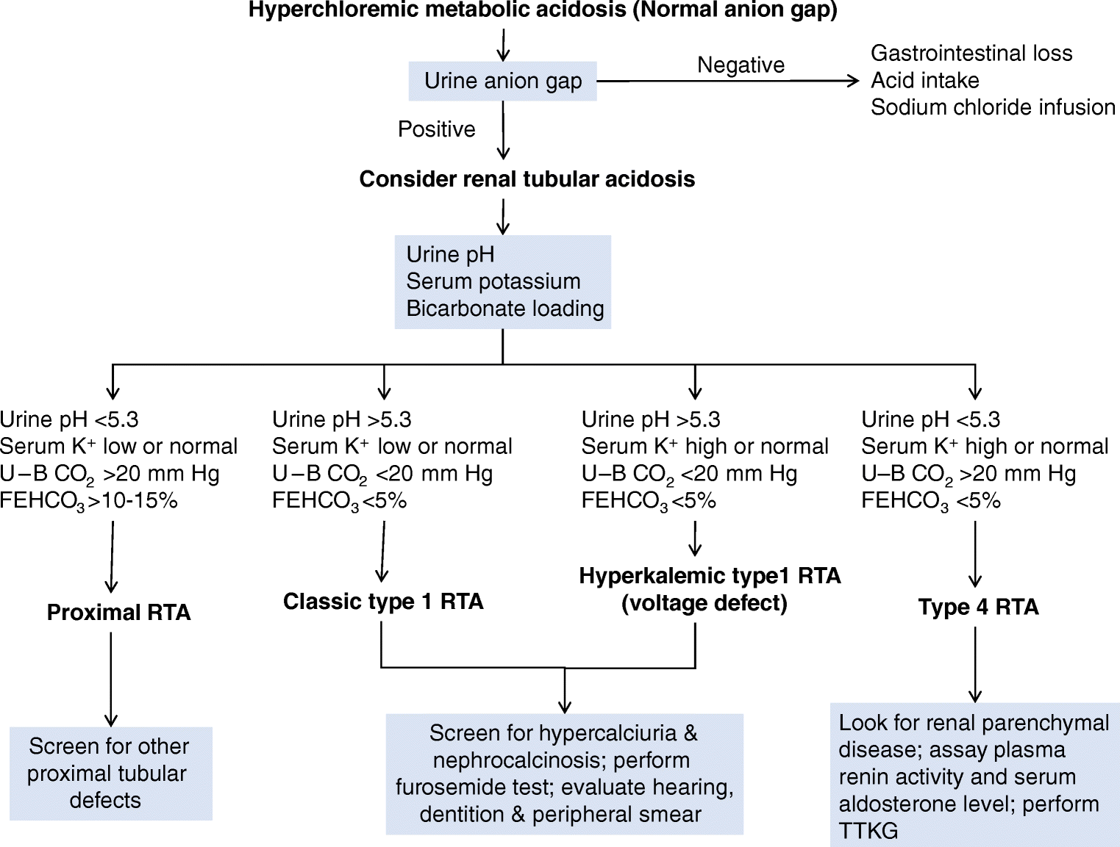
Bagga 2020
  - The mainstay of treatment for RTA is alkali therapy (potassium citrate, potassium/sodium citrate, sodium salts) to correct the underlying metabolic acidosis. (Alexander 2019).

- Bartter Syndrome: (Objective I.4)
  - Bartter syndrome is a renal tubulopathy caused by a mutation in one of the many transporters in the thick ascending loop of Henle. Clinically, Bartter syndrome is classified into two subtypes: the antenatal and classical subtype. The antenatal subtype presents with polyhydramnios and prematurity. The classical subtype presents with failure to thrive during infancy. Bartter syndrome is further divided into 5 subtypes dependent upon the genetic mutation involved (Nozu 2019).
    - Type 1 Bartter syndrome is caused by a mutation in the Na-K-2Cl co-transporter. Type 1 presents as the antenatal form with progression to hypokalemia, hypercalciuria, and nephrocalcinosis (Nozu 2019).
    - Type 2 Bartter syndrome is caused by a mutation in the ROMK potassium channel. Type 2 presents as the antenatal form. These patients typically exhibit a transient hyperkalemic metabolic acidosis after birth before developing the typical phenotype of hypokalemia, hypercalciuria, and nephrocalcinosis (Nozu 2019).
    - Type 3 Bartter syndrome is caused by a mutation in the ClC-Kb transporter. This subtype presents as the antenatal form, with a milder phenotype (Nozu 2019).
    - Type 4 Bartter syndrome is caused by a mutation in Barttin, ClC-Ka, and ClC-Kb. It presents in the antenatal form with sensorineural hearing loss (Nozu 2019).
    - Type 5 Bartter is caused by a mutation in the MAGE-D2 gene. It is the most severe life-threatening phenotype and presents in the antenatal period (Nozu 2019).
  - Diagnostic features suggestive of Bartter syndrome include hypokalemic metabolic alkalosis, elevated renin, and hyperaldosteronism. Diagnosis is confirmed with genetic testing (Nozu 2019).
  - Barter syndrome is treated with maintaining hydration, potassium supplementation, and NSAIDs (Nozu 2019).

- Gitelman Syndrome: (Objective I.4, I.5)
  - Gitelman Syndrome is an autosomal recessive genetic disorder caused by a mutation in the SCL12A3 gene that encodes the sodium-chloride cotransporter in the distal convoluted tubule (Blanchard 2017).
  - Classic features of Gitelman syndrome include hypokalemic metabolic alkalosis with concurrent hypomagnesemia and hypocalciuria. Additional diagnostic features favoring the diagnosis include renal potassium and magnesium wasting, elevated serum renin, a fractional excretion of chloride >0.5%, decreased blood pressure, and a normal renal ultrasound. The diagnosis is confirmed with genetic testing for SCL12A3 mutations (Blanchard 2017).
  - Treatment of Gitelman Syndrome consists of liberal intake of NaCl in addition to potassium chloride and magnesium supplementation. Patients with refractory hypokalemia may also benefit from potassium sparing diuretics, angiotensin-converting-enzyme inhibitors/ angiotensin receptor blockers, or indomethacin (Blanchard 2017). These patients may also benefit from lifestyle modifications including a diet rich in magnesium and potassium.

