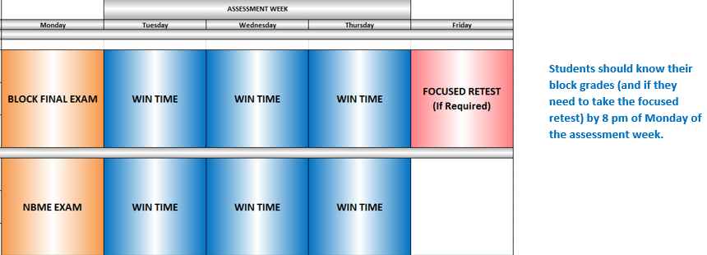

Assessments | When | Type | % Grades
Quizzes | Intra-block | MCQ, FITB, SAQ, Essay | 15-20
Anatomy Lab | Intra-block | Practical | 5-10
Assignments | Intra-block | MCQ, SAQ, Essay | 10-15
Engagement (in required sessions) | Intra-block | Participation | 5-10
Clinical | Intra-block | Competency | 5-15
Others (PBL, TBL, CBL, etc.) | Intra-block | Participation, iRAT, gRAT (tRAT) | 5-10
Block Final Exam | End-block | MCQ, FITB, SAQ | 30-40
NBME Exam | End-block | MCQ | 5

