Connecting to UMMS
The default SSI for UMass Medical School is UMMS. UMMS uses WPA2 Enterprise encryption which is the standard level for large organizations. Please refer to this sheet for connection instructions. These instructions can be used for both Macintosh and Windows wireless connections.
ADDING UMMS – Windows:
- Click on Network icon wireless bars in System Tray (see screenshot)
- Click on UMMS
- You may get a popup stating the more information is needed to connect to UMMS.
Click on that message and enter your UMMS credentials to gain access to UMMS. Accept any certificate that may pop up.
- Once complete, you will see UMMS change to bold and see the word Connected.
Removing UMW – Windows
- Click on UMW and then click Remove.

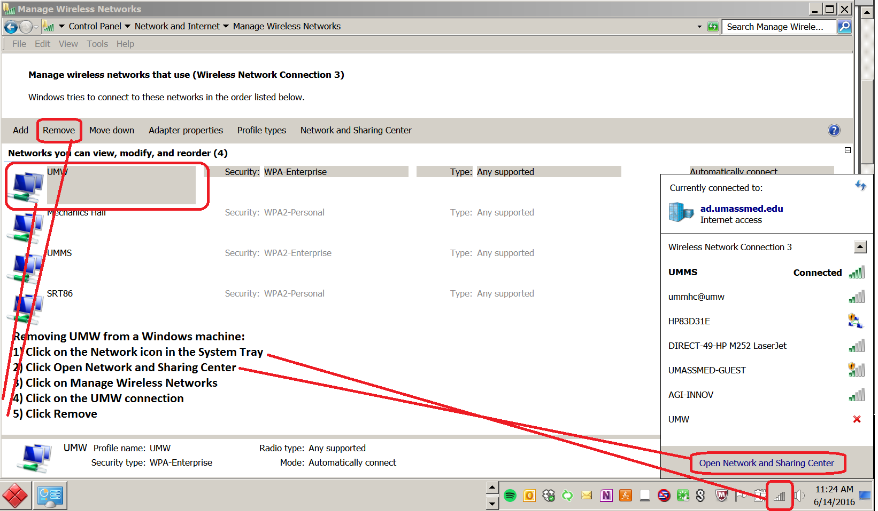
MACINTOSH:
