**Guide to Using the Annual Merit Increase Calculation Tool**

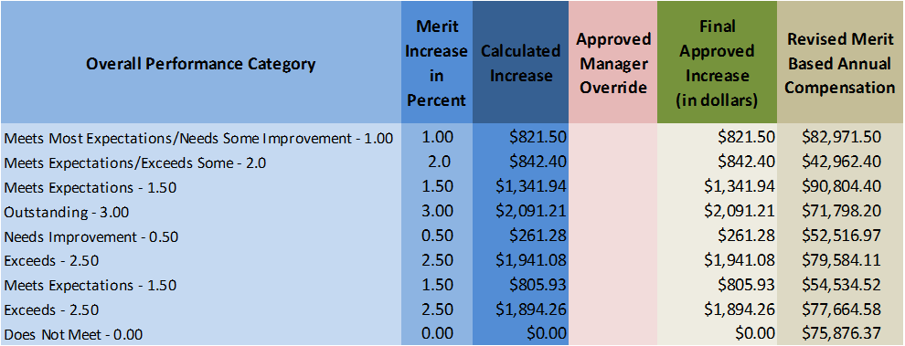

|  |
| --- |
|  |
|  |



**Introduction**

What is the Merit Increase Calculation Tool?

The Merit Increase Calculation Tool is a Microsoft® Excel-based calculator designed to assist managers and supervisors with apportioning the UMMS approved merit increase “pool” to their employees based primarily upon their respective performance ratings.

The tool includes features such as:

* Pre-populated with employee salary amounts that are eligible for the merit pool increases
* Automatically calculates a merit increase amount for each employee, based upon their performance category (rating/score), or enables a manager to award an “across-the-board” merit increase, except for those whose performance “Does Not Meet” expectations
* Permits an “override” increase amount to be inserted, within certain limits
* Provides a chart illustration of the merit increase distribution
* Calculates a “running total” of the total Incentive (merit) Pool, Total Increases applied, and Remaining dollars
* Pop-up instruction boxes for each cell to be entered or calculated
* Programmed “buttons” to Save, Print and Submit the Tool

**Using the Tool**

**Step 1:**

The Tool will be sent to you with the list of your employees and their Annual Compensation. Enter the performance score for each employee in the “Overall Performance Category” column.



Entries can be made using the pull-down menu:



These entries will automatically calculate a **Merit Increase in Percent** (%) a **Calculated Increase** (amount in dollars), a **Final Approved Increase (in dollars)** and a **Revised Merit Based Annual Compensation**:



Or, if preferred, you can *remove the check box* (see illustration below) to assign the same percentage increase to all employees, which will assign an increase equal to the merit pool amount (e.g., 2%) to all employees, with the exception of those whose performance score is “Does Not Meet” expectations.

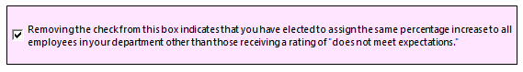

If you select the option to assign the same percentage increase to all employees, the tool will assign an **Average Increase** (e.g., 2%) to each employee as noted above, and calculate a **Revised Averaged Annual Compensation**:



**Step 2:**

Next, if you did not select the option to assign the same percentage increase to all employees, review the results of the calculated Merit Increase Percent and Calculated Increase, and if/where necessary, and insert “override” amounts to adjust for factors such as:

* Performance sustainability – has employee performed at same level for several years (go higher in the merit guideline range)
* Variation within performance level – low exceeds vs. high exceeds (go lower in the merit guideline range)
* Position in Salary Range – above midpoint vs. below midpoint (above midpoint, go lower in the merit guideline range)

*Please note that the tool includes limits on how much you can “override“ above and below the calculated amount.*

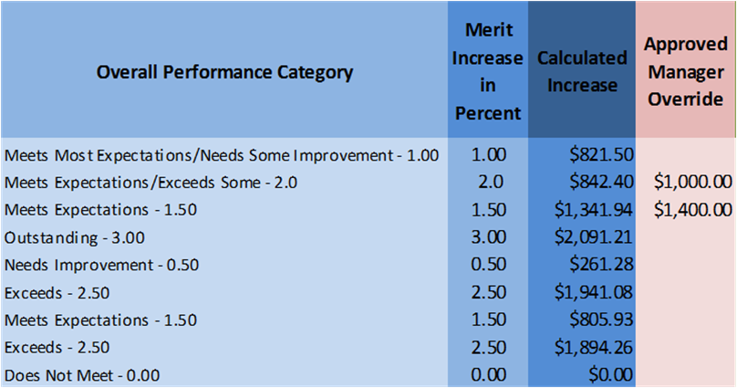

For those increases where overrides have been inserted, the tool will calculate a new/updated “**Final Approved Increase (in dollars)**” and a “**Revised Merit Based Annual Compensation**” amounts:



The tool will calculate the total **Incentive Pool** dollars available, and as you enter information for your employees, it will calculate the **Total Merit Based Increases** awarded and the **Remaining from Merit Based Increases** still available. It will also calculate the **Total Average Based Increases** and **Remaining from Average Based Increases** whether or not youselect the option to assign the same percentage increase to all employees:



The tool workbook also has a tab entitled “Annual Increase Summary” which provides an illustration (chart) of the above totals.

**Step 3:**

Review the distribution of performance ratings in the Merit Increase Distribution workbook tab, and assess whether the distribution is appropriate and make adjustments, if necessary.

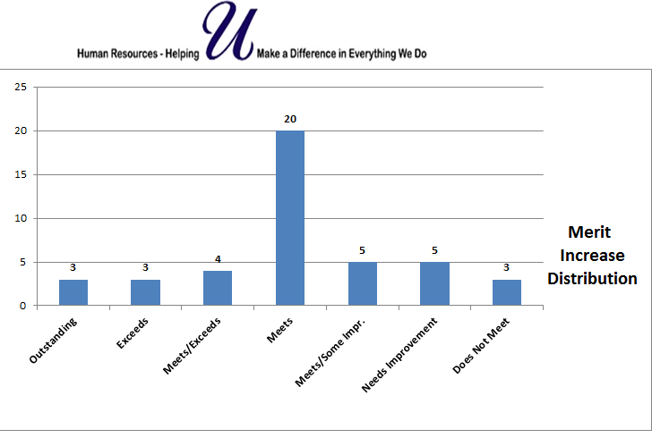

**Step 4:**

Type in your Department name and the Department Head should type their name as an electronic “signature”.

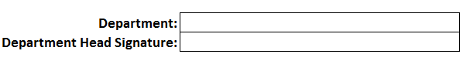

**Save, Print and Submit**

The Tool has buttons that enable you to save the document and return to it for completion or editing. It also includes a print button so that you can print a hard copy for your files, if desired.

Finally, the Tool has a “Submit Form” button, which will send the completed document to the Compensation group, for processing and filing.



**Resources**

**Compensation Website:**

* Merit Tool Worksheet (generic)
* Guide to Using the Performance Management Merit Tool

**Compensation Contacts:**

* **Compensation email box** – Compensation@umassmed.edu
* **Vacant –** Supporting Commonwealth Medicine and MassBiologics departments
* **John Roy –** Currently supporting Commonwealth Medicine and MassBiologics departments,ext. 6-3950
* **Denise Raskett -** Supporting Medical School departments, ext: 6-3143 or [denise.raskett@umassmed.edu](mailto:denise.raskett@umassmed.edu)