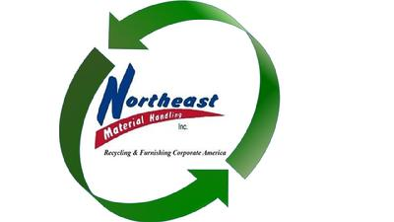
Acceptable Items:

- Phones
- Printers*
- Batteries *
- Computer Speakers (Household are $10.00 a set)
- Ballasts*
- Wire
- Cell Phones
- Lawn Mowers
- Medical Equipment
- White Goods
- PC’s
- Copiers
- Fax Machines
- Scanners
- Servers
- Switches
- Microwaves
- Light Fixtures*
- Electrical Equipment
- Laptops
- Modems
- Radios
- Towers
- Routers
- Switch Gear
- Refrigerators*
- Chargers
- AC Units
- All Appliances
- Fire Alarm Equipment
- Scrap Metals*
- Pipe
- Battery Operated Tools (The batteries are $.80/lb)
- Filing Cabinets*
- Printed Circuit Boards
- Metal Desks*
- Bicycles*
- Keyboards

***Keep in mind, the above items are a guideline – if you have something to recycle, that plugs in or is metal and you do not see it on this list, please call or email me. Chances are that we take it.***

-CHARGEABLE ITEMS – Some Metal/Appliances May Be Subject to a Pick Up Fee -
- TV’s are $30.00 apiece
- CRT Monitors: are $15.00 apiece with or without a computer / Flat Screen Monitors without a computer are $15.00 apiece
- Light Bulbs [Call for Pricing] ****Not Accepted on Recycle Days ****
- Batteries – Alkaline $.55/lb
- Wood $.25/lb
- Dumpsters – New and Pre-owned Furniture and Warehouse/Storage Equipment – Labor
- Car Seats $15.00 each
- Toners: $.25/lb
- Propane Tanks $10.00 Apiece
- Any Furniture is evaluated on an per a situation basis
- * May have a fee attached
- *** WE DO NOT ACCEPT TOY PLASTICS, AT ALL ***

(P): 978-772-4545 (F): 978-772-9599
Email: Francine@liquidatedstuff.com
REQUEST A RECYCLE PICK UP AT : WWW.LIQUIDATEDSTUFF.COM

