|  |  |  |  |  |  |  |  |  |
| --- | --- | --- | --- | --- | --- | --- | --- | --- |
| |  |  | | --- | --- | | |  | | --- | | http://files.constantcontact.com/a9da200c201/83895fd9-9f7c-4a0e-bd4f-6b4115dfdaa9.gif | | |  | |  | |  | |  | | |  | | --- | |  | | |

TO:                University of Massachusetts Medical School Faculty and Staff

FROM:          Marcy Culverwell, Associate Vice Chancellor, Administration & Finance

DATE:           March 26, 2020

SUBJECT:    Corporate Travel Card, Procard and out-of-pocket expense reimbursement transactions

_______________________________________________________________­­­­­______________________

In accordance with the UMMS policy, “Travel and Business Expense Reimbursement,” employees are reimbursed for necessary and reasonable travel expenses incurred for authorized UMMS travel.

Effective immediately, the following guidelines should be followed for processing corporate travel card, Procard and out-of-pocket expense reimbursement transactions:

* The employee/administrator should download an electronic version of the credit card statement, scan* relevant supporting documentation (i.e. receipts) and email to the approver for electronic approval. Approval can be evidenced by email or electronic signature via DocuSign.

*Pictures of receipts can be submitted in lieu of scanned documents

* If relevant supporting documentation is not accessible, please complete and attach the “Receipt Affidavit” form (see attached). For receipts listed on a Receipt Affidavit form, please maintain and file the originals in accordance with audit and document retention policies.
* Due to the current remote work environment and the limited capability to process paper expense reports, a new process will be implemented to submit expense reports to UPST. The employee/administrator should attach* the required documentation including the printable view of the expense report, relevant supporting documentation and evidence of approval into PeopleSoft Travel and Expense module (“expense module”). Acceptable forms of documentation and approval are noted above. Hard copies of expense reports should not be sent to UPST for processing. *Instructions on how to attach documentation into the expense module are attached.
* The documentation attached electronically into the expense module will serve as documentation required for audit purposes and for meeting document retention policies. Suggested best practice: maintain hard copies of the documentation until the expense has been paid.

Expense module questions can be directed to UPST by submitting a request through the [UPST website](https://upst.umassp.edu/s/), [Request Assistance form](https://umassforms.formstack.com/forms/upst_umass_employee_case_v2) , email to [upst@umassp.edu](mailto:upst@umassp.edu) or UPST Customer Service Team at 774-545-UPST (8778).

All other questions can be directed to UMMS Financial Services - Marcy Culverwell at 508-856-4337 or Jennifer Robinson at 505-856-1507.

Attachments in Expense Module

Scanned images of receipts, the printable view expense report or other documents can be attached to the Expense Report in the Expense module. The attachment feature works the same way as attaching a document to an email.

1. The Expense Report needs to be saved but not submitted in order for the attachment link to become available. An expense document that has already been submitted can also be sent back by an approver in order to attach receipts.
2. The **Attachments** hyperlink becomes available under the GSA Per Diem Rates hyperlink when the expense document is saved. Click on the **Attachment** hyperlink.

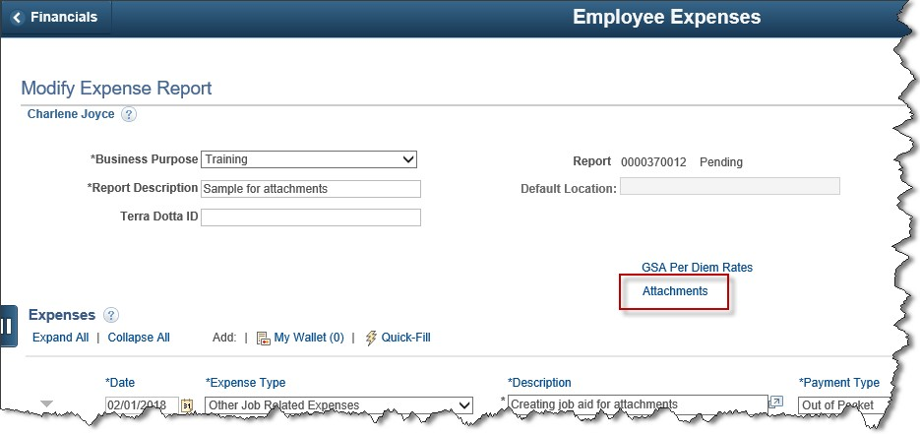

1. Click on the paperclip icon to attach a scanned document

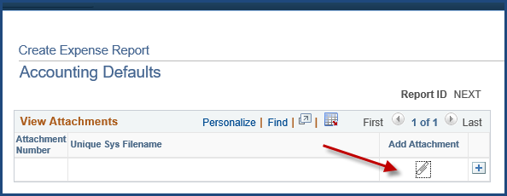

1. Click on the **Browse** button to locate the desired file.

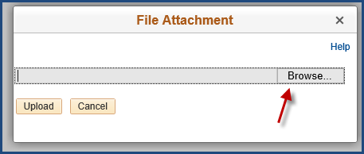

1. When you locate the document to attach, double-click on it.
2. Click the **Upload** button. **One PDF of all documents is the preferred method.**

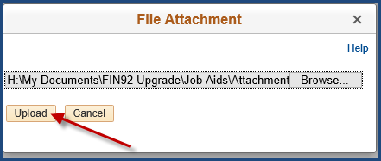

1. To include additional documents, click the The Add icon is the plus symbol. (plus) icon to add a new line.
2. Repeat steps 3 through 5 until all required documentation has been attached.

NOTE: You can only attach one document at a time. Using the control key while in the Browse search to select multiple items will only attach one of the items selected.

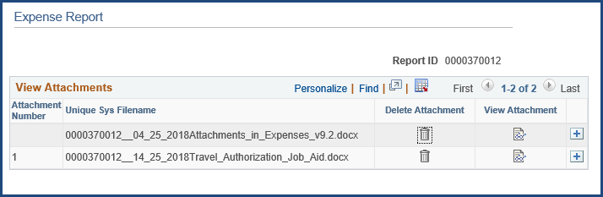

1. Trash canTo remove an attached document, click the icon on the desired line.
2. To view an attached document, click on the Page and eyeglasses icon.



RECEIPT AFFIDAVIT - Covidvirus Shutdown

I certify that each ticket stub or other receipt described below is currently filed

on-site at UMMS, however, due to the current Covidvirus shutdown the receipt is not accessible and cannot be included for review at this time. I certify that the actual receipt will be filed and maintained in accordance with UMMS record retention policy. It has not and will not be submitted in the future for reimbursement to the University of Massachusetts or any other organization.

**Detailed Description of Receipt(s) Amount**

|  |  |  |
| --- | --- | --- |
| Date |  | Traveler's Signature |
| Date |  | Approving Authority  Signature |