Entering a Direct Payment Form in BuyWays

From the Home/Shop page, click on the ‘Forms’ hyperlink

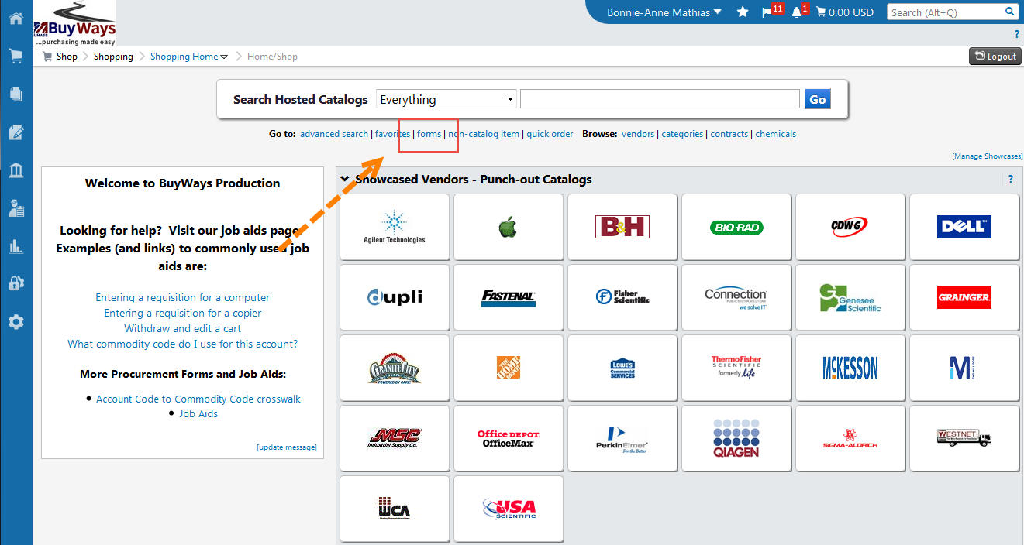

Click on ‘Medical School Direct Payment Form’

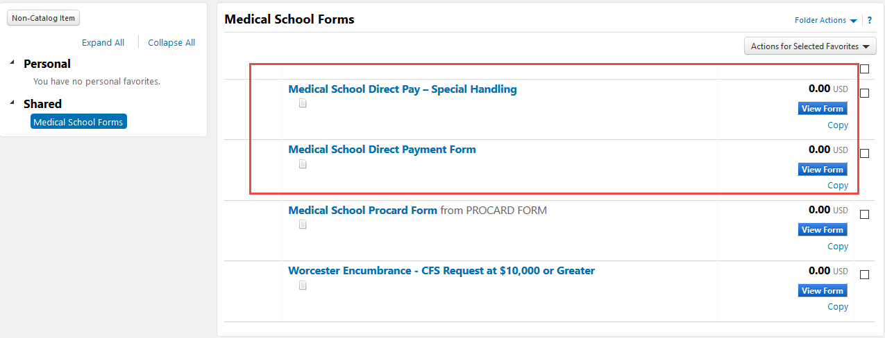

Choose the radio button for the Type of Purchase in the Purchase Category section

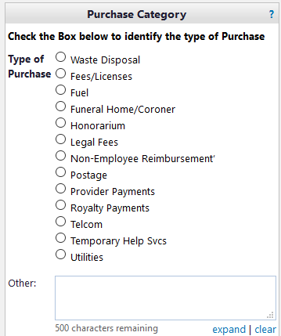

From the invoice, add the Invoice Date, Supplier Invoice Number and Vendor Name. Note – after typing the 1st 3 letters, BuyWays will begin displaying a list to choose from. The vendor address information will auto populate from the vendor name chosen.

* When an invoice number is available the number should be input on the DP Form as follows
All dashes, spaces, periods and symbols should be omitted (see example)
EG: Invoice number: (12345.6 8-6) should be processed as follows (12345686)

**Non-employee reimbursements invoice numbers are entered using the 1st date of travel followed by ‘-reimb’. Eg: 04/14/16-REIMB

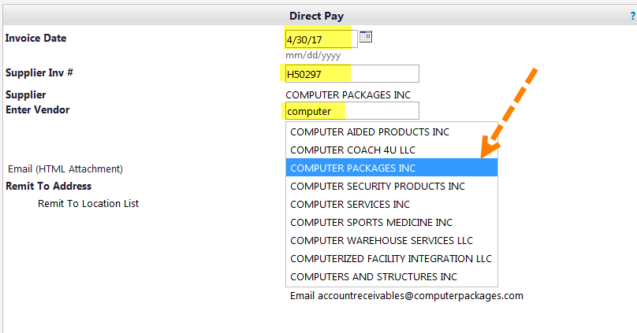

Add the Description, Qty (1) and Unit Price (invoice amount), and select the commodity code from the drop down list. Click on ‘Add Attachment’ to upload the invoice.

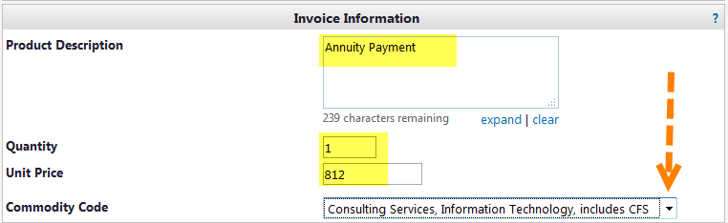

Scroll to the top of the page and choose ‘Add and go to Cart’, the click ‘Go’

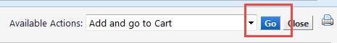

A BuyWays cart will be displayed with your invoice information. If the payment is against a contract, click on the ‘choose contract’ hyperlink and select the radio button to the left of the contract.

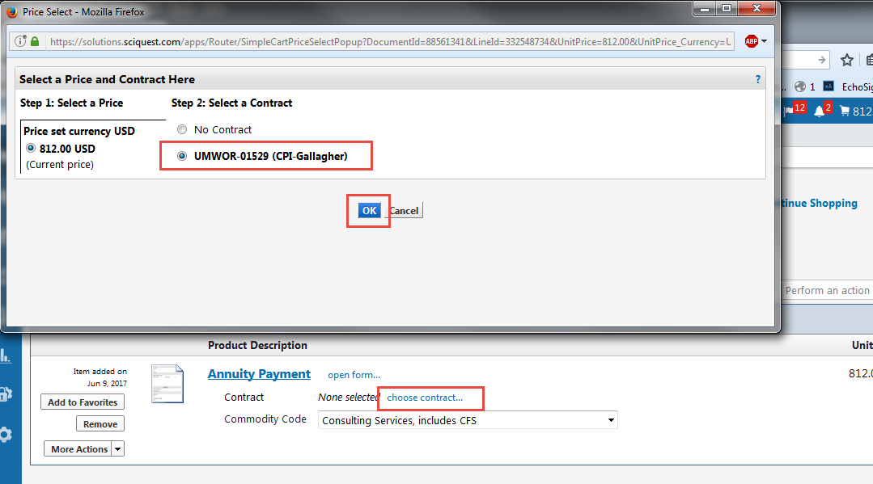

Proceed to check out

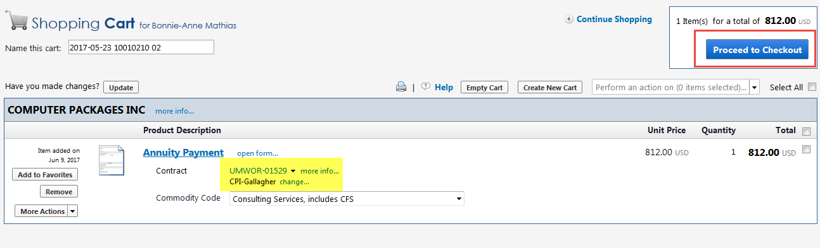

On the Accounting tab of the requisition, add your ST and Account Code.

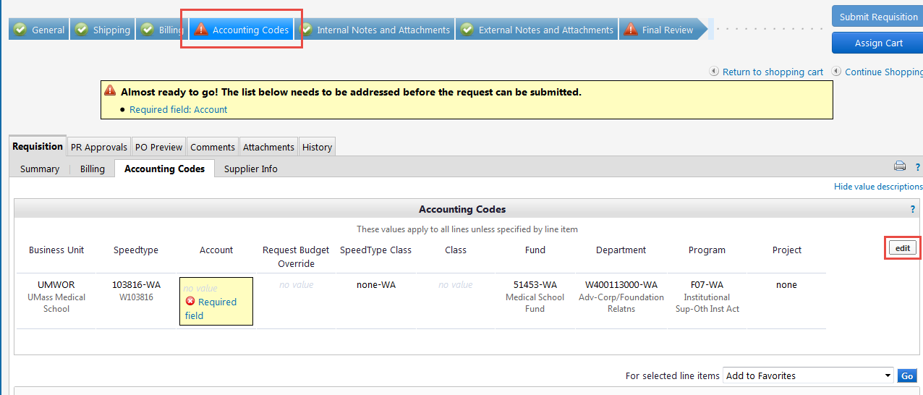
On the ‘Internal Notes and Attachments’ tab of the requisition, click on ‘Add Attachment’ and upload a copy of the invoice to be paid.

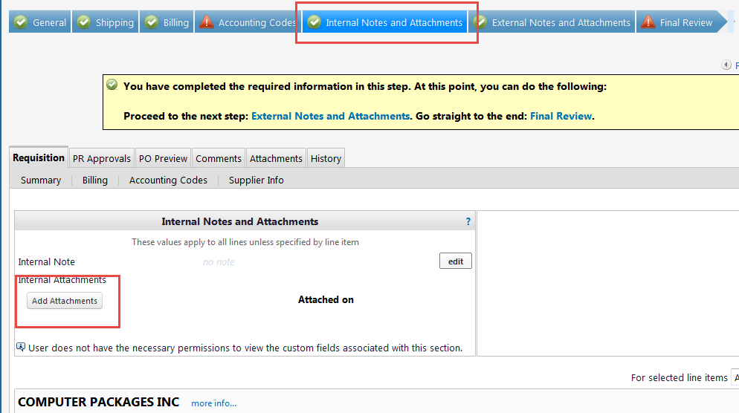

Click on ‘Select Files’ and browse for your file, or drag your file from your desktop to the box for upload

**For non-employee expense reimbursments, please attach the expense form in one file, and the supporting documents in a separate file.
*** Please do NOT upload any W-9 forms as they contain protected information

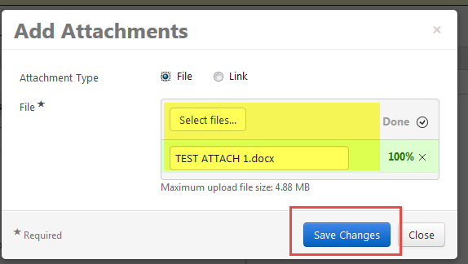

Go to the ‘Final Review’ tab and submit the requisition. Direct Pay requisitions will go to workflow for approval – the same way other requisitions are approved

Viewing your Voucher

Your Direct Pay requisition will route through approvals, then create both a Purchase Order and the Voucher. To view the voucher, go to the Purchase Order and click on the Invoices tab. You can view the Supplier Invoice number you entered and see the payment status. Click on the Voucher Number hyperlink to go to the voucher page.

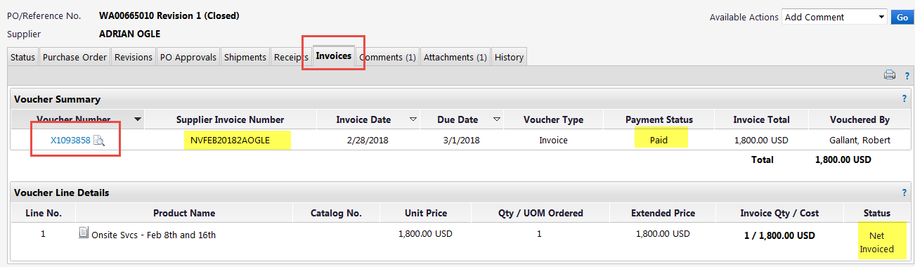

From the voucher, you can view the payment information and open a copy of the invoice:

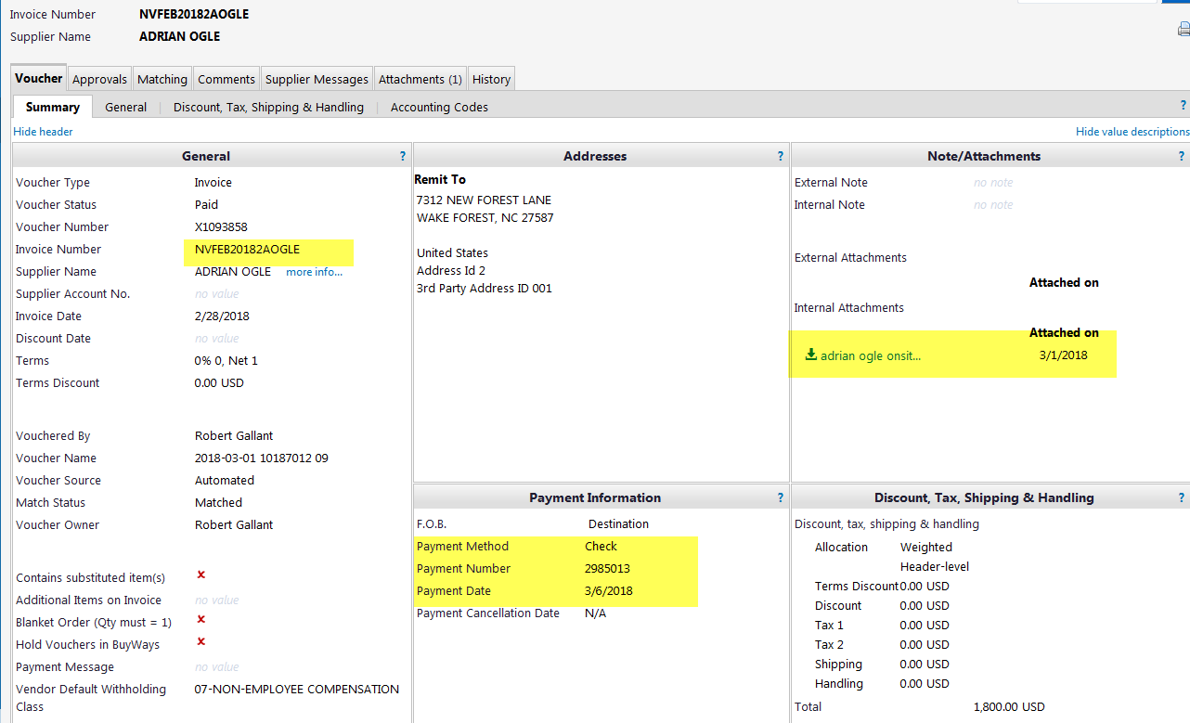

If you only have an invoice number, you can search for it by using the Search function in the upper right corner

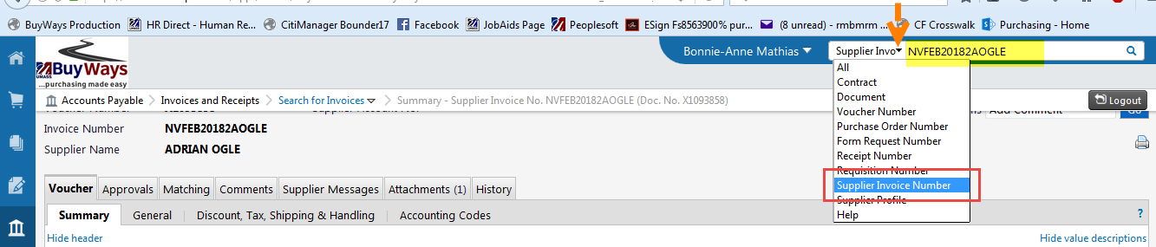

New:

Special Handling form

