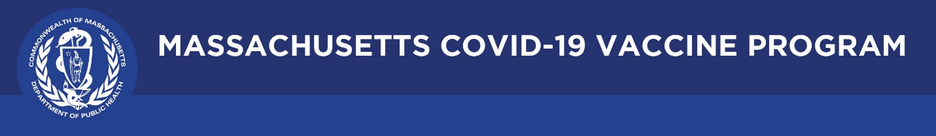

COVID-19 Vaccine Education and Outreach Materials: Children and Families
January 2022

COVID-19 vaccinations for children ages 5-11 and youth ages 12-17
Learn about consent, safety and effectiveness, eligibility, where and how to get the vaccine.

Trust the Fax, Get the Vax campaign materials
TV ads, animated videos, and other materials for the Commonwealth's multilingual public awareness campaign to promote the safety and efficacy of the COVID-19 vaccine. Materials can be printed or posted to websites or social media. Materials include (but are not limited to):
- Video & Factsheet: Pregnancy and the COVID-19 vaccine
- Video: COVID-19 Vaccine and Kids - Hear from the Experts
- Factsheet: COVID-19 Vaccine Facts for Parents

Guide to hosting a forum on the COVID-19 Vaccine: children and teens edition
A downloadable PowerPoint for providers, community groups, and others to host meetings about the COVID-19 vaccine, with a focus on children and teens. The guide includes answers and talking points on commonly asked questions.

COVID-19 vaccine FAQ
Responses to the most common questions about the COVID-19 vaccine, getting vaccinated, and vaccine safety. Example questions include:
- Can someone who is pregnant or breastfeeding get a COVID-19 vaccine?
- Will getting the vaccine impact a person’s immigration status?
- Should someone with a history of allergies get the COVID-19 vaccine?

COVID-19 vaccine FAQ: Children & Youth with Special Health Needs
Frequently asked questions about the COVID-19 vaccine with a focus on children and youth with complex medical needs.

COVID-19 boosters
Common questions related to COVID-19 vaccine booster doses, including a downloadable FAQ.

COVID-19 Vaccine Communications for Children and Families: Information for Partners and Providers
Recommendations and resources for providers and partners to help promote COVID-19 vaccination among pregnant and breastfeeding people, parents, children, and youth, including children and youth with special health needs.

Multilingual COVID-19 Materials
Available COVID-19 resources organized by language. In addition to vaccination, includes topics such as: testing, tips for at-home quarantine, and how to safely cover your face when you're away from home.

