Information for Power Prompting 101 by Dr. LeMoine
Feb 2026
Before the workshop:
If possible, familiarize yourself with one way, your favorite way to login to the UMass Chan Intranet to the UMass Chan approved Generative Artificial Intelligence (GenAI) tools for prompting. We will use both Copilot and Chan Chat during the class just to show both. However, feel free to use your favorite or both!
You MUST login to UMass Chan prior to using Chan Chat (https://aichat.umassmed.edu/ )
You will need to log into your browser or UMass Chan prior to using Copilot – See Image below for Copilot
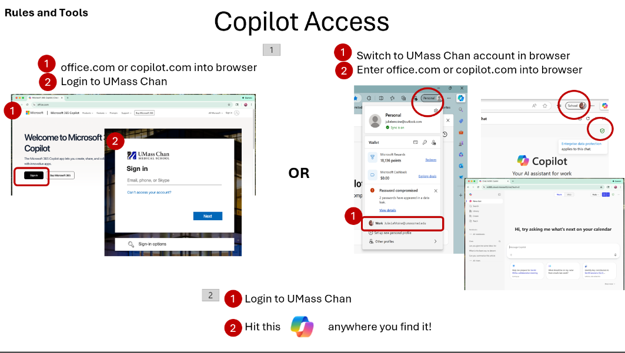

During the workshop: If possible, bring your laptop to the workshop and prompt along with Dr. LeMoine!
The best way to learn to prompt is to do it, hands-on. This workshop moves quickly through more than 14 prompts. The following prompts are provided, in the intended order of use, so that you can cut and paste them quickly into Copilot or Chan Chat. This will allow you to prompt along, not just follow along, on your laptop during the workshop. Let’s do this!
Note: We may not cover all prompts in class
# | Prompt
1 | Please create a 4-verse poem, in verses, in the style of Dr. Seuss, about stitching up an arm in the ER during Halloween. The ER head nurse gets no sleep and the resident in the ER may be a zombie.
2 | Summarize this page
3 | I am a professor at UMass Chan, summarize this page and prioritize what I should focus on
4 | Please take this email and improve it. Act as a collegial academic collaborator. Make the tone more supportive and collaborative. Here is my current email
5 | Let’s refine this further. The email is going to a peer faculty collaborator at another institution.  The goal is to reset clarity on deliverables without implying fault. I want to keep it under 250 words.  Include a simple table listing deliverables with columns for: Deliverable, My Current Understanding of Status, Partner Confirmation/Update.  Do not sound supervisory. Do not imply blame. Do not over-apologize. Avoid urgent or commanding language.
6 | Create a slogan for team building in a neurodiverse research lab using 3D tech
7 | What were the top 5 researched areas in the field of ADHD in 2022?
8 | Act like a research assistant and create a table that includes the top 5 research areas related to ADHD in 2022. Summarize each of these topic areas in the table and for each, provide at least 1 of each reference article or paper I should read to get caught up on the topic area. Don’t include white papers, include only journal or juried papers.
9 | Please make the last output into a table in a printable excel spreadsheet.
10 | Create an analogy using Ancient Rome about how hard it is to create an NIH or NSF grant proposal. Make the it educational and something a 6th grader could understand.
11 | I am an educator and am preparing to teach a class on how hard it is to create NIH and NSF grant proposals.  Create a very brief analogy using Ancient Rome concepts to illustrate how hard it is to create these types of proposals.  Be sure to tie each part of this analogy to the process of grant proposal writing.  My learners vary so do not use language over 9th grade reading level and inject humor.  I’d like this analogy in English and then in Spanish.  Then create on printable, lesson plan in English outline format to help me run this 1.5 hour class.
12 | Please create a short C# code set to turn on and off an object within a Unity scene
13 | Please create a flow diagram of the cell cycle, including prophase through telophase
14 | Create an image of Worcester Center with a beach and a peaceful scene with birds and summer flowers and trees.
15 | Please create an ultra high-definition, futuristic city in the clouds created of chrome and gleaming metal. It should also have trees and fauna everywhere
16 | Create an image of a teenager getting a flu shot. The teen should have a very sad face

