Shopper – Entering a Blanket Order Requisition

- From the Shopping Cart icon, select My Carts and Orders, View Draft Shopping carts

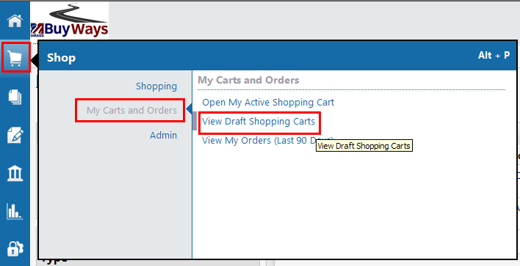

- Click Create Cart

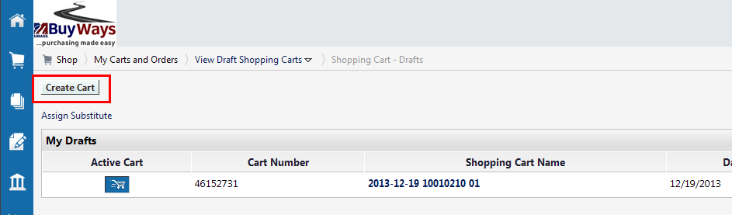
- From an empty or new cart, It is recommended that you name your cart to assist with finding the correct cart in later searches, then click Update. Next, click on ‘Add Non Catalog Item’

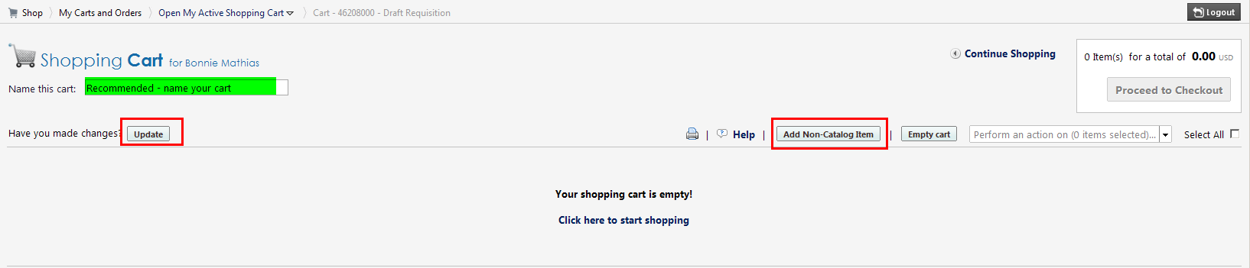

- A Non-Catalog Item pop up box will appear.
- Enter the vendor name. After typing the first 3 letters of the name, BuyWays will start showing vendors who’s name starts with those letters for you to choose from.
- Provide a description of the purchase. Please use meaningful descriptions of the item like “Radioactive materials”
- The Quantity for a blanket order will be 1
- Provide the total spend amount needed for the order
Click ‘Save and Close’
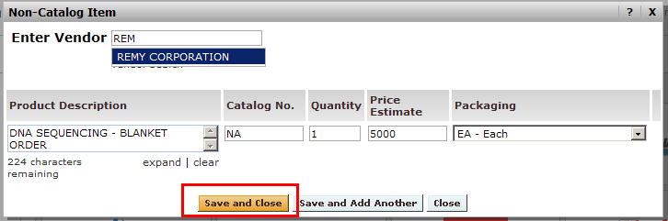

- Your cart is now open showing the item you added. For vendors who the University has existing contracts available, the ‘choose contract’ will be visible on the page. If the link is available, Click the ‘choose contract’ link. If no contract is available skip to step 11.
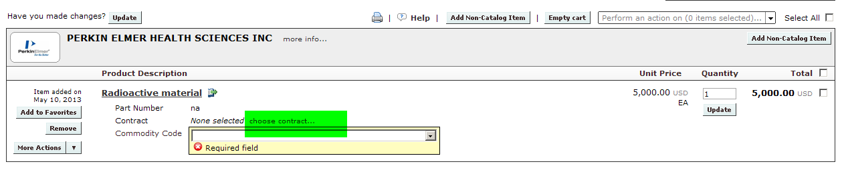

Optional for shoppers is the selection of the ‘Commodity Code’. If you will not be responsible for adding this information, please skip to step 10

- To add the Commodity code, click on the drop down arrow to the right of the list field. The commodity list will pop open allowing you to choose the correct commodity code.
Hint: Typing the first letter of the commodity name will bring you to that section of the list
Next click on ‘Proceed to Checkout’
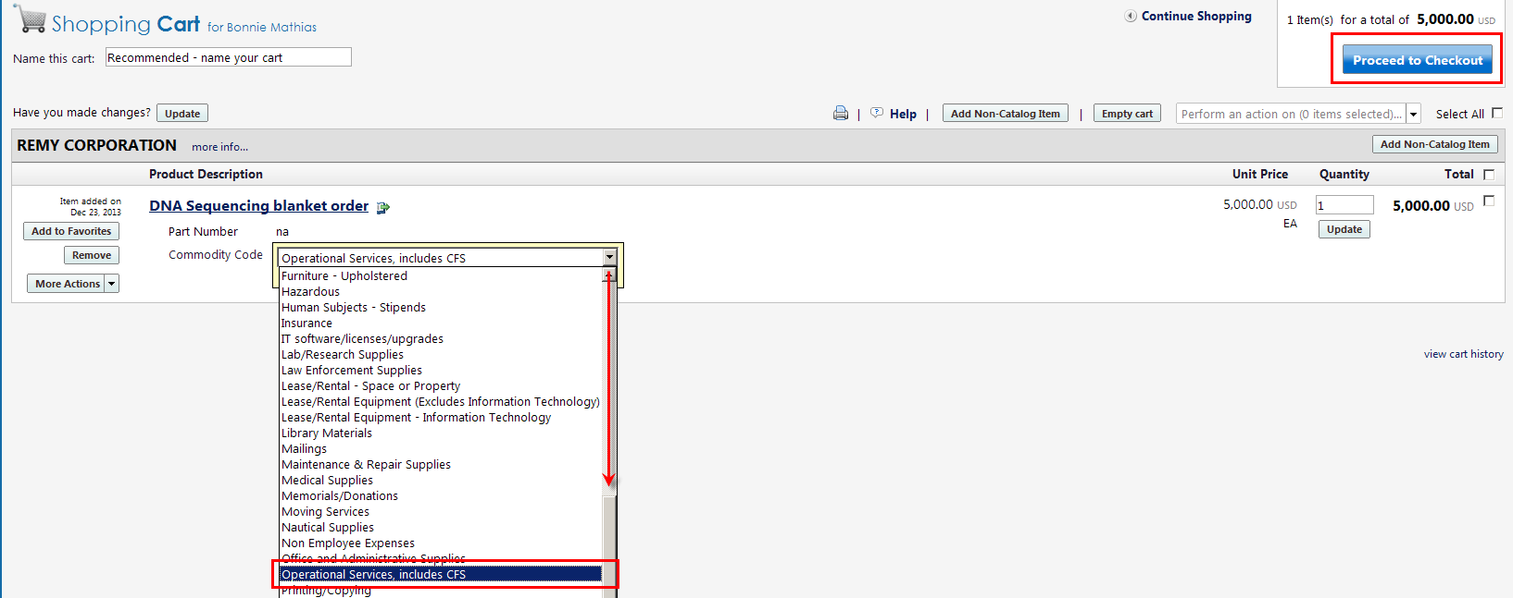

- Verify your ship to information for the requisition. If changes are needed to the information, click ‘Edit’ on the shipping tab. You can update the ship to building by clicking ‘To choose a different address, click here’. Be sure the Attn: name is the correct individual, and that the Rm/Fl/Ste is correct so that your items can be delivered to you
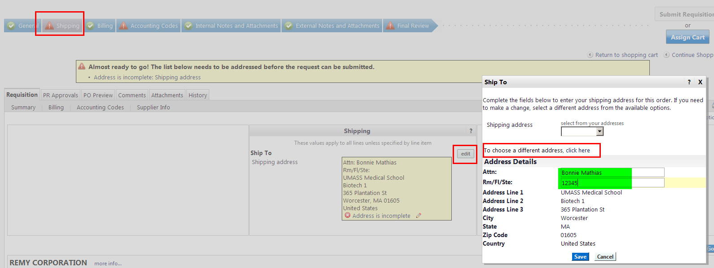
As a SHOPPER, as an OPTION add the speed type and account code for your order. While these fields indicate they are required, your department may elect to have the REQUISITIONER complete this information on your behalf. If you will not be adding chartfield information, please skip to step 10

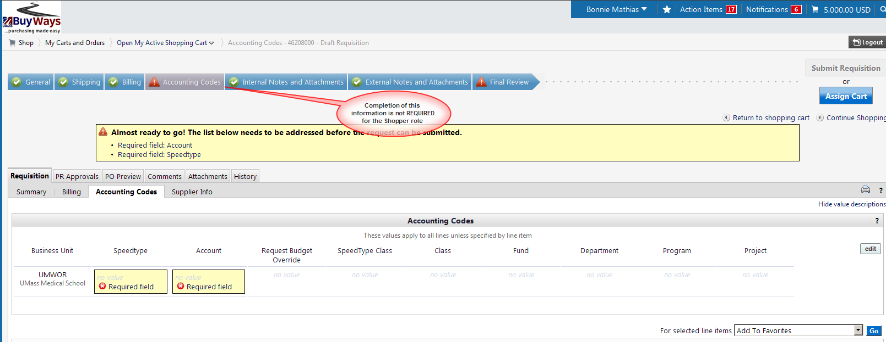

- To add SpeedType and Account Code information, click on ‘edit’

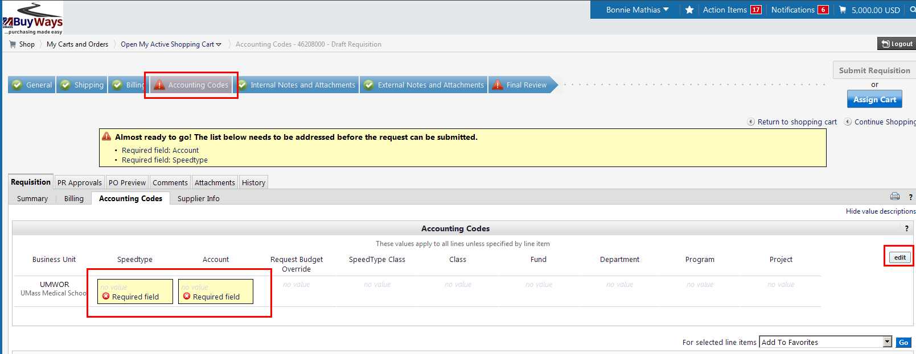
- Add the SpeedType and Account code followed by ‘-WA’ into the appropriate fields. The click ‘Save’. Do not type any additional information to other fields – the Speedtype & Account are the only fields you should touch. DO NO enter any value in the Class Field.
Note: the ‘WA’ is case sensitive, you must use upper case letters.
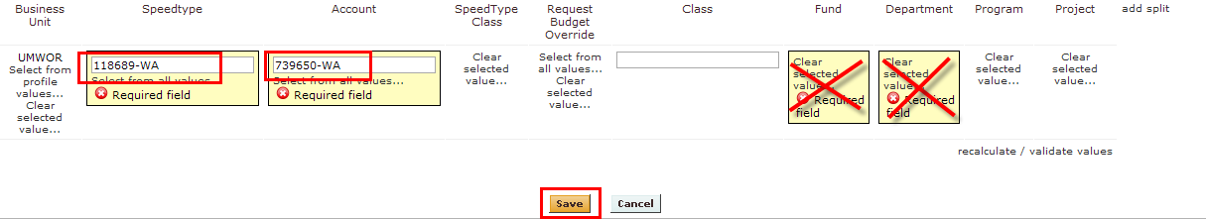

- Blanket orders require special settings on the requisition and PO:
  - Blanket orders are not sent to the vendor – you must update the ‘Confirming/not sent to vendor checkbox
  - Blanket orders are liquidated by amount, not Quantity – you must check the ‘Blanket Order’ checkbox
To update the settings for the order, click on ‘Edit’ in the General Section of the Summary page

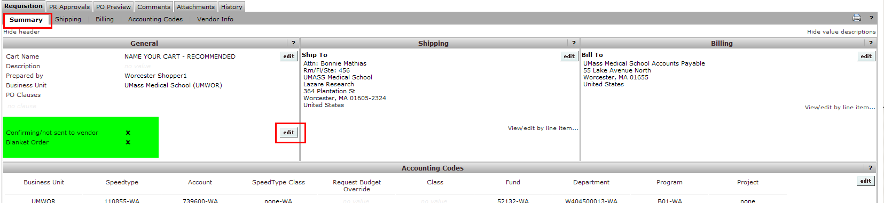

- To update the settings for the order, click on ‘Edit’ in the General Section of the Summary page, then ‘Save’

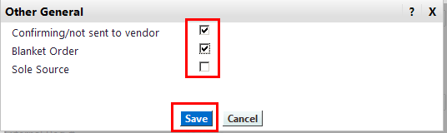

- Your requisition will now show green check marks indicating the order is a Blanket Order and the order will not be sent to the vendor

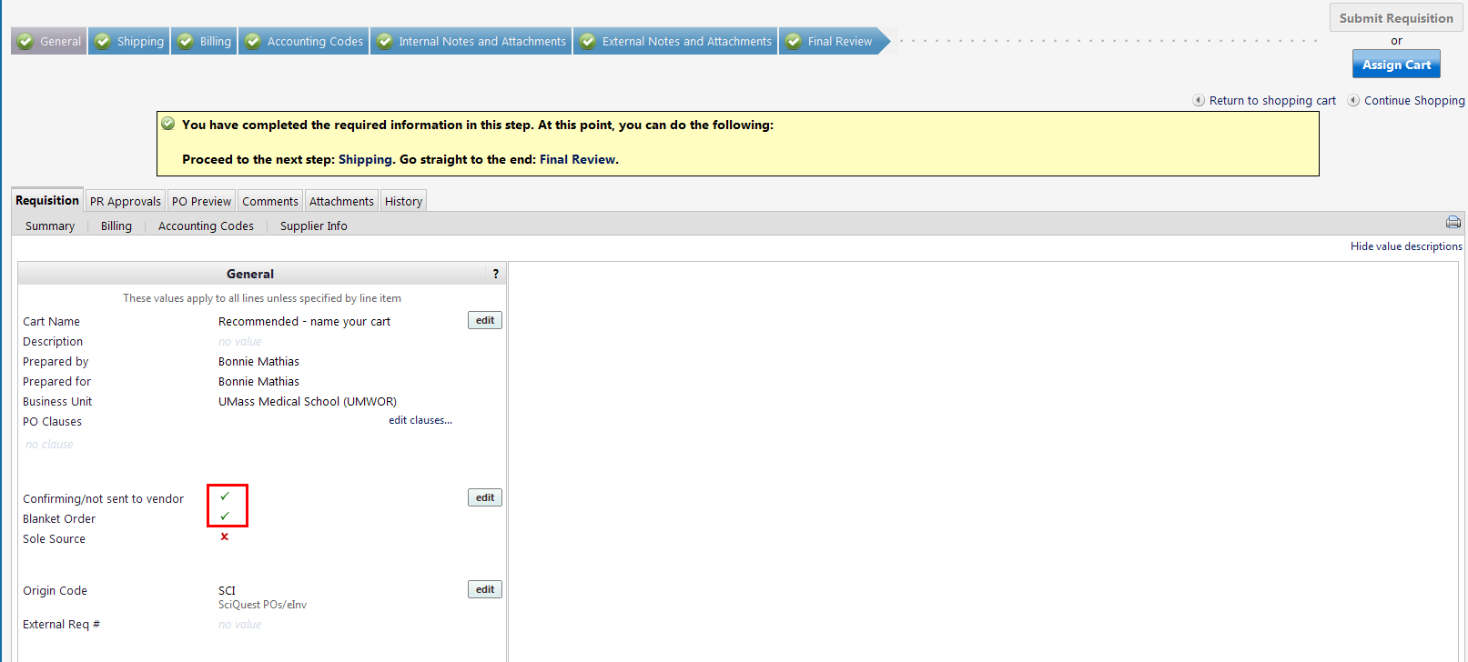

- You are now ready to ‘Assign’ your cart to your requisitioner or ‘Submit’ your cart. Click on the ‘Final Review’ Tab. To submit your cart (requisitioners), click the Submit button
For Shoppers, you must Assign your cart to a requisitioner. If you have added your Requisitioner to your profile, you can select them by clicking ‘Select from Profile Values’, or you can search from all available Requisitioners by clicking ‘Search for an Assignee’. From the search return, click on [Select] to the right of the Assignee name. You can also add a note to the requisitioner with any additional information they may need to process your order.

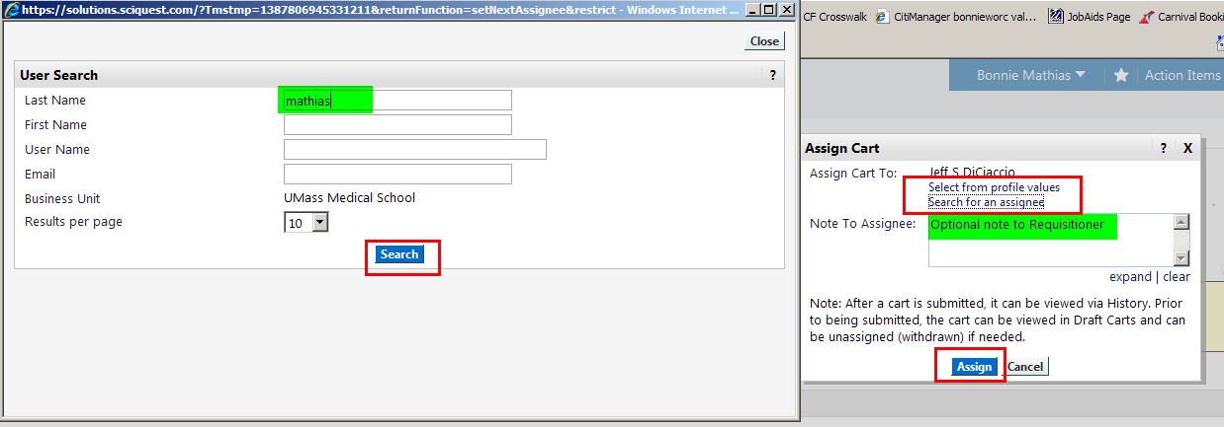
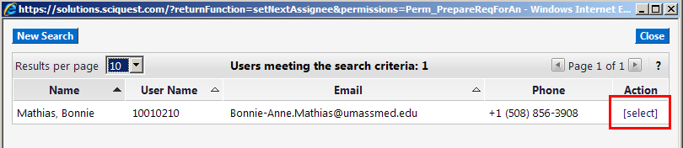

- Your cart has been sent to the Requisitioner. A summary page will appear, showing your comments to the requisitioner, your cart Name & Number, total amount and number of items.


