Phoenix Interface - Navigation

In the “Phoenix” user interface view in BuyWays, the navigation tabs have been replaced by icons and dropdowns. You can access system functions or find requisitions, purchase orders or other documents in one of two places – the menu at the top right of the page or the icons on the left border of the page. Both places can be accessed from any BuyWays page.

This is a view of the Home/Shop page , which gives you access to the BuyWays Catalogs.

Place #1
Place #2 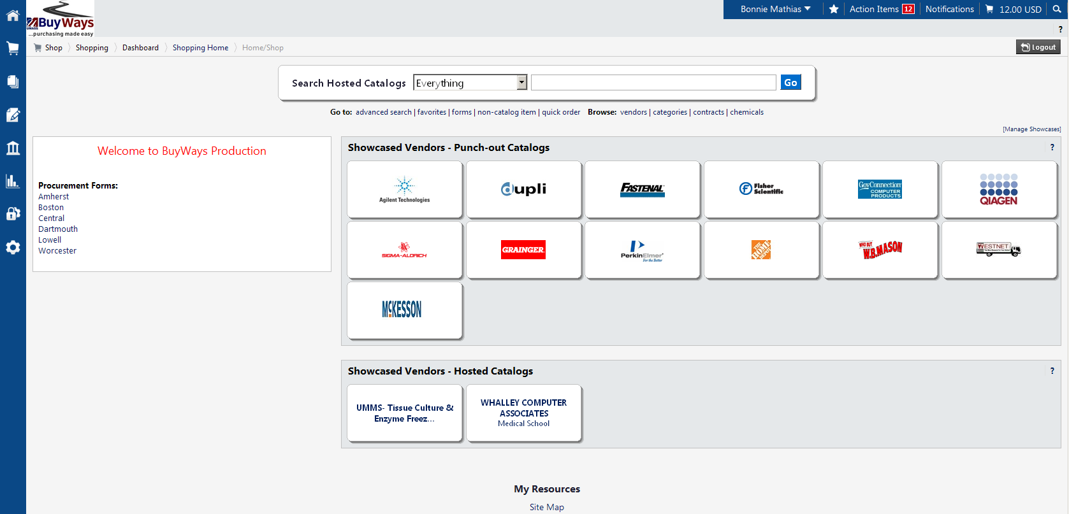

This is a view of a subset of the Home/Shop page where you can browse vendors and look up contracts.
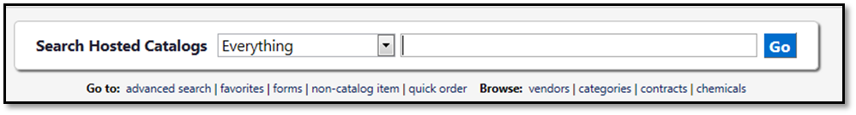

See page 2 for a Table of Contents, to help you locate the desired BuyWays page.

Access to | Place # | Icon/Menu Item | Click on Page #
Approval , Requisitions Needing my Approval | 1-Top right of page |  | 4
Bookmarks [Favorites], Add/Access | 1-Top right of page |  | 4
Worcester Encumbrance – CFS Request form, Access to | 2-Left border of page |  | 6
Document Search, Access to | 2-Left border of page |  | 6
Email Notifications, Access to | 1-Top right of page |  | 5
Home/Shop Page, Return to [for access to Catalogs, Browse Vendors, Look up Contracts] | 2-Left border of page |  | 5
Log out of BuyWays | 1-Top right of page |   [Your Name] | 3
Menu Search, Search for desired pages | 2-Left border of page, at bottom |  | 7
Profile, Update  Includes Access to Default User Settings, such as Ship To’s and Speedtypes | 1-Top right of page | [Your Name] | 3, 3
Purchase Orders, My Pending | 1-Top right of page | [Your Name] | 4
Purchase Orders, My Recently Completed | 1-Top right of page | [Your Name] | 4
Requisitions, Locate My Pending | 1-Top right of page | [Your Name] | 4
Requisitions, My Recently Completed | 1-Top right of page | [Your Name] | 4
Search, Quick, Locate by Document ID | 1-Top right of page |  | 5
Shopping Cart, Create New | 2-Left border of page |  | 6
Shopping Cart, Display My Active | 1-Top right of page |  | 5
Shopping Cart, Locate Carts assigned to me | 1-Top right of page |  | 4
Shopping Carts, View My Drafts | 2-Left border of page |  | 6

All of the following items begin at place #1, the Menu, at the top right of the page:

Update profile  [Begin at 1, top right of page]  Click on both:  Your Name  View My Profile | 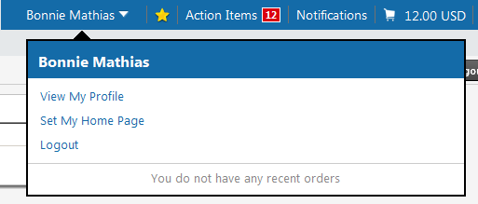
Access to Default User Settings to Change/Edit Speedtypes, Ship to Addresses, Cart Assignments:  [Begin at 1, top right of page]  Click on both: Your Name, View My Profile  Under User Information & Settings  Click on Show All…  Under Default User Settings  Click on the desired task | 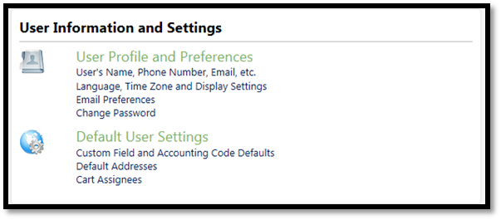
Log out of BuyWays  [Begin at 1, top right of page]  Click on both:  Your Name  Logout | 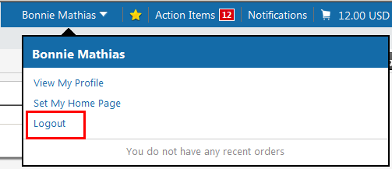

Return to Table of Contents

Locate pending requisitions, recently completed requisitions and purchase orders  [Begin at 1, top right of page]  Click on both:  Your Name  My Pending Requisitions  My Recently Completed Requisitions  MY Pending Purchase Orders  My Recently Completed Purchase Orders | 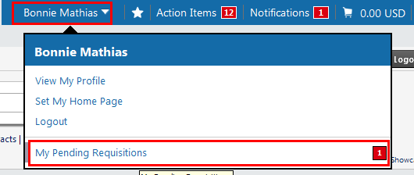
Bookmarks [Favorites]  [Begin at 1, top right of page]  To get Access to, or Bookmark, your frequently used pages  (To bookmark, open desired page and Click on the star icon - then Click on  Bookmark this page) | 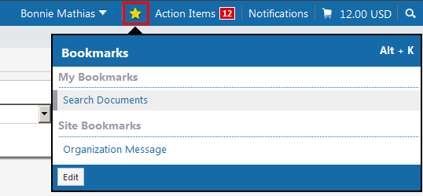
Locate requisitions you need to approve [Begin at 1, top right of page]  Click on Action Items  My Assigned Approvals  Click on Requisitions to Approve  Unassigned Approvals  Click on Unassigned Requisitions Needing Approval | 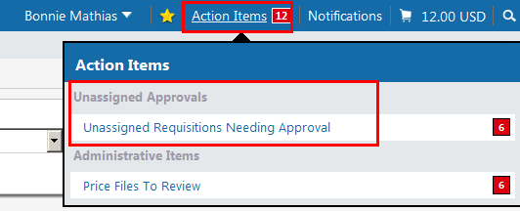

Return to Table of Contents

Access Email Notifications  [Begin at 1, top right of page]  Click on Notifications and then Click on the desired email notification | 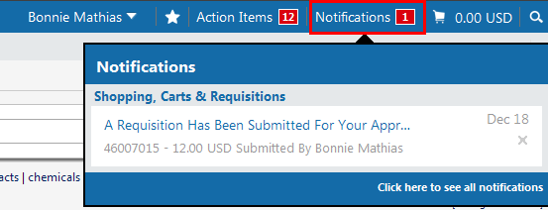
Display the active shopping cart  [Begin at 1, top right of page]  Click on the Shopping Cart Icon  and View My Cart | 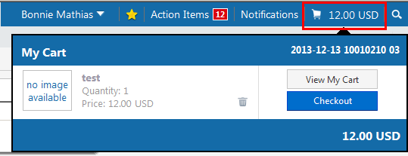
Quick Search  Search for your documents when you know the Document Number  [Begin at 1, top right of page]  Click on the magnifying glass icon. Insert the Document Number. Click on the Magnifying Glass icon at the end of the line. | 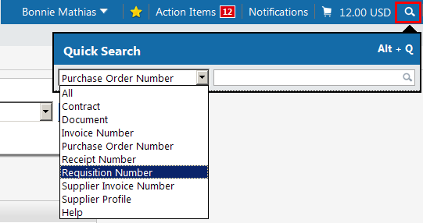
Return to Table of Contents

Return to the Home/Shop page [Begin at 2, left border of page]
(Also click here to see page 1 of this document for information on how to browse vendors and look up contracts.)

Click on:
Home icon
Access the Worcester Encumbrance - CFS Request form:  Begin at 2, left border of page]  Hover over:  Shopping Cart Icon  Shopping  Then Click on:  View Forms | 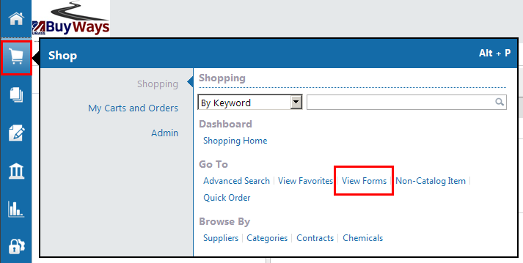
Create a new shopping cart or View Draft Shopping Carts  [Begin at 2, left border of page]  Hover over:  Shopping Cart Icon  My Carts and Orders  Then click on:  View Draft Shopping Carts | 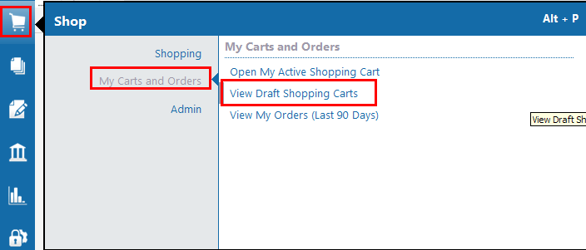
Search for requisitions, purchase orders, vouchers or receipts [Document Search]  [Begin at 2, left border of page]  Hover over:  Orders & Documents Icon  Document Search  Then Click on Search Documents | 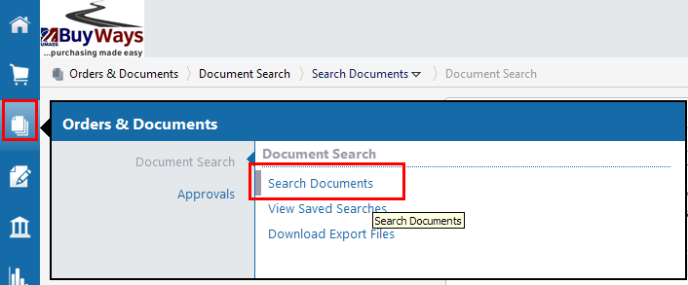
Return to Table of Contents

Search the Menu for desired pages based on one or more words:  [Begin at 2, left border of page at the bottom]  Hover over:  Menu Search Icon  In box, Insert word(s) to search on.  All pages in menu that contain the word(s) appear | 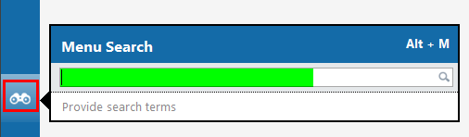

Return to Table of Contents

