Act on a Assigned Cart - Phoenix

- From the Action Items drop down, Carts Assigned to me can be found

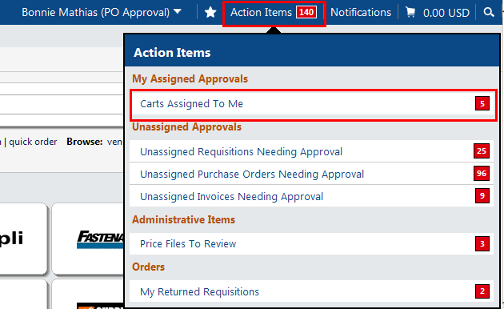

- From the Drafts Assigned to Me, select the cart you need to act on by clicking on the Shopping Cart Name link.
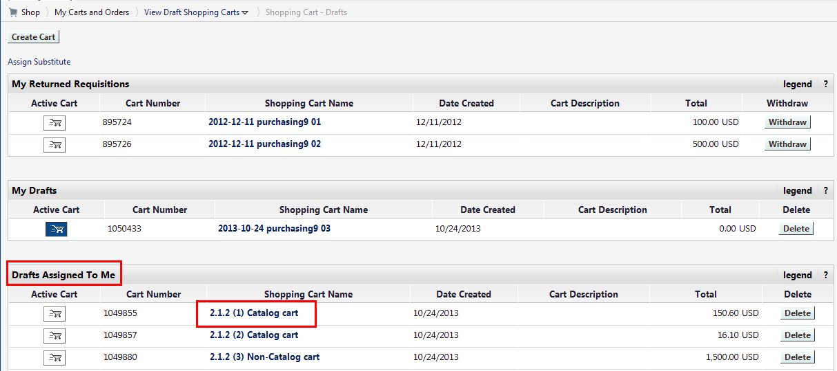

- Review the Commodity Code, using the drop down box to select the commodity or correct it if the Shopper has selected the wrong item. Then click ‘Proceed to Checkout’

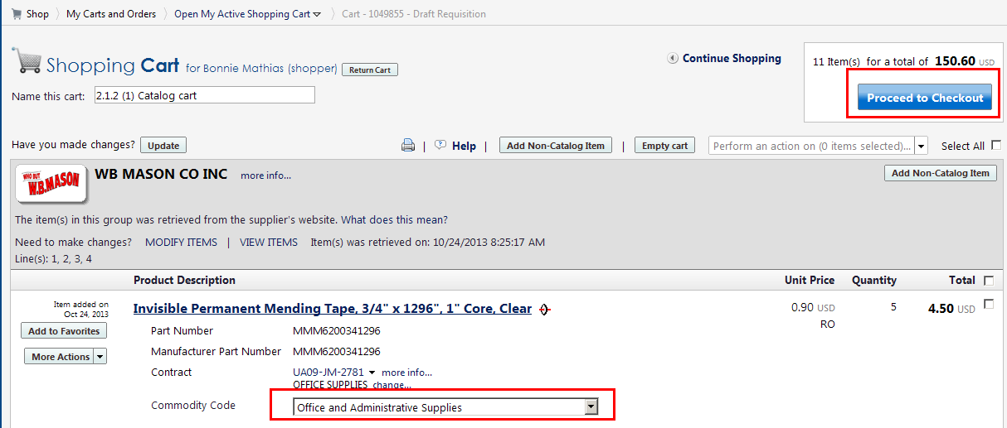

- The Cart flow will appear, with any missing information indicated by red caution triangles on the tabs. First, verify the Ship to information. To update the Ship to, click the ‘Edit’ button

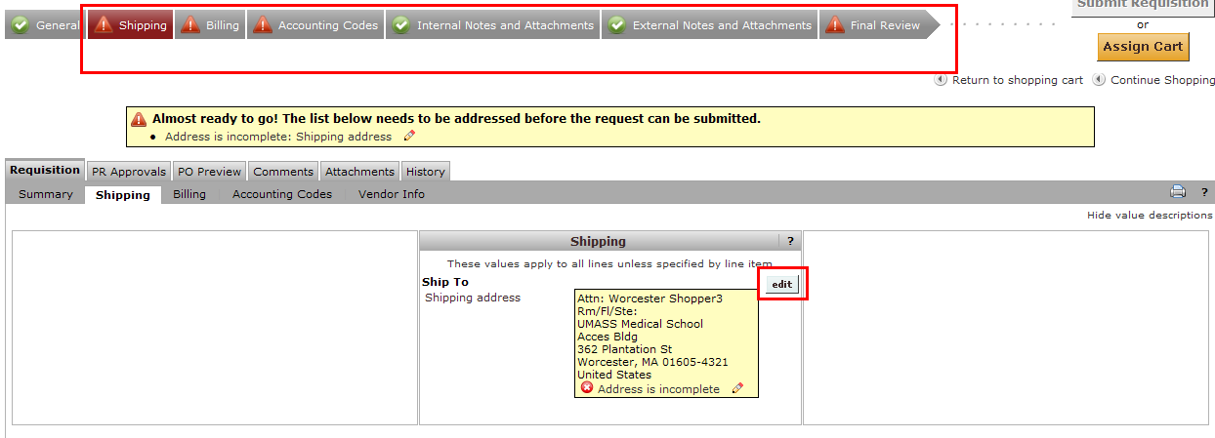

- Add or update the ‘Attn:’ field to reflect who should receive the order. Also add/update the ‘Rm/Fl/Ste’ field to the delivery location needed.
To select a different address, click the ‘click here’ link and search for other UMMS addresses.
Click ‘Save’ when the ship to address is correct

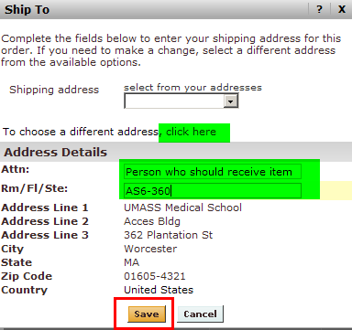

- The ‘Billing Address’ is required information. As UMMS has a single billing address, this should be set up in your Profile. For training, click on the ‘Edit’ to update the information.

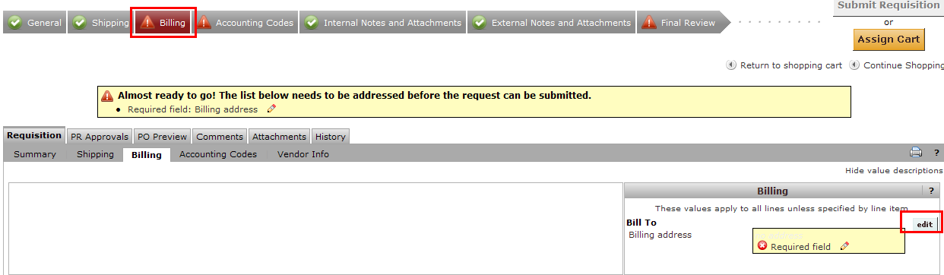

- Click ‘Save’

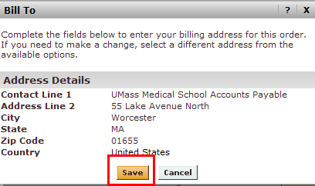

- Move to the ‘Accounting’ tab. This is required information. In this example, the Shopper has provided the SpeedType and Account Code, but it needs correction. Click ‘Edit’

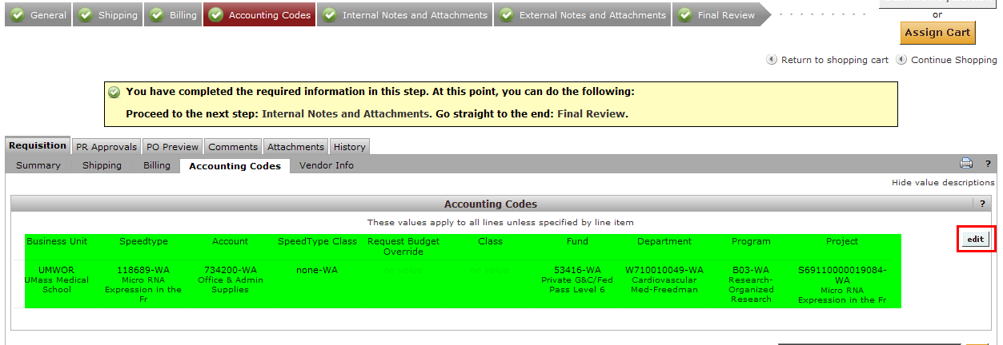

- For this transaction, we need to update the SpeedType as this item would not be allowed on the grant. Type in the correct SpeedType, or you search from all values by clicking on the link below the field. Once your update has been entered, click ‘Save’

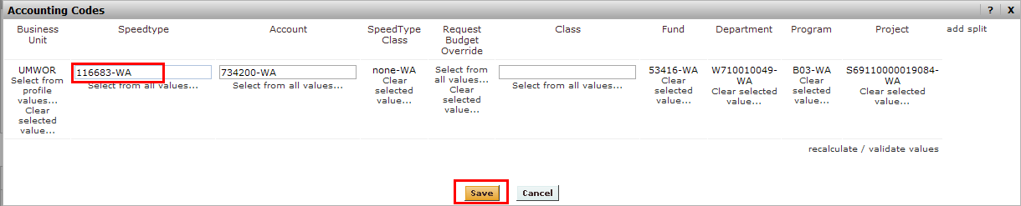

- Review your updated accounting information. If all is correct, click on the ‘Final Review’ tab to complete the cart.
Note: When all required fields have been populated, a Green Circle with a check will appear on the tab. You will not be able to submit your requisition until all red caution items have been resolved.

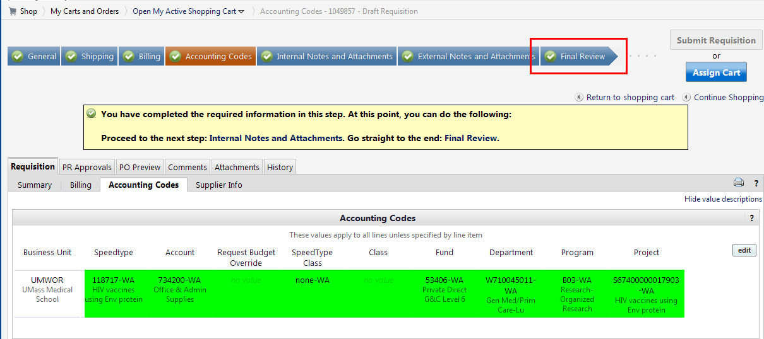
- The Final Review page should be used to verify that all cart information is correct. After reviewing, click ‘Submit Requisition’

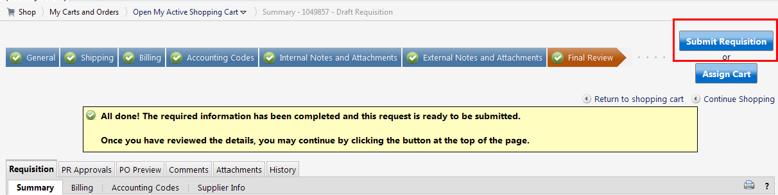

- Your cart has now created and submitted a Requistion. To see who will need to approve this requisition, click on the ‘Approvals Tab’ link

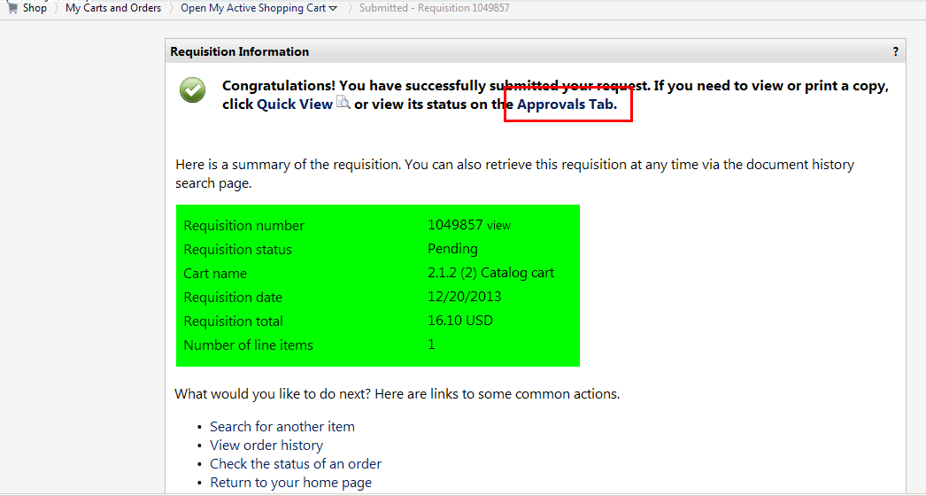

- This order required only Requisitioner approval, and sourced to a PO immediately following the Budget Validation steps



