Course Schedule Submission Form Guidelines

- Fill in highlighted areas on the Course Schedule Submission Form with your course information. You may want to do a ‘Save As’ at this point and make this your blank template for future usage. SAMPLE:
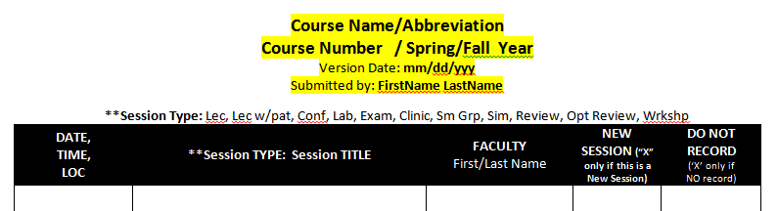

- You can add any other columns/information that will make copying and pasting to/from BBL easier for you – so long as the information for the columns shown above is there.

- Please be sure to show all information for each of the 5 columns:
  - For Session TYPE: Session TITLE – use the Session Types listed at the top of the form:
**Session Type: Lec, Lec w/pat, Conf, Lab, Exam, Clinic, Sm Grp, Sim, Review, Opt Review

  - A typical session entry might look as follows:
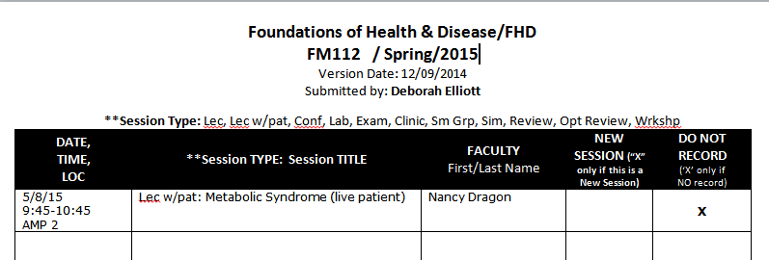
- Please show Exam Reviews as a separate scheduled entry.

- NEW: Please indicate new sessions by placing an ”X” in the New Session Column.

- For corrections, please make changes on a copy of your original schedule submission, highlight the changed information, change the version date, and send the page(s) with the correction(s) to me via email.

SAMPLE:
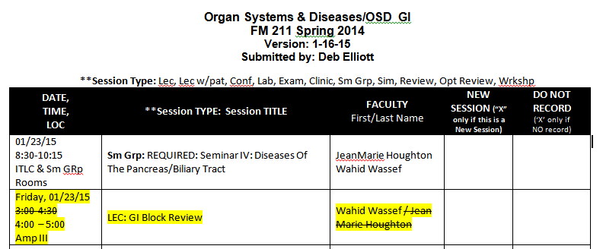

- At the end of your schedule, please feel free to include any special notes.
EXAMPLE:
NOTE: please reserve Small Group Rooms 15 minutes before and after each session start time/end time to allow for set-up and breakdown of space.

- NEW: ALL SMALL GROUP ROOM LOCATIONS MUST SHOW #OF ROOM NEEDED AND IF YOU NEED TECH OR NOT:
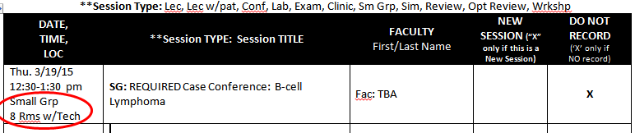

- Please submit all completed forms via email to: angela.grubert@umassmed.edu and please be sure to ‘cc’ Sue Gagliardi for FOM 1 and Tom Smith for FOM 2.

