What are Umeboshi?
Umeboshi are fermented or pickled plums made from young sour Japanese fruit called ume, a cross between an apricot and a plum. After pickling and drying, they are soaked in vinegar and then aged. They can be found whole, as a paste, or in vinegar form.

What Makes Umeboshi So Awesome?
These salty-sweet plums are thought to
have potent medicinal properties secondary
to their high citric acid content that helps
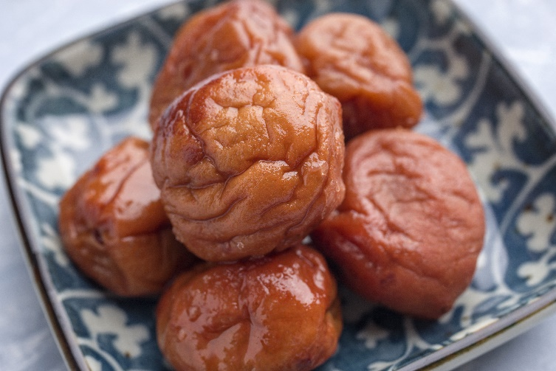

alkalinize the blood, urine, and saliva. Traditional uses range from staving off respiratory infections and gingivitis to curing hangovers, but because umeboshi plums reduce gastrointestinal inflammation and promote elimination of toxins, they are particularly useful as a digestive aid and treatment for heartburn and nausea—including morning sickness!

How Do I Use Umeboshi?
Because of their saltiness, umeboshi are most commonly enjoyed atop rice, as a pickled side dish (tsukemono), or added in small quantities to add tang to Japanese dishes. Umeboshi pastes and vinegars are equally useful for imparting sharp and fruit flavors to dishes and dressings. Here are three delicious ways to introduce umeboshi into your diet:

- Umeboshi with Oats: Cut 2 pitted umeboshi into 1/4-inch dice and serve over warm oat groats.

- Umeboshi Tea: Add 1 pitted and shredded plum to a cup of your favorite tea and allow to steep for 1-2 minutes, then serve.

- Umeboshi Salad Dressing: Combine ¹⁄₄ cup rice vinegar, ½ cup extra-virgin olive oil, 1 tablespoon honey (local is best), 1 teaspoon sesame oil, 1-2 tablespoon umeboshi paste or 2 large pitted umeboshi, and salt and pepper (to taste) in a blender and puree.

- Simply break off a small piece of the plum (or use the pit) and place it your mouth each time you experience nausea or heartburn.

Where Can I Buy Umeboshi?
Umeboshi can be purchased at Asian specialty grocers, Whole Foods, Thrive Market, Amazon, and many grocery and specialty foods shops.

