Tracking the WRTA buses
There are several ways to track the bus. You can track the bus by:
- calling 1(508)296-TRAK and following the prompts, (landline or cell phone) – you must know your bus stop I.D.(see below)
- text your bus stop I.D. to 41411
- on the website www.therta.com using the bus tracker or
- by QR code.

Every bus stop in Worcester has an I.D. You can find a stop ID by looking at Google maps and clicking on the bus stop icon. This will give you the bus stop ID.
The routes 15, 16 and 24 serve this campus. Route 15 goes to Shrewsbury Center. Route 16 goes to Lincoln Plaza, and Route 24 takes Belmont St. and stops at UMass Memorial.
The bus stop I.D. for UMass Medical is #1149. This is the bus stop shelter across from the parking garage. The bus stop by the parking garage is #1148. Type WRTA [bus stop I.D.] and send to 41411. Within a minute or less, you will get a response that will look like this: (Picture on next page)
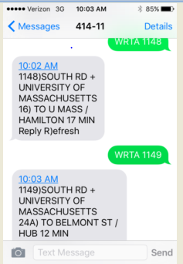

The Bus Tracker at bustracker.therta.com will also help you track your bus. Put in the route #, if the bus is going outbound or inbound, and the closest street intersection.
You can download the app Transit Stop (for IPhones) or Bus Tracker Pro (for Android phones) to help track the buses in your area. These are not official WRTA apps.
Many of your bus stops have a QR code, so you can download a QR code reader (or use the one on your SnapChat) and track the bus that way. However, you have to be at the bus stop to use this tool. The others can be done from the comfort of your home or room.
If you have any questions, please email ttrainer@therta.com.
Happy travels!
#1148 serves outbound Route 15; inbound Route 16
#1149 serves inbound Route 15, outbound Route 16, and Route 24/24A

