Entering a catalog order

- From the left navigation bar in BuyWays, click the Shopping cart icon, the My Carts and Orders, View Draft Shopping Carts
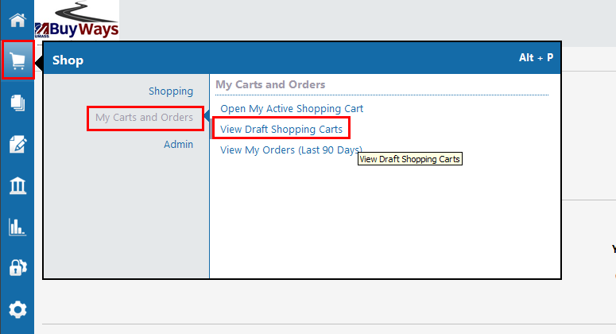
- Click on the ‘Create Cart’ button to create a new (empty) cart
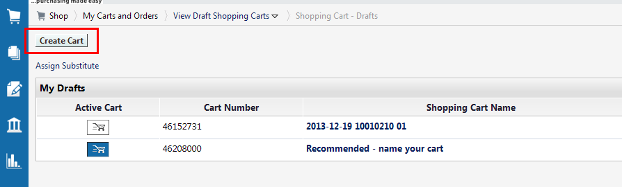

- It is recommended that you name your cart, then update to save the name. Next click on ‘Click here to start shopping
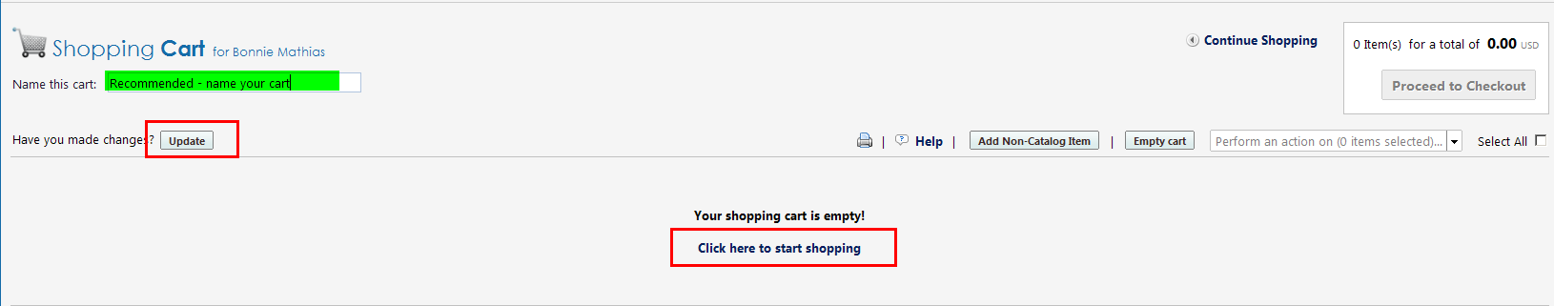
- Click on the Icon for the vendor you will be ordering items from to open their catalog
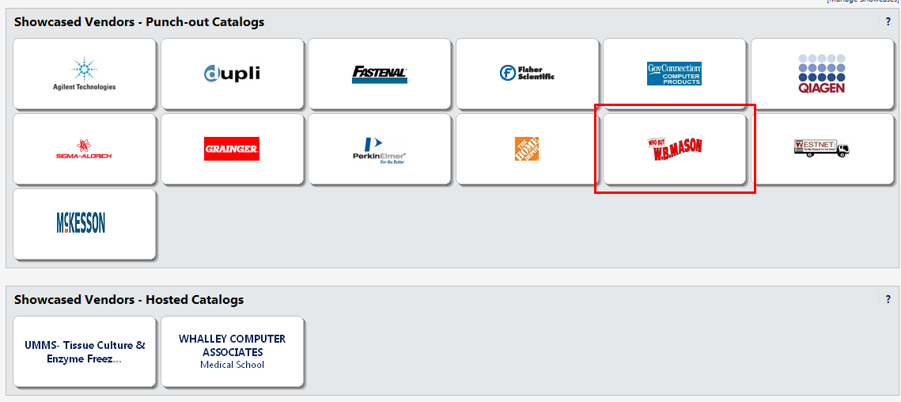
- You will see the system message as you are being connected to the catalog. You can cancel this function at any time using the ‘Cancel Punchout’ button on the right. A message box may appear during connection with a security message. Always choose NO for this message.
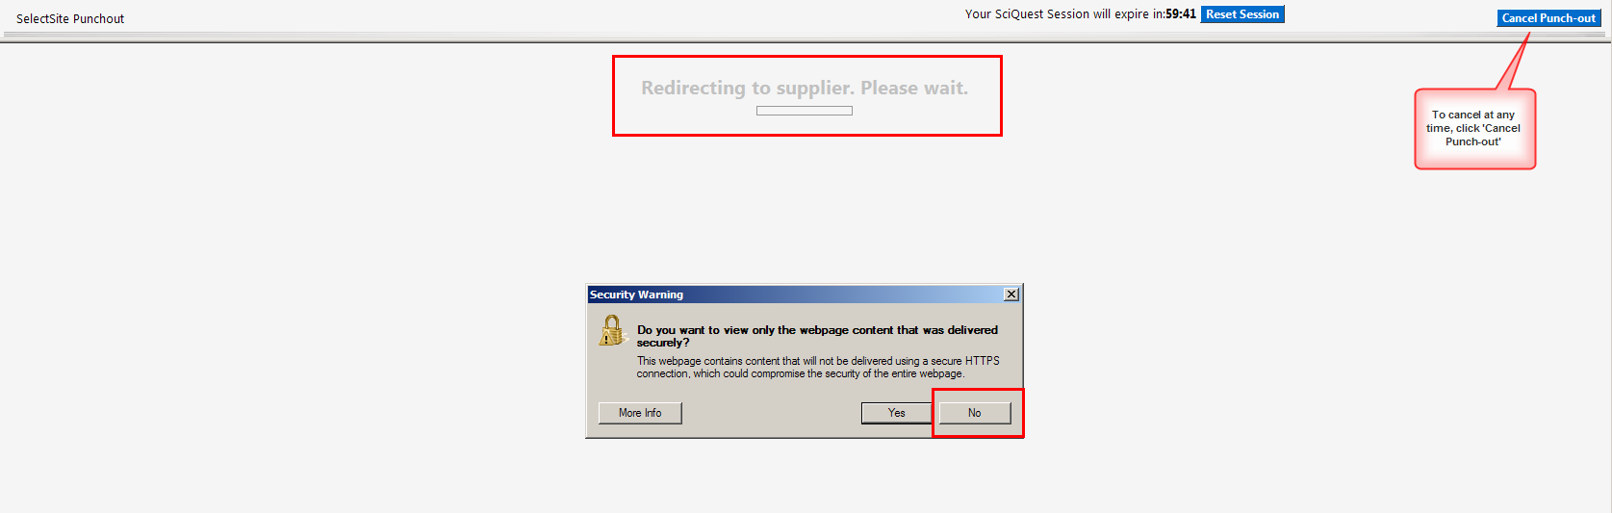

- If you know your item number, you can enter it to the search field and click search
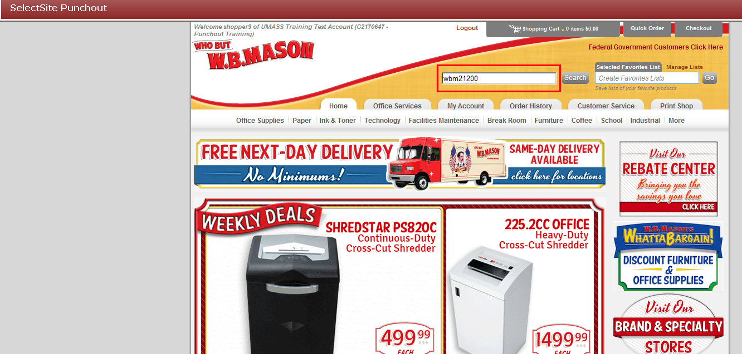
- When your item appears, enter the quantity you wish to purchase, then click ‘Add to Cart’
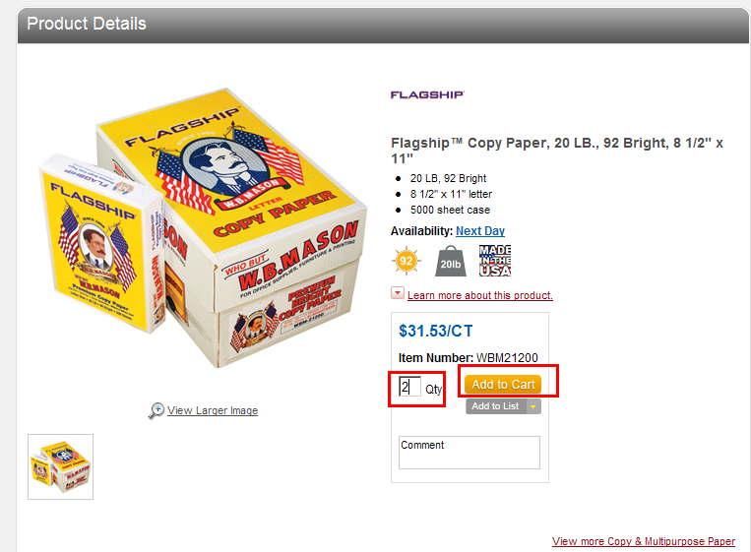
- Your cart will be updated with the item information
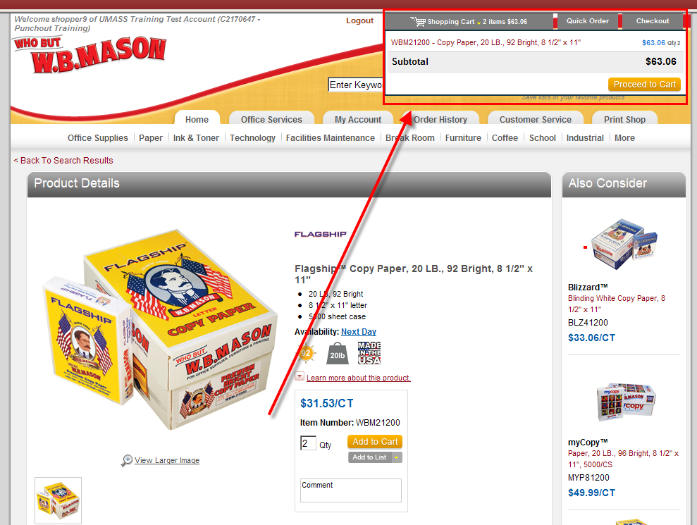
- You can also use the search functionality in the site (Note: Vendor sites will vary)
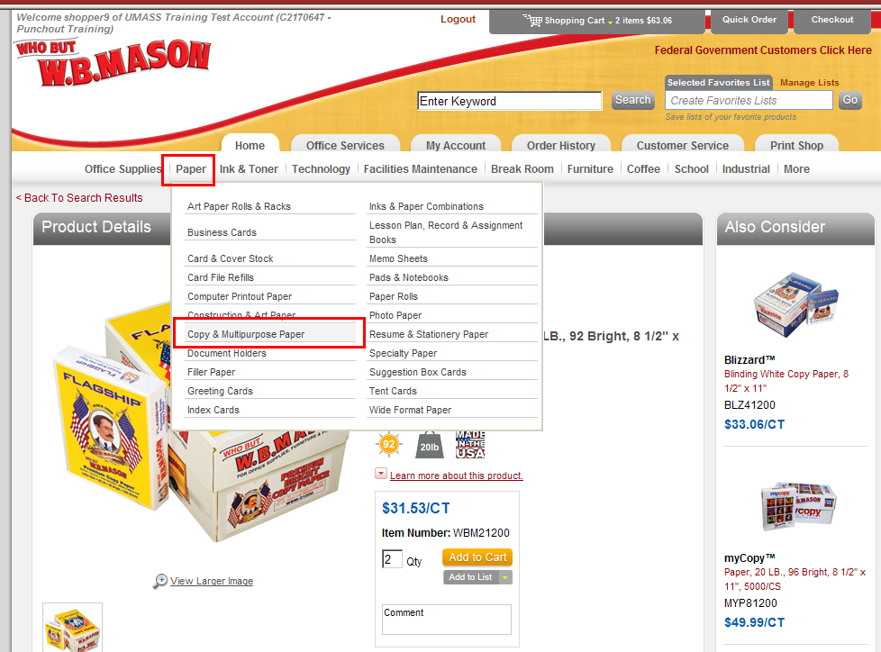
- Add your desired quantity and click the ‘Add to Cart’ button
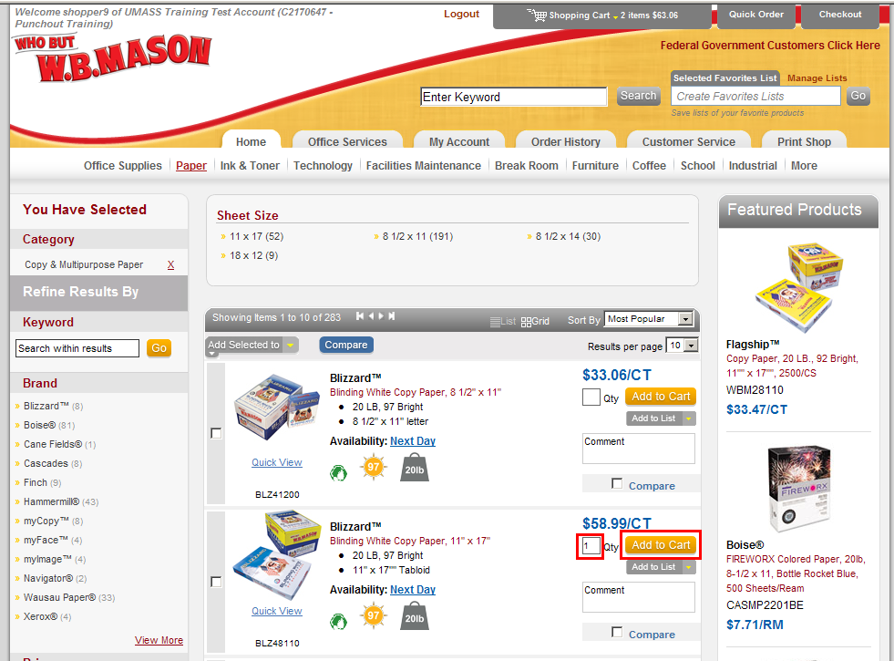

- Your cart will be updated. When you have added all the needed items, click the ‘Checkout’ button
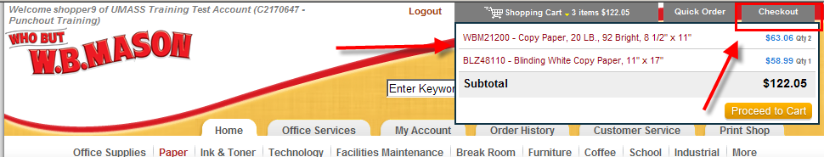

- Optional for shoppers is the selection of the ‘Commodity Code’. If you will not be responsible for adding this information, please skip to step 14
If your department policy requires you to complete this information, click on the arrow to the right of the field.
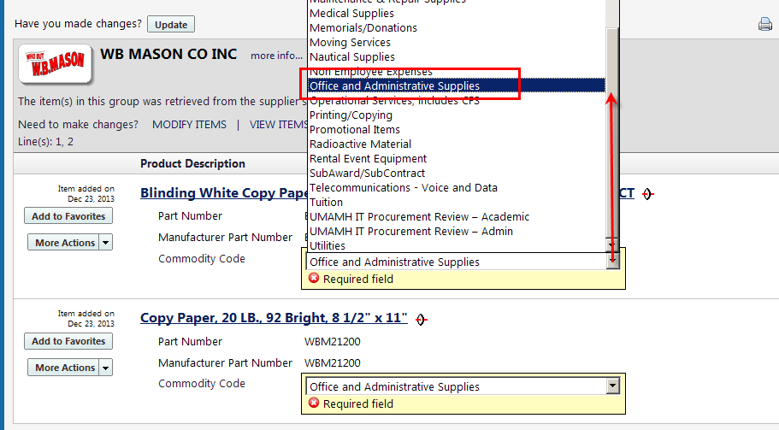
Please note while this field indicates that it is a REQUIRED field, it is not required that the SHOPPER complete this task. Your Requisitioner may complete this field at a later time on your behalf.
- To quickly navigate through the list, type the first letter of the commodity – in this instance the letter ‘O’ – to go to that part of the list and select ‘Office and Administrative Supplies’
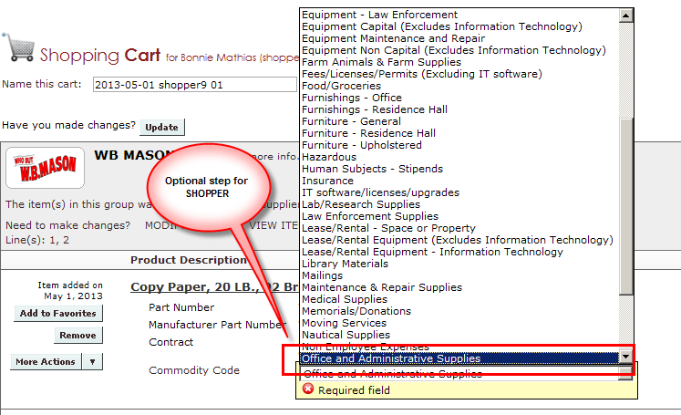

- Please click ‘Proceed to Checkout’.
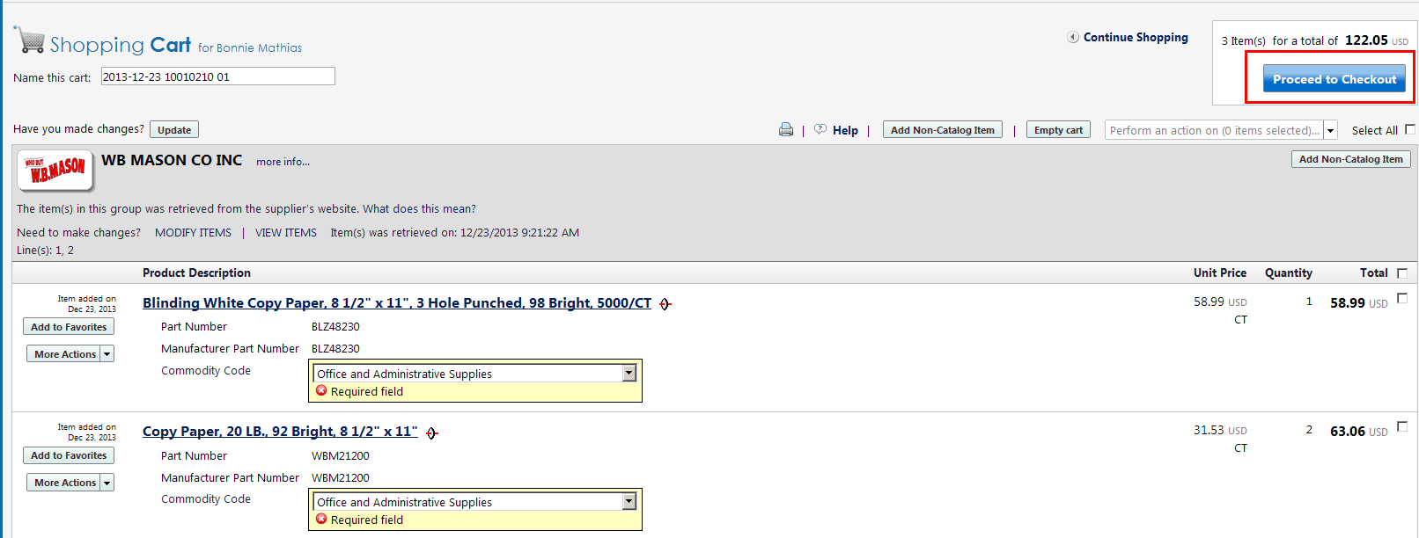
- Verify your ship to information for the requisition. If changes are needed to the information, click ‘Edit’ on the shipping tab. You can update the ship to building by clicking ‘To choose a different address, click here’. Be sure the Attn: name is the correct individual, and that the Rm/Fl/Ste is correct so that your items can be delivered to you
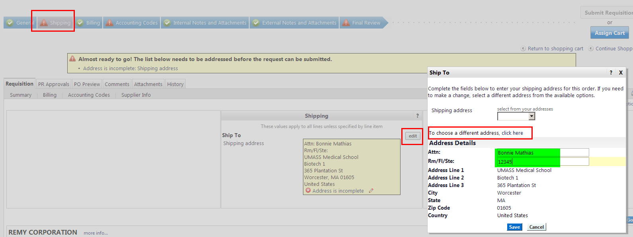

- As a SHOPPER, as an OPTION add the speed type and account code for your order. While these fields indicate they are required, your department may elect to have the REQUISITIONER complete this information on your behalf. If you will not be adding chartfield information, please skip to step 20
To add information to the SpeedType or Account field, click on the ‘Edit’ button on the right
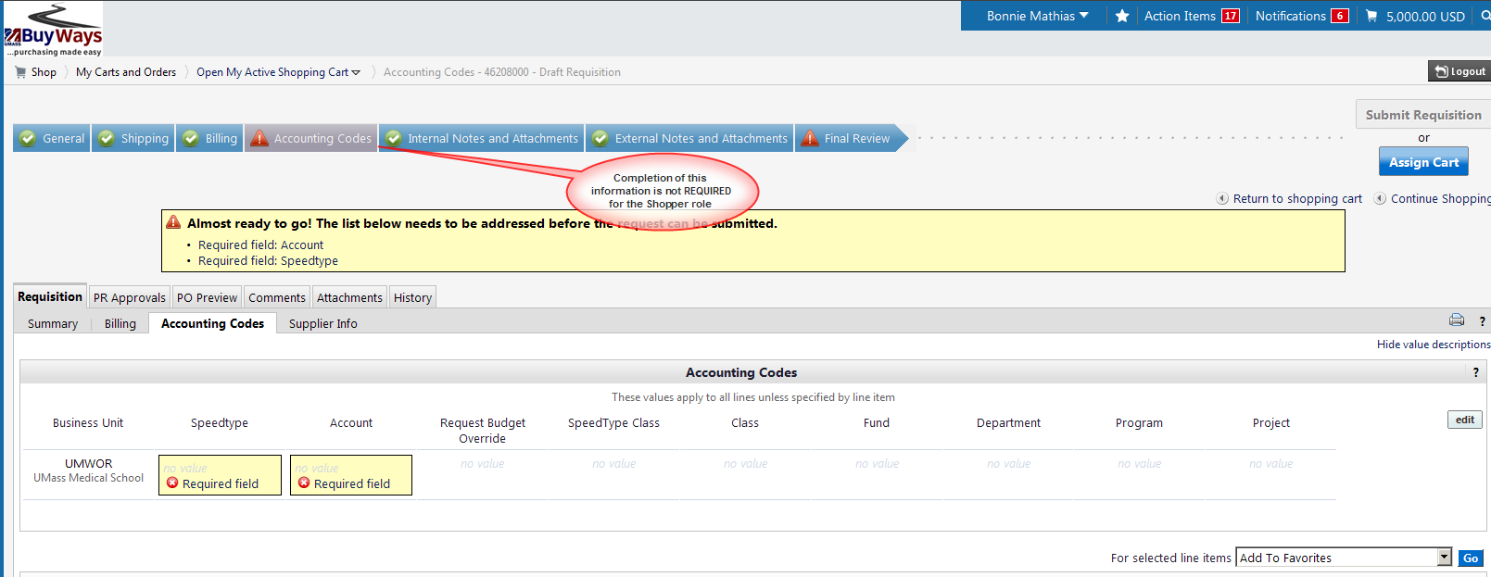

- To add the SpeedChart, click on the ‘Select from all Values’ link. A pop us box will appear, where you can type in part or all of your speed chart number, then click ‘search’

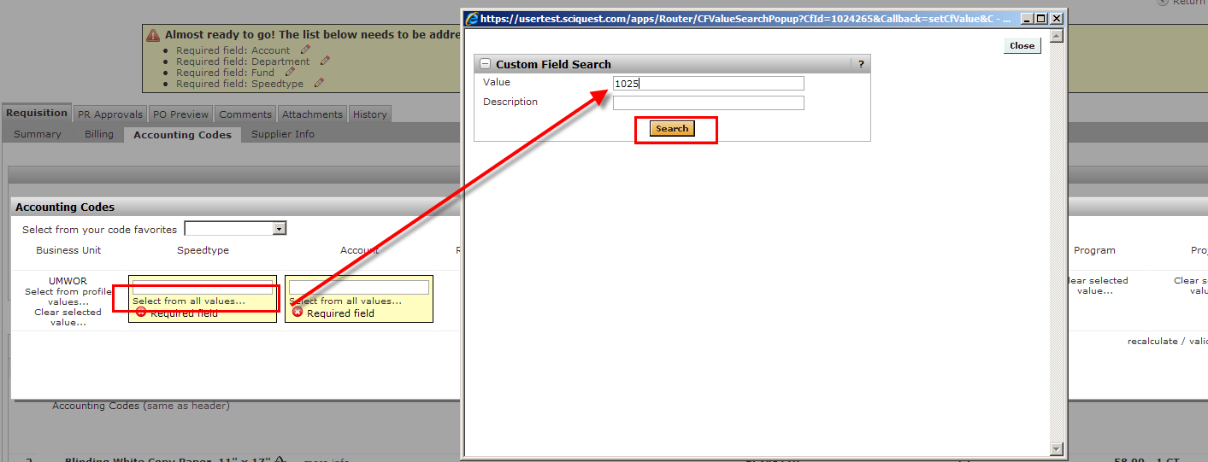
- Click on ‘Select’ to the right of the Speedchart you need
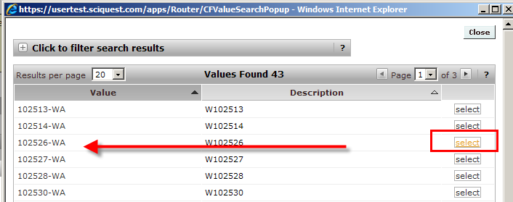

- All of your chartfield values will populate the fields where needed. Click the ‘Save’ button
Please do NOT enter any value in the ‘Class’ Field.

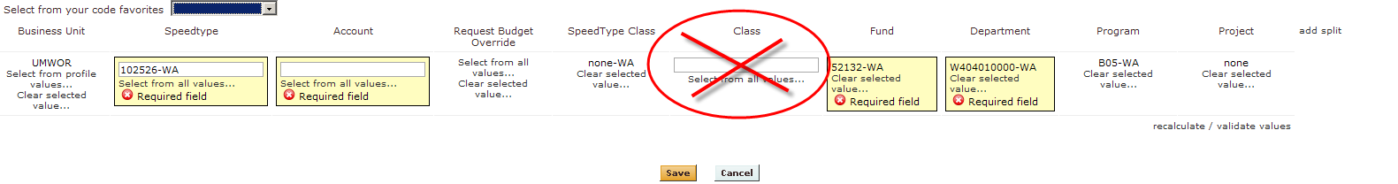
- If you are using restricted (grant) funds, you will need the PI to authorize your purchase. To print a copy of the requisition, go to the Final Review tab and click on the printer icon on the right side
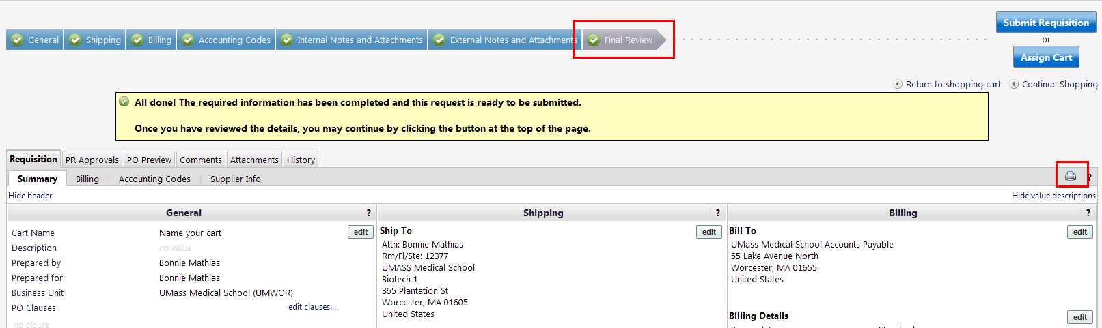

- A PDF document will be created with your requisition details, which can then be signed by your PI.
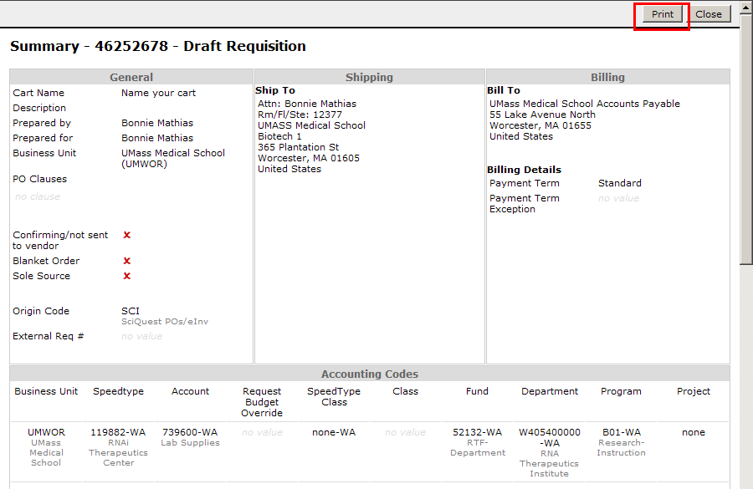

- To attach documents to the requisition first save your document on your computer, then scroll down on the final review tab to the Internal/External Notes and Attachment section. Examples of documents are PI Signed requisition, vendor quotes, sole source documents. To add a document, click on ‘add attachment’ in the appropriate section (internal/external)
Note: Catalog orders will not transmit External Notes or Attachments with the order. Do not use External Notes or External Attachments with any catalog orders
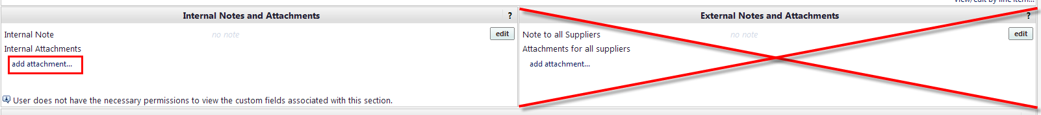

- To add a note to the document (example: Quote #12345), click on the ‘edit’ button in the appropriate section
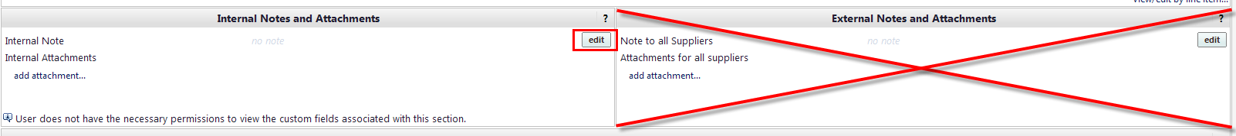

- You are now ready to ‘Assign’ your cart to your requisitioner or ‘Submit’ your cart. Click on the ‘Final Review’ Tab. To submit your cart (requisitioners), click the Submit button
For Shoppers, you must Assign your cart to a requisitioner. If you have added your Requisitioner to your profile, you can select them by clicking ‘Select from Profile Values’, or you can search from all available Requisitioners by clicking ‘Search for an Assignee’. From the search return, click on [Select] to the right of the Assignee name. You can also add a note to the requisitioner with any additional information they may need to process your order.
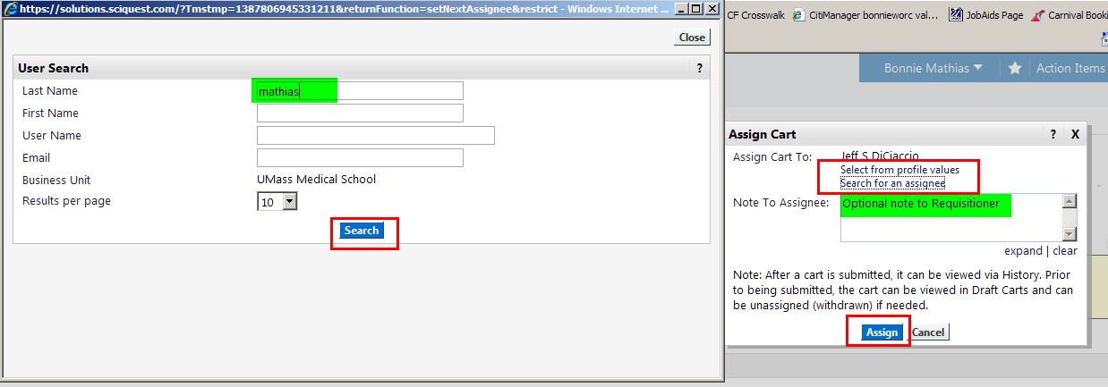
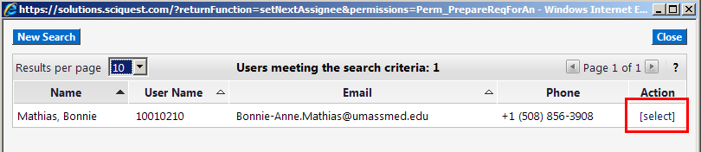

- Your Shopping cart has been successfully submitted


