Ordering a Desktop/Laptop computer in BuyWays
What you need:
- A list of specifications for your order – the model #, memory, other configurations
- A quote from the vendor UNLESS you are ordering a computer that is available from the Whalley Computer hosted catalog or the Apple Punch-out catalog. Note – to order from the catalog, ALL items must be available within the catalog. If all options are not available, you must use a non-catalog order for ALL items. You can’t mix catalog and non-catalog items on a single requisition.
- For PC’s, Windows 7 Professional

Use the links below to access the job aid for the type of requisition you need
Ordering a Desktop/Laptop from Whalley Computer hosted catalog
Ordering a Desktop/Laptop computer using a Non-Catalog order
Ordering from Apple Computer using the punch-out catalog
Ordering a Desktop/Laptop computer from the Whalley Computer hosted catalog
  - In BuyWays, go to Carts, My Carts and Orders, View Draft Shopping Carts. The click ‘Create Carts.
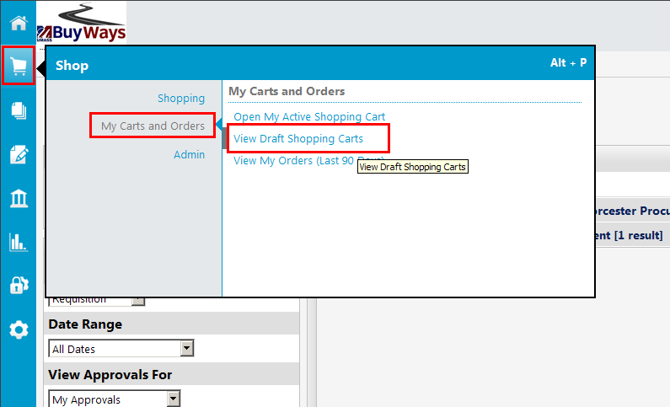
  - Click Create Carts
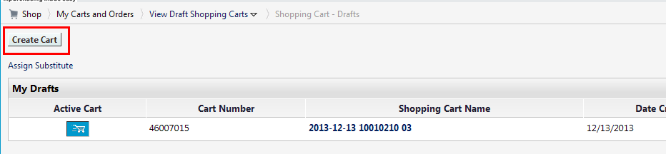
  - Type in the name for your card (recommended), then click ‘update’. Next Click on ‘Click her to start shopping’
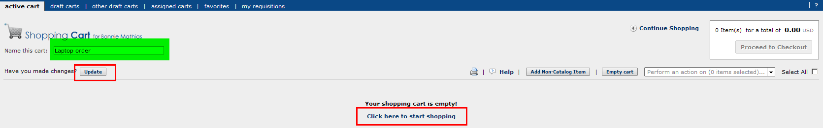

  - To order a standard computer from Whalley, you can use the Hosted Catalog. Click on the Whalley Computer link, then type the model number in the text box and click ‘search’
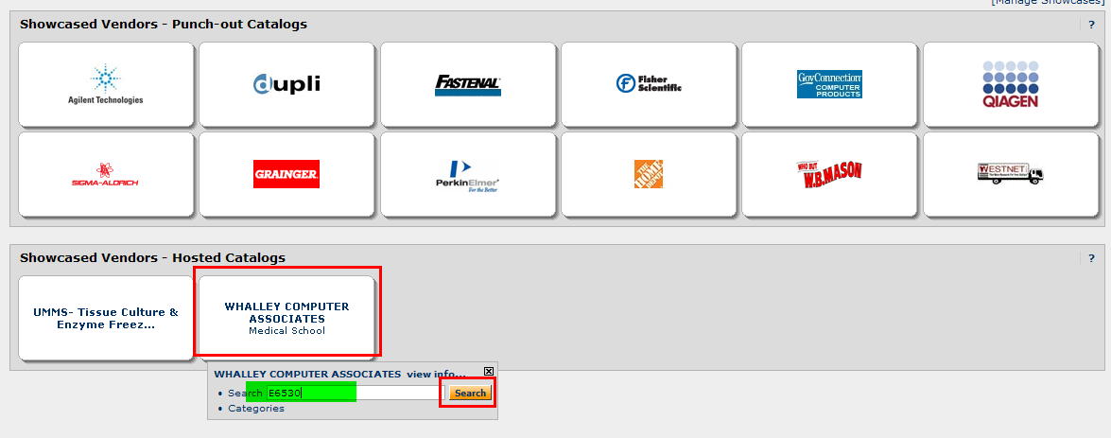
  - A list will appear with the catalog options available for that model. Look carefully at the descriptions and choose the one that meets your requirements. Hint: If you know the total cost of the model with any memory upgrades, you can look at the prices to start.
The model shown below comes in a 4GB, 6GB or 8GB version, with either 500 or 750GB options for each.
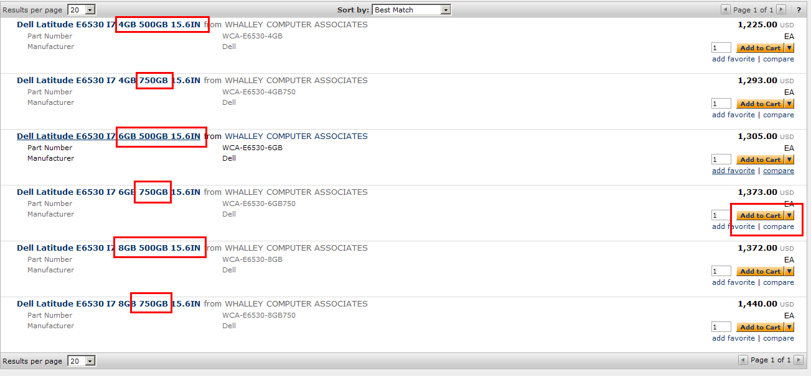

  - For this example, we want the E6530 with 6GB, 750GB configuration at a cost of $1373.00. Using the ‘Search Hosted Catalogs’ function, enter E6530, then click ‘Go’. Find the item, enter the quantity you need, then click ‘Add to Cart’
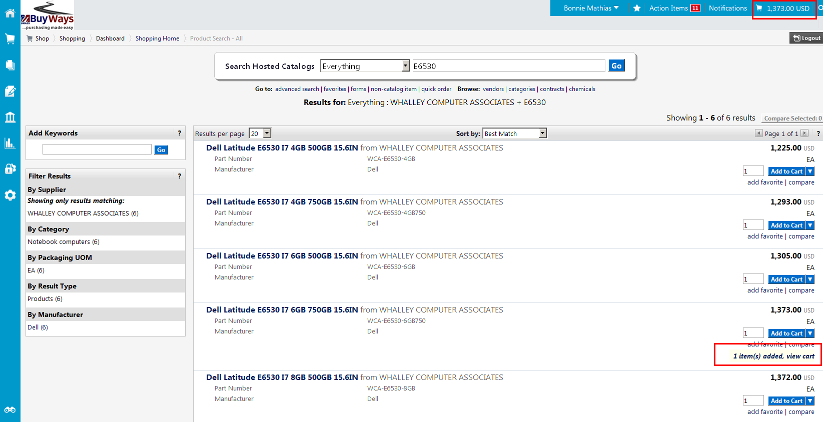

  - You also want a Conquer case for this computer, enter ‘Conquer’ to the Search Hosted Catalogs field, then click ‘go’. From the results, select the desired case, update the quantity, then click ‘Add to Cart’
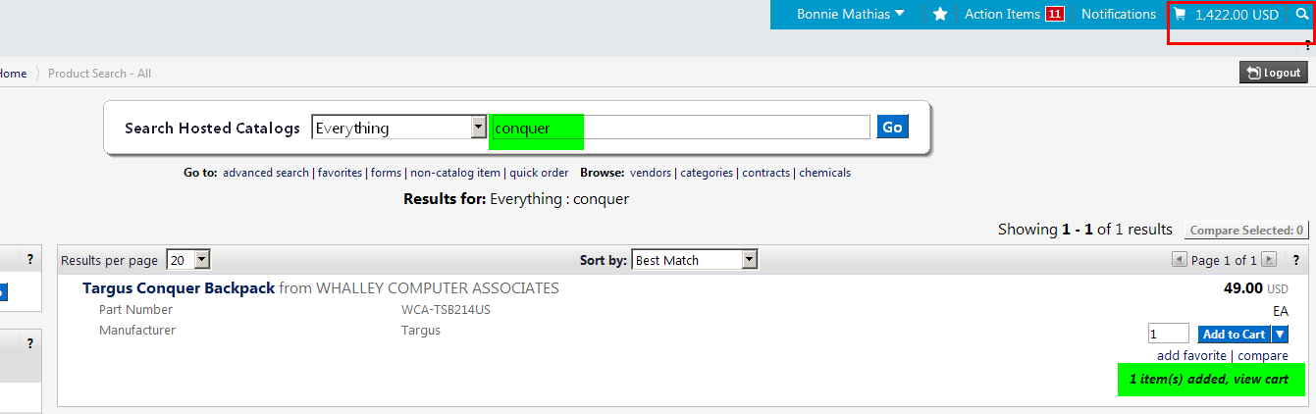
  - Your cart information in the upper right side of your screen should now show a total cost of $1422.00. Click on the Cart icon in the box shown below, then ‘View My Cart’ to retrieve your cart.
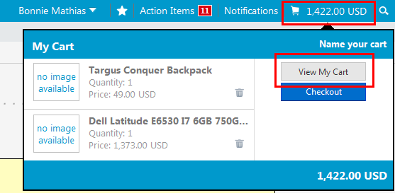
  - When your cart opens, update the commodity code to ‘Computerss – Desktop/Laptop (UMMS Only). Then click ‘Proceed to Checkout’
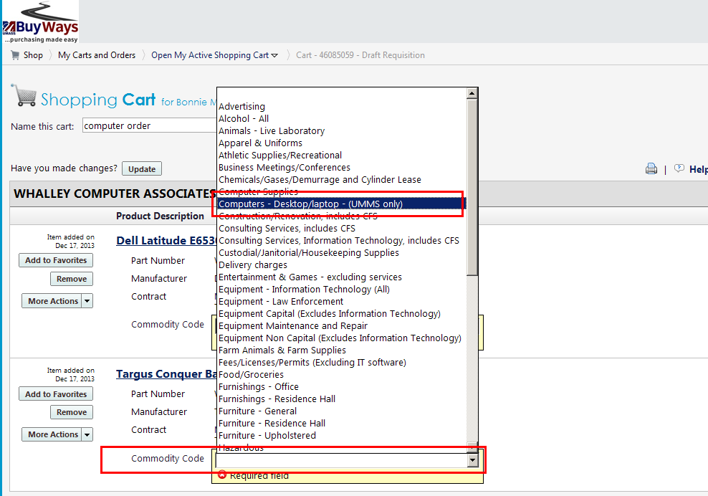

  - Validate the shipping address is correct. Please be sure this information is correct as it is used by the vendor to supply your equipment AND by the Asset Management department to tag and inventory the computer. **Note: If the computer is to be delivered to someone other than the requisitioner, please add the phone number after the name in the ‘Attn:’ field
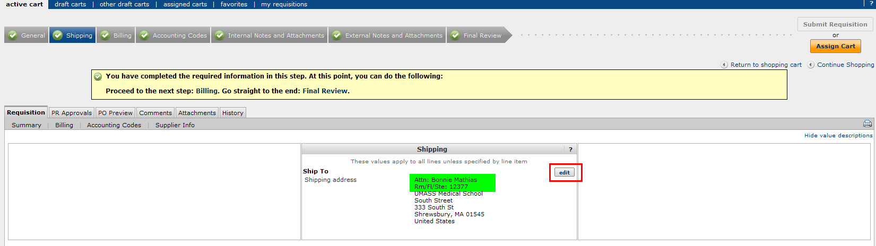

  - On the Account Codes tab, enter the Speed Type number and the Account Code of 741970-WA, then save.
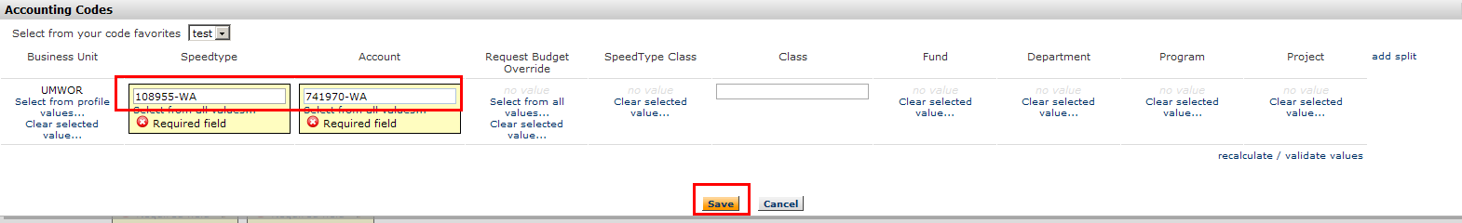
  - If your requisition requires a hard copy signature, Print your requisition using the Printer Icon in the upper right, obtain your hard copy signature, then scan and attach the signed copy using the Internal Notes and Attachments page. Click on ‘Edit’ to add any notes to the requisition. Click ‘Add Attachment’ to upload your signed document.
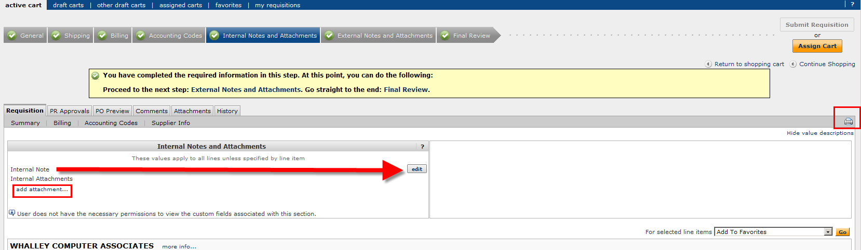
  - Once your requisition information is complete, click on the ‘Final Review’ tab and Submit Requisition (Requisitioners) or Assign Cart (Shoppers) to move your requisition to workflow
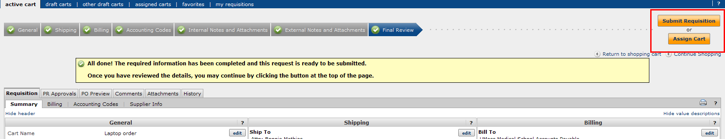

- Ordering a Desktop/Laptop from the Apple Punch-out Catalog
  - In BuyWays, go to Carts, Draft Carts and click ‘Create Cart’

  - Type in the name for your cart (recommended), then click ‘update’. Next Click on ‘Click here to start shopping’
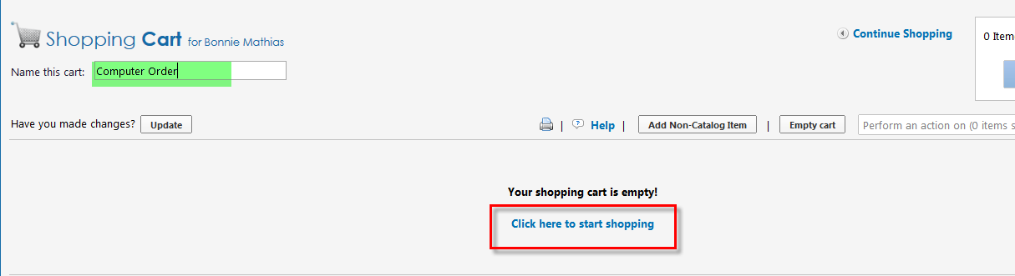

  - Choose the Apple Catalog from the Showcased Vendors
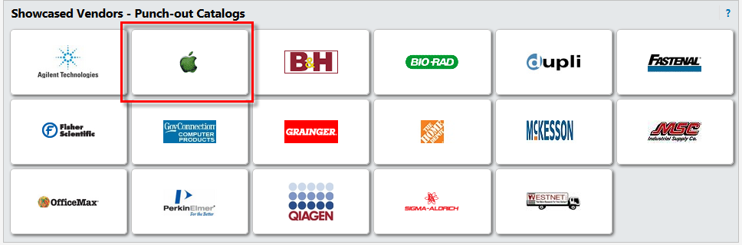

  - A new browser window will open and bring you to the Apple Store
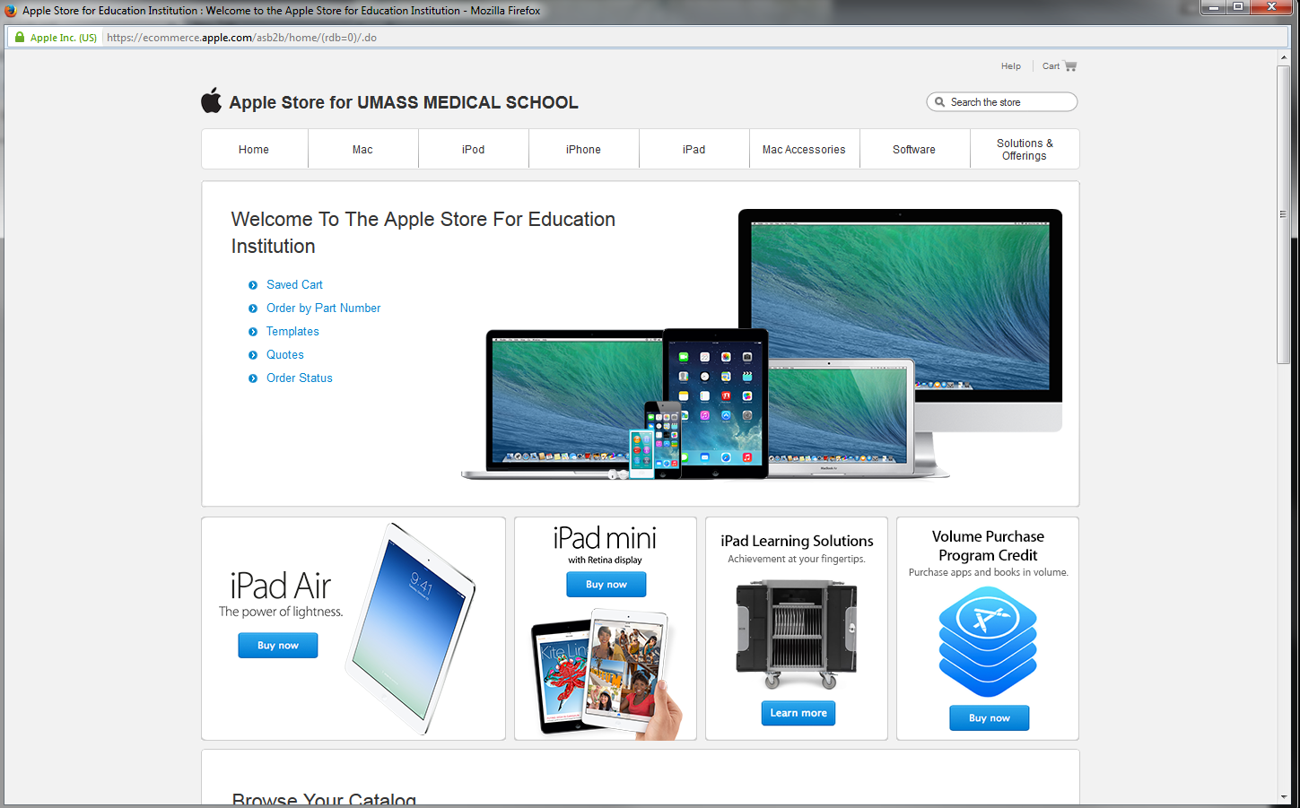
  - You can use the search box or select your items using the drop down menus. Choose your base computer by adding the Quantity needed, the click ‘Add to Cart’
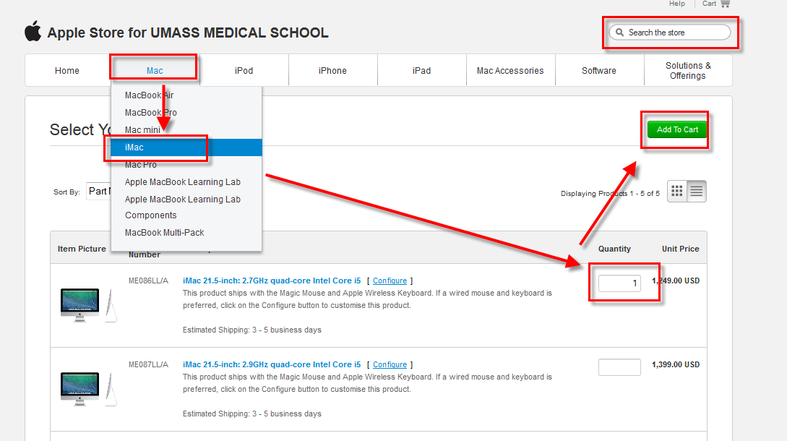
  - The next screen will show you available upgrades or options for selection. To select AppleCare protection, click the checkbox and then ‘Update’
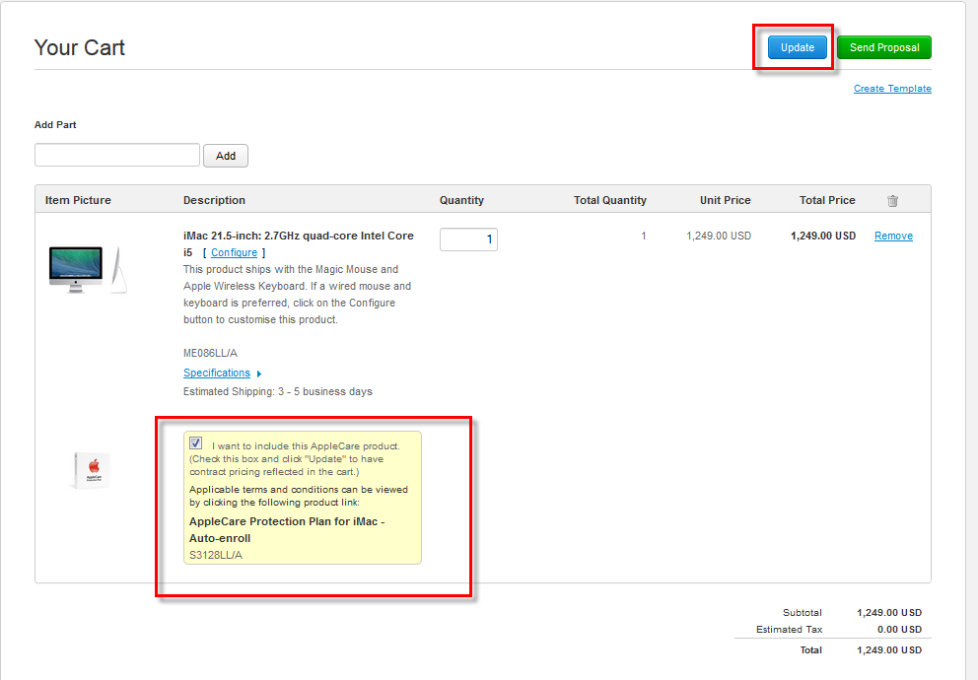
  - Your cart will be updated. Once all needed upgrades and options have been selected, click ‘Send Proposal’
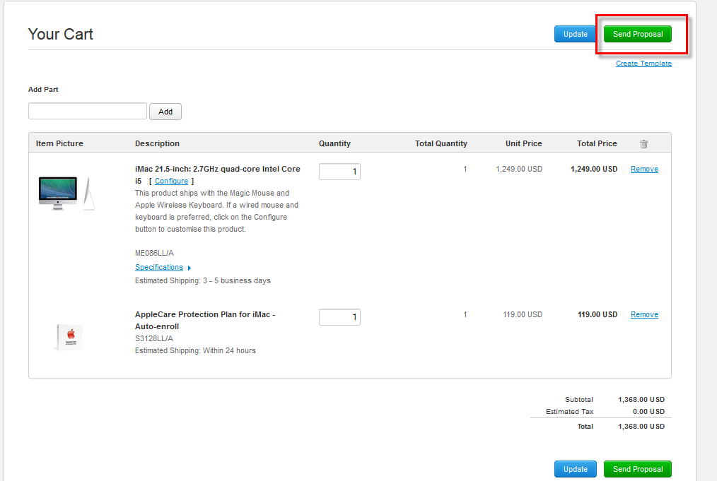
  - Confirm your order is correct, the click ‘Submit’
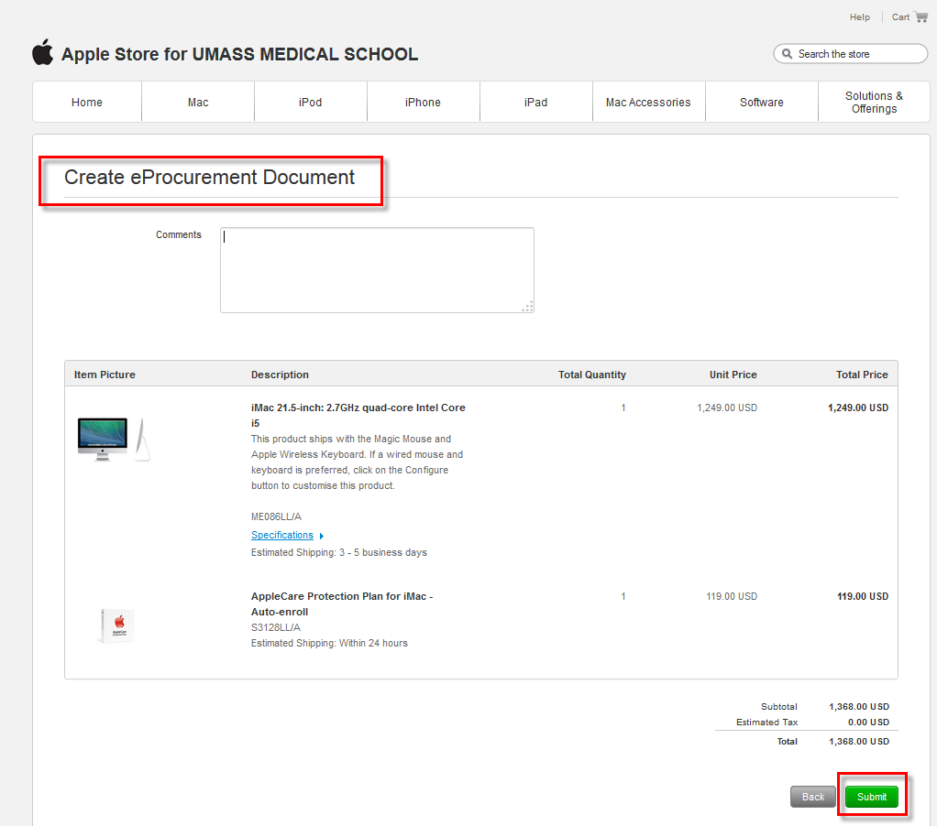
  - A confirmation screen with your proposal number is created. Click ‘Continue’ to bring the proposal information back to BuyWays to complete your requisition.
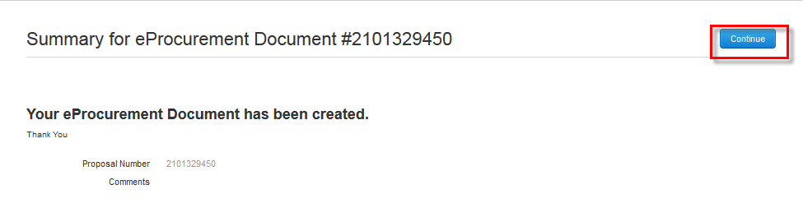

  - Using the drop down boxes on your items, choose “Computers – Desktop/Laptop – (UMMS Only) for the commodity code on each line. Then click ‘Proceed to Checkout’
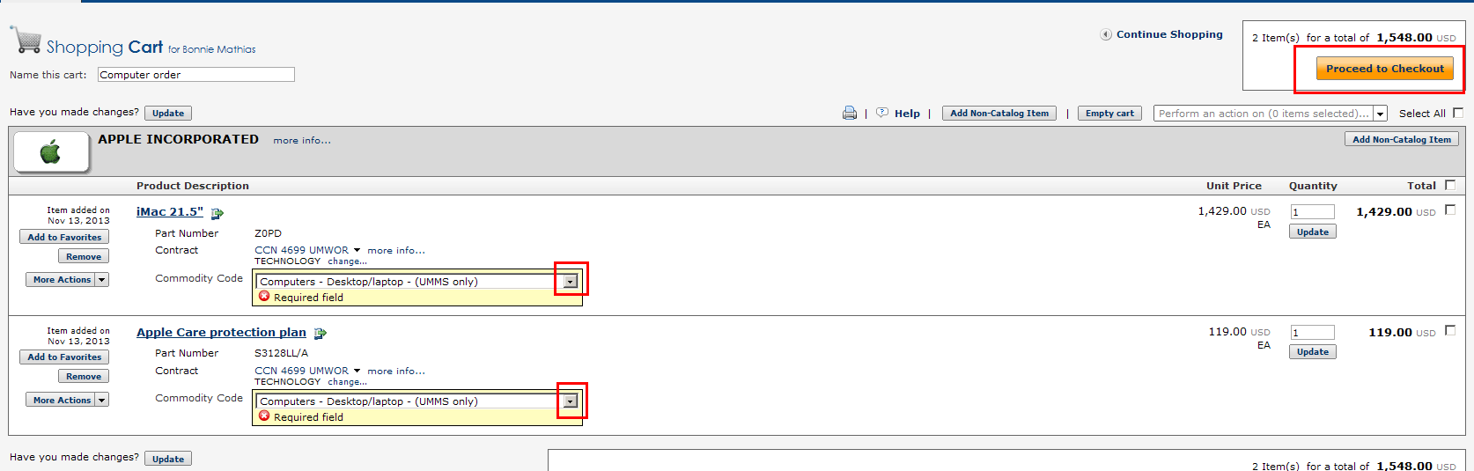

  - Validate the shipping address is correct. Please be sure this information is correct as it is used by the vendor to supply your equipment AND by the Asset Management department to tag and inventory the computer.

  - On the Account Codes tab, enter the Speed Type number and the Account Code of 741790-WA, then save.

  - Once your requisition information is complete, click on the ‘Final Review’ tab and Submit Requisition (Requisitioners) or Assign Cart (Shoppers) to move your requisition to workflow

