Using RSO365
RSO365 allows users to filter for meeting spaces and resources they need within the familiar scheduling tool of Microsoft Outlook. Because the filtering process is data-driven, unique attributes configured in a user's Exchange are available.
NOTE: The Swap Resource functionality are not useable once the interface is installed. Additionally, you cannot add services (example: A/V) in Outlook with the interface.

Opening RSO365 in Outlook Desktop App
- Using your preferred workflow, open an Appointment or Meeting event.
- Click the add-in displaying in the main ribbon.
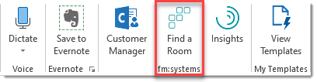
Result: A side menu displays.

Opening RSO365 in Outlook Web App
- Using your preferred workflow, open an Appointment or Meeting event.
- In the Calendar window menu, click the ellipsis (), then select Find a Room.
Note: if you don't see a menu with an ellipsis, click "More options" to expand the Calendar window.
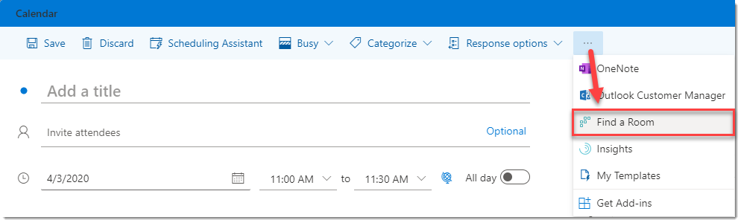
Result: A side menu displays.
Tip: to add the "Find a Room" add-in to the main list of icons at the top of the Calendar window, complete the following steps:
  - From the top toolbar, click the Settings icon > View all Outlook Settings.
  - Next, select the Calendar tab > Customize actions.
  - Select the "Find a Room" check box. To change the order in which these icons appear, select them in a different order.
  - Save.

Create a New Meeting
- Open a new meeting or appointment event in Outlook, then enter basic meeting details, such as Title, Description, and Attendees.
Note: Users can fill out these fields in Outlook before or after opening RSO365.
- When you're ready to find a meeting space, open RSO365 in the Outlook platform.
- From the Find section, choose a resource to filter by enabling its radio button.
- Set a Capacity value, if needed.
- Next, expand the location you want and select the appropriate group, for example First Floor, from the expandable list.
- Click Search to view spaces that have the resources requested.
- Click the space name you want, then Reserve to add it to the event window in Outlook. A link to the Resource Scheduler is also added to the body of the event information.

Update an Existing Meeting
Select an existing meeting in either the Outlook desktop or web application. Click the RSO365 add-in and, using the same steps as when creating a new meeting, update the meeting.

